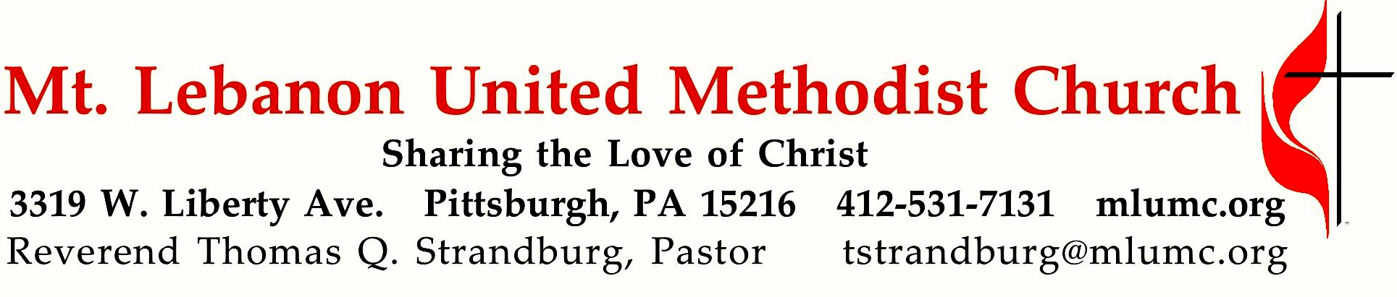
6th Sunday after Pentecost

Fifty years ago, human beings touched down on the moon. Hundreds of millions of people around the world watched live as it happened. Since then, we have asked ourselves, “What does this mean?” What is the meaning of the universe, and humanity in the midst of it? An ancient hymn about Christ’s work gives us something to think about: “Because all the fullness of God was pleased to live in him, and he reconciled all things to himself through him —whether things on earth or in the heavens. He brought peace through the blood of his cross.” (Colossians 1:19-20 CEB)

July 21, 2019 8:30 & 10:45

WE GATHER IN GOD’S NAME …

*Asterisk indicates to stand as able

8:30 Gathering Music Hymnal 141 Children of the heavenly Father Tryggare kan ingen vara

Greeting

Leader: O magnify the Lord with me,
People: and let us exalt God’s name together! Psalm 34:3

Announcements

*Call to Worship
Leader: We gather this day from a week filled with needs and demands
People: We come to find rest and renewal of our spirits.
Leader: Open your hearts in love to hear the voice of God.
People: We want to quietly rest in God’s presence,
free from the clamor of the world.
Leader: This is the day that the Lord has made.
People: Let us rejoice and be glad in it.
… TO GIVE PRAISE TO GOD …

*Hymnal 568 Christ for the world we sing Italian Hymn

*Opening Prayer (in unison)
From the demands and pressures of this past week, we come, O Lord, seeking rest and renewal. Hear the cries of our hearts, our prayers, and our needs. Heal and restore us. For we ask this in Jesus’ Name.

*Silent Prayer

*Hymnal 543 O Breath of Life (stanza 2) Bishop Powell
O Wind of God, come, bend us, break us, till humbly we confess our need.
Then in your tenderness remake us; revive, restore, for this we plead.

TO CELEBRATE THE FAMILY OF FAITH …
*The Sign of Peace
Leader: The peace of Christ be with you.
People: And also with you.

Gathering Song
This, this is where children belong,
welcomed as part of the worshiping throng.
Water, God’s Word, bread and cup, prayer and song:
This is where children belong. words and music: James Ritchie ©1999 Abingdon Press

Message for Young Disciples
All children are invited. Please sing as children come forward. After the children’s message at the 10:45 service, children ages 3 - 3rd grade may attend Kids Praise in the Welcome Center. Children will be escorted to and from Kids Praise by teachers. They will return near the end of the service.

Hymnal 149 Let’s sing unto the Lord Rosas

… TO HEAR GOD’S WORD PROCLAIMED …

Scripture Reading 8:30 Judi Phelps 10:45 Sally Munro
A Lesson from the New Testament
Colossians 1:15-28 Hymn about Christ’s work

Response
Leader: Hear what the Spirit is saying to God’s people.
People: Thanks be to God.
Pastoral Prayer

The Lord’s Prayer
Our Father, who art in heaven, hallowed be thy name. Thy kingdom come, thy will be done, on earth as it is in heaven. Give us this day our daily bread. And forgive us our trespasses, as we forgive those who trespass against us. Lead us not into temptation, but deliver us from evil. For thine is the kingdom, the power, and the glory forever. Amen.

*Celtic Alleluia (standing) Fintan O’Carroll
Alleluia. (sing 4 times)

*Scripture Reading
*A Lesson from the Gospel
Luke 10:38-42 Jesus visits Martha and Mary

*Response
Leader: The Word of the Lord.
People: Thanks be to God.

… TO OFFER OUR GIFTS AND TO DEDICATE OUR LIVES …

10:45 Offertory Anthem Chaz Bowers
1. O breathe on me, O Breath of God, fill me with life anew,
that I may love the things you love and do what you would do.
2. O breathe on me, O Breath of God, until my heart is pure in you;
until my will is one with yours, to do and to endure.
3. O breathe on me, O Breath of God, my will to yours incline,
until this selfish part of me glows with your fire divine.
4. O breathe on me, O Breath of God, so I shall never die, but live,
but live with you the perfect life for all eternity. Amen.

*Hymnal 94 Praise God, from whom all blessings flow (standing) Lasst uns erfreuen
Praise God, from whom all blessings flow;
Praise God, all creatures here below; Alleluia! Alleluia!
Praise God, the source of all our gifts!
Praise Jesus Christ, whose power uplifts!
Praise the Spirit, Holy Spirit! Alleluia! Alleluia! Alleluia!
adapt. © 1989 The U. Methodist Publishing House

Prayer of Dedication

Sermon “One Small Step – One Giant Leap” Rev. Thomas Q. Strandburg
… TO GO REJOICING IN GOD’S NAME!

*Hymnal 150 God, who stretched the spangled heavens (stanzas 1-3) Holy Manna

*Benediction

*Hymnal 150 God, who stretched the spangled heavens (stanza 4) Holy Manna

Today’s Services
The flower arrangement provided for worship today is given by Linda and Duane Kish in celebration of our dad, Bill Gollburg, whose birthday was July 20.
Greeters 8:30 Erma Henry 10:45 Jane Casey

Special music for the 10:45 service is provided by the Chancel Choir.
The anthem “O breathe on me” was composed by Chaz Bowers, organist and choir director at our neighboring St. Bernard’s Church. Chaz slightly altered the words of Edwin Hatch (1835-1889), found in our Hymnal, 420, and breathed new life into it with this sweet yet profound setting.
Worship options for children We encourage children to participate in the Children’s Sermon at both services, and in Kids Praise during the 10:45 service. Nursery services are offered in Room 204 of the Education Building. Ask ushers or greeters and follow signs for direction.

Honor or remember a loved one with a flower donation. The flowers that grace the sanctuary each week are generously donated by our church family members. This is a great way to honor or memorialize a special person, event, or milestone in your personal life or in the life of the church. If you are interested in donating flowers on a particular Sunday, contact Lizzie Diller , 412-860-3614. The cost is $33 for the altar, narthex, or columbarium arrangements, and $66 for the chancel flowers.

Podcasts of Sunday Sermons Catch up on messages from MLUMC with a podcast of Pastor Tom’s and others’ Sunday sermons. Sermons can be found at http://mlumc.buzzsprout.com or navigate to the site from the link on our webpage, www.mlumc.org. Sermons also will be posted to iTunes. Full recordings of the service are available upon request.

Today’s Scriptures

Colossians 1:15-28
¹⁵He is the image of the invisible God, the firstborn of all creation; ¹⁶for in him all things in heaven and on earth were created, things visible and invisible, whether thrones or dominions or rulers or powers—all things have been created through him and for him. ¹⁷He himself is before all things, and in him all things hold together. ¹⁸He is the head of the body, the church; he is the beginning, the firstborn from the dead, so that he might come to have first place in everything. ¹⁹For in him all the fullness of God was pleased to dwell, ²⁰and through him God was pleased to reconcile to himself all things, whether on earth or in heaven, by making peace through the blood of his cross. ²¹And you who were once estranged and hostile in mind, doing evil deeds, ²²he has now reconciled in his fleshly body through death, so as to present you holy and blameless and irreproachable before him— ²³provided that you continue securely established and steadfast in the faith, without shifting from the hope promised by the gospel that you heard, which has been proclaimed to every creature under heaven. I, Paul, became a servant of this gospel.²⁴I am now rejoicing in my sufferings for your sake, and in my flesh I am completing what is lacking in Christ’s afflictions for the sake of his body, that is, the church. ²⁵I became its servant according to God’s commission that was given to me for you, to make the word of God fully known, ²⁶the mystery that has been hidden throughout the ages and generations but has now been revealed to his saints. ²⁷To them God chose to make known how great among the Gentiles are the riches of the glory of this mystery, which is Christ in you, the hope of glory. ²⁸It is he whom we proclaim, warning everyone and teaching everyone in all wisdom, so that we may present everyone mature in Christ.

Luke 10:38-42
³⁸Now as they went on their way, he entered a certain village, where a woman named Martha welcomed him into her home. ³⁹She had a sister named Mary, who sat at the Lord’s feet and listened to what he was saying. ⁴⁰But Martha was distracted by her many tasks; so she came to him and asked, “Lord, do you not care that my sister has left me to do all the work by myself? Tell her then to help me.” ⁴¹But the Lord answered her, “Martha, Martha, you are worried and distracted by many things;⁴²there is need of only one thing. Mary has chosen the better part, which will not be taken away from her.”

From Mike Staab:
I would like to thank everyone who contributed to this year’s American Blind Bowling Association National Tournament that was held here in Pittsburgh. Your generous donation and support made our tournament a huge success. Nothing but good comments coming from all the members who attended. Everyone wants to know when are we coming back again.

Mike Staab
Event Coordinator
American Blind Bowling Association

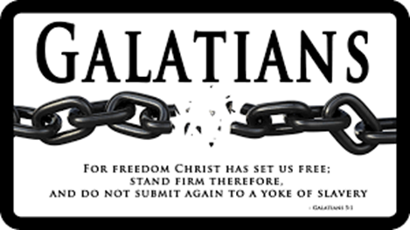

SUMMER SERMON SERIES
August 4th Galatians 1 “No Other Gospel”
August 11th Galatians 2 “It is No Longer I”
August 18th Galatians 3 “Out of Many, One”
August 25th Galatians 4 “Born of the Spirit”
Sept. 1st Galatians 5 “The Only Thing That Counts”
Sept. 8th Galatians 6 “Everything!”

Join us in worship or through the online podcast each week!

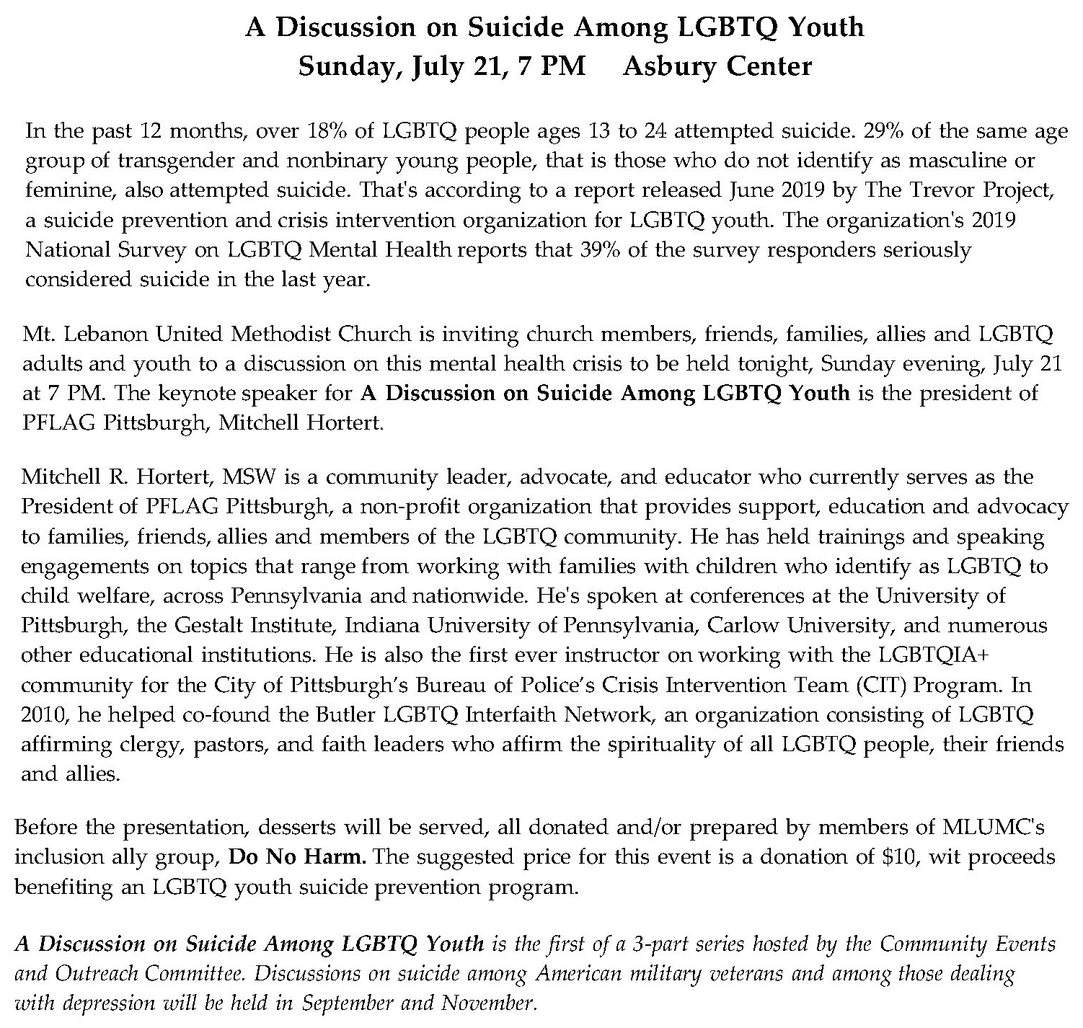

Keep in Prayer

Convalescing in Care Facilities
Bonnie Amos, Providence Point
Ed Clarke, Asbury Heights
Isabella (Langston) Field, St. Alphonsus Medical Center, Boise
John Katshir, Asbury Heights
Pat Seitz, Concordia
Olivia Woods, Baptist Manor

Convalescing at Home
Bishop George Bashore, Jean Boyer,
Mary Caldwell, John Dean,
Joseph Festor, Leon Grant, Jr., Dave Lewis,
Susan Lichtenfels, George Lindow,
Sara Mercer, Carol Van Sickle,
Jinny Sheppard, Ruth Seip, Arlene Stewart

In the Military

Jason Boyer, SPC Natalie Brown,
Maj. Zachary Allen Finch, USMC,
James Iantelli, 1st Lt. Jaskiewicz,
S. Sgt. Keith Kimmell,
Sgt. Brendan Lamport,
Sgt. Matthew McConahan, Thomas Orda,
David Poncel, Sgt. Steven Reitz,
Capt. Scott B. Rushe, Pastor Rick Townes,
Maj. Azizi Wesmiller,

Maj. Matthew C. Wesmiller,
Sgt. Keith Scott Winkowski,

Sgt Michael Zimmerman

CALENDAR – SUNDAY, JULY 21 THRU SATURDAY, JULY 27

SUNDAY 7/21
8:30 am Worship Sanner Chapel
9:30 am Faith for Today Asbury Center
10:45 am Worship Asbury Center
10:45 am Kids Praise Welcome Center
6:30 pm Eagle Board of Review Various
7 pm Discussion on Suicide Among LGBTQ Youth Asbury

TUESDAY 7/23
7 pm Board of Reviews Network
7 pm Boy Scout Meeting Wesley

WEDNESDAY 7/24
7 pm Bear, Tiger, & Wolf Den Meetings Various

