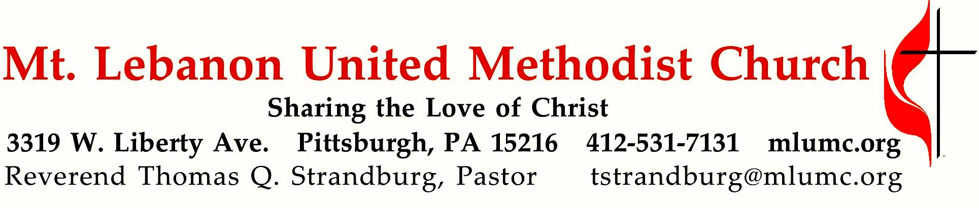
GALATIANS: The Freedom of Christ
Summer Sermon Series

The focus of this sermon series is on the six essential claims that are made by the Apostle Paul pertaining to the Christian life. As of today, we’ve considered the first four:

- There is no other gospel. (1:7)
- It is no longer I who live, but Christ who lives in me. (2:20)
- You are all one in Christ Jesus. (3:28)
- You are born of the Spirit. (4:29)

August 25, 2019 8:30 & 10:45

WE GATHER IN GOD’S NAME …

*Asterisk indicates to rise in body or spirit
8:30 Gathering Music Hymnal 521 I want Jesus to walk with me Sojourner
Greeting
Leader: I was glad when they said unto me,
People: Let us go into the house of the Lord! Psalm 122:1

Announcements

*Call to Worship
Leader: You are the salt of the earth.
People: May we season the world with faithfulness, O God.
Leader: You are the light of the world.
People: May your love shine through us, O Christ our Savior.
Leader: You are a city built on a hill.
People: May your vigor make us bold witnesses, O Spirit of the living God.

Worship & Song
… TO GIVE PRAISE TO GOD …

*Hymnal 539 O Spirit of the living God Forest Green

*Opening Prayer (in unison)
O God, our Guide and Guardian,
you have led us apart from the busy world into the quiet of your house.
Grant us grace to worship you in Spirit and in truth,
to the comfort of our souls
and the upbuilding of every good purpose and holy desire.
Enable us to do more perfectly the work to which you have called us,
that we may not fear the coming of night,
when we shall resign into your hands
the tasks which you have committed to us.
So may we worship you not only with our lips at this hour,
but in word and deed all the days of our lives;
through Jesus Christ our Savior. Amen. Karl Ludvig Reichelt

*Worship & Song 3146 O Breath of Life (stanza 2) Adieu
O Wind of God, come bend us, break us
till humbly we confess our need.
Then in your tenderness remake us;
revive, restore, for this we plead.

TO CELEBRATE THE FAMILY OF FAITH …

*The Sign of Peace
Leader: The peace of Christ be with you.
People: And also with you.

Gathering Song
This, this is where children belong,
welcomed as part of the worshiping throng.
Water, God’s Word, bread and cup, prayer and song:
This is where children belong. words and music: James Ritchie ©1999 Abingdon Press

Message for Young Disciples
All children are invited. Please sing as children come forward. After the children’s message at the 10:45 service, children ages 3 - 3rd grade may attend Kids Praise in the Welcome Center. Children will be escorted to and from Kids Praise by teachers. They will return near the end of the service.

Hymnal 393 Spirit of the living God Living God

… TO HEAR GOD’S WORD PROCLAIMED …

Pastoral Prayer

The Lord’s Prayer
Our Father, who art in heaven, hallowed be thy name. Thy kingdom come, thy will be done, on earth as it is in heaven. Give us this day our daily bread. And forgive us our trespasses, as we forgive those who trespass against us. Lead us not into temptation, but deliver us from evil. For thine is the kingdom, the power, and the glory forever. Amen.

Scripture Reading 8:30 Kathy Tremblay 10:45 Joyce Magill
A Lesson from the New Testament
Galatians 4:1-31 Paul’s concern for the Galatians

Response
Leader: The Word of the Lord.
People: Thanks be to God.

… TO OFFER OUR GIFTS AND TO DEDICATE OUR LIVES …

10:45 Offertory Solo Prayer of St. Francis Allen Pote
*Hymnal 94 Praise God, from whom all blessings flow (standing) Lasst uns erfreuen
Praise God, from whom all blessings flow;
Praise God, all creatures here below; Alleluia! Alleluia!
Praise God, the source of all our gifts!
Praise Jesus Christ, whose power uplifts!
Praise the Spirit, Holy Spirit! Alleluia! Alleluia! Alleluia!
adapt. © 1989 The U. Methodist Publishing House

Prayer of Dedication

Sermon “Born of the Spirit” Rev. Thomas Q. Strandburg

… TO GO REJOICING IN GOD’S NAME!

*Hymnal 369 Blessed assurance (stanzas 1-2) Assurance

*Benediction

*Hymnal 369 Blessed assurance (stanza 3) Assurance
Today’s Services
The flower arrangement provided for worship today is given by Cheryl Herrington in loving memory of her family: father, Artemis Herrington, mother, Shirley Herrington, and sisters Gail Beeson and Judy Androus.
Greeters 8:30 Kathy Karnes 10:45 Cleon & Vera Jane Cornes

Soloist at 10:45 is Kathy Whittaker, soprano section leader in our Chancel Choir. Dr. Whittaker, a psychologist, teaches at Chatham University and is part of the music team for the Taizé services at the East Liberty Presbyterian Church.

Worship options for children We encourage children to participate in the Children’s Sermon at both services, and in Kids Praise during the 10:45 service. Nursery services are offered in Room 204 of the Education Building. Ask ushers or greeters and follow signs for direction.

Honor or remember a loved one with a flower donation. The flowers that grace the sanctuary each week are generously donated by our church family members. This is a great way to honor or memorialize a special person, event, or milestone in your personal life or in the life of the church. If you are interested in donating flowers on a particular Sunday, contact Lizzie Diller , 412-860-3614. The cost is $33 for the altar, narthex, or columbarium arrangements, and $66 for the chancel flowers.

Podcasts of Sunday Sermons Catch up on messages from MLUMC with a podcast of Pastor Tom’s and others’ Sunday sermons. Sermons can be found at http://mlumc.buzzsprout.com or navigate to the site from the link on our webpage, www.mlumc.org. Sermons also will be posted to iTunes. Full recordings of the service are available upon request.

Today’s Scripture

Galatians 4:1-31
4My point is this: heirs, as long as they are minors, are no better than slaves, though they are the owners of all the property; ²but they remain under guardians and trustees until the date set by the father. ³So with us; while we were minors, we were enslaved to the elemental spirits of the world. ⁴But when the fullness of time had come, God sent his Son, born of a woman, born under the law, ⁵in order to redeem those who were under the law, so that we might receive adoption as children. ⁶And because you are children, God has sent the Spirit of his Son into our hearts, crying, “Abba! Father!” ⁷So you are no longer a slave but a child, and if a child then also an heir, through God.
⁸Formerly, when you did not know God, you were enslaved to beings that by nature are not gods. ⁹Now, however, that you have come to know God, or rather to be known by God, how can you turn back again to the weak and beggarly elemental spirits? How can you want to be enslaved to them again? ¹⁰You are observing special days, and months, and seasons, and years. ¹¹I am afraid that my work for you may have been wasted.
¹²Friends, I beg you, become as I am, for I also have become as you are. You have done me no wrong. ¹³You know that it was because of a physical infirmity that I first announced the gospel to you; ¹⁴though my condition put you to the test, you did not scorn or despise me, but welcomed me as an angel of God, as Christ Jesus. ¹⁵What has become of the good will you felt? For I testify that, had it been possible, you would have torn out your eyes and given them to me. ¹⁶Have I now become your enemy by telling you the truth?
¹⁷They make much of you, but for no good purpose; they want to exclude you, so that you may make much of them. ¹⁸It is good to be made much of for a good purpose at all times, and not only when I am present with you.
¹⁹My little children, for whom I am again in the pain of childbirth until Christ is formed in you, ²⁰I wish I were present with you now and could change my tone, for I am perplexed about you.
²¹Tell me, you who desire to be subject to the law, will you not listen to the law? ²²For it is written that Abraham had two sons, one by a slave woman and the other by a free woman. ²³One, the child of the slave, was born according to the flesh; the other, the child of the free woman, was born through the promise. ²⁴Now this is an allegory: these women are two covenants. One woman, in fact, is Hagar, from Mount Sinai, bearing children for slavery. ²⁵Now Hagar is Mount Sinai in Arabia and corresponds to the present Jerusalem, for she is in slavery with her children. ²⁶But the other woman corresponds to the Jerusalem above; she is free, and she is our mother. ²⁷For it is written, “Rejoice, you childless one, you who bear no children, burst into song and shout, you who endure no birthpangs; for the children of the desolate woman are more numerous than the children of the one who is married.” ²⁸Now you, my friends, are children of the promise, like Isaac. ²⁹But just as at that time the child who was born according to the flesh persecuted the child who was born according to the Spirit, so it is now also. ³⁰But what does the scripture say? “Drive out the slave and her child; for the child of the slave will not share the inheritance with the child of the free woman.”³¹So then, friends, we are children, not of the slave but of the free woman.
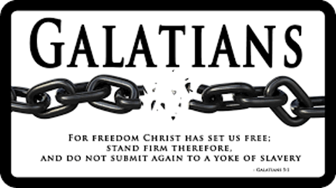

SUMMER SERMON SERIES
August 25th Galatians 4 “Born of the Spirit”
Sept. 1st Galatians 5 “The Only Thing That Counts”
Sept. 8th Galatians 6 “Everything!”

Join us in worship or through the online podcast each week!

Called By God -- Gifted to Serve
Hasn't it been a wonderful 65th anniversary season for Faith for Today? Let's keep the momentum rolling right into the fall! A special combined adult Sunday School class will be offered on Sunday, September 1st, 9:30 - 10:30 a.m., in Asbury Center (NOTE location change). The theme will be "Called By God - Gifted to Serve." Pastor Tom will lead the class in a study of the gifts of the Spirit, as described in 1 Corinthians 12 and Romans 12. We'll consider how each gift is intended by God for the building up of the Church, the Body of Christ. Join us for this challenging and informative hour.

Join the UMW for the September 10th Dinner Meeting

On Tuesday, September 10 at 6 pm in Asbury Center, you’re invited to join the United Methodist Women as we gather to share a salad supper as we kick off our new year and learn more about the UMW Legacy Fund.
The Legacy Fund Endowment Campaign

In 2014, the Legacy Fund Endowment Campaign set a goal to raise $60 million. The campaign is both historic and unprecedented, with the campaign's theme, Together, we are building our legacy, celebrating the legacy of the courageous women who founded this mission movement, as well as the legacy that today's members will leave for future generations of United Methodist women, to create their legacy to carry the mission of faith, hope, love in action forward in the world for years to come.

Please bring a salad to share. We’ll provide drinks and dessert.

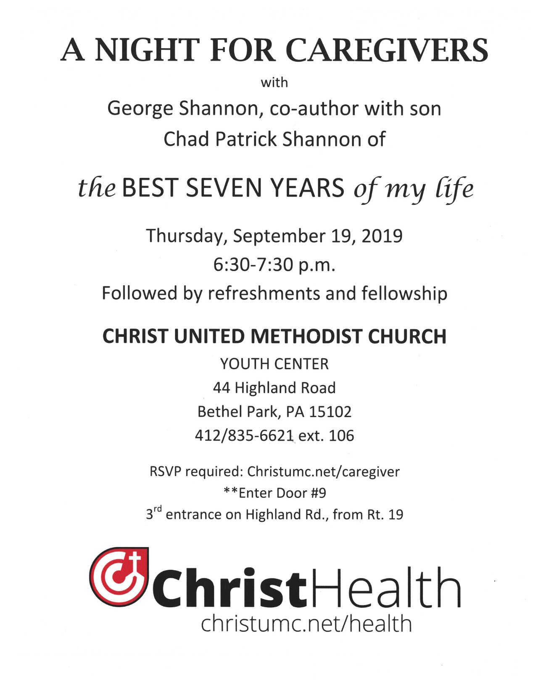
Keep in Prayer

Convalescing in Care Facilities
Bonnie Amos, Providence Point
Ed Clarke, Asbury Heights
Isabella (Langston) Field, St. Alphonsus Medical Center, Boise
John Katshir, Asbury Heights
Reagan Rizzo, Renfrew Center, Philadelphia
Pat Seitz, Concordia
Doris Trimble, Providence Point
Olivia Woods, Baptist Manor
Ezra Gibson, Memorial Sloan-Kettering
Cancer Center, New York City
Sandra Clarke, St. Clair Hospital

Convalescing at Home
Bishop George Bashore, Jean Boyer,
Mary Caldwell, John Dean,
Joseph Festor, Leon Grant, Jr., Dave Lewis,
Susan Lichtenfels, George Lindow,
Carol Van Sickle, Jinny Sheppard,Ruth Seip, Arlene Stewart
In the Military

Jason Boyer, SPC Natalie Brown,
Maj. Zachary Allen Finch, USMC,
James Iantelli, 1st Lt. Jaskiewicz,
S. Sgt. Keith Kimmell,
Sgt. Brendan Lamport,
Sgt. Matthew McConahan, Thomas Orda,
David Poncel, Sgt. Steven Reitz,
Capt. Scott B. Rushe, Pastor Rick Townes,
Maj. Azizi Wesmiller,

Maj. Matthew C. Wesmiller,
Sgt. Keith Scott Winkowski,

Sgt Michael Zimmerman

CALENDAR – SUNDAY, AUGUST 25 THRU SATURDAY, AUGUST 31

SUNDAY 8/25
8:30 am Worship Sanner Chapel
9:30 am Faith for Today Asbury Center
10:45 am Worship Asbury Center
10:45 am Kids Praise Welcome Center
7 pm Troop 23 Leadership Meeting Wesley

TUESDAY 8/27
7 pm Board of Reviews Network
7 pm Boy Scout Meeting Wesley

WEDNESDAY 8/28
7 pm Bear, Tiger, & Wolf Den Meetings Various

