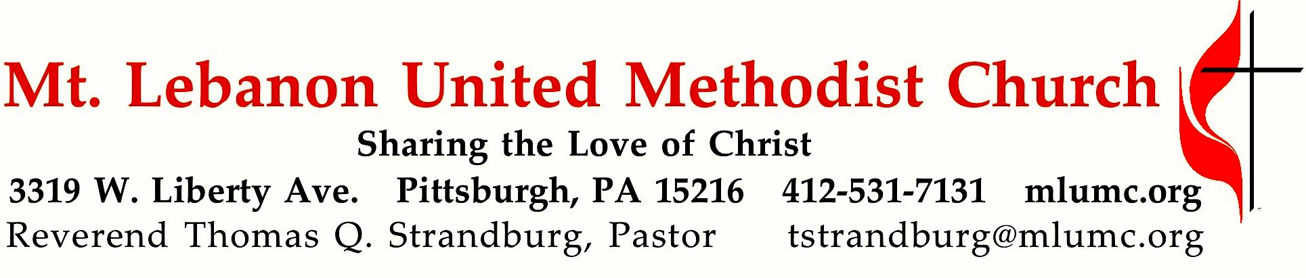
15th Sunday After Pentecost

Addressing the church in Corinth, Greece, the Apostle Paul wrote, “Now concerning spiritual gifts, brothers and sisters, I do not want you to be uninformed.” Paul was wise in his teaching. We must all be informed about the gifts of the Spirit, which is our theme for this morning.

September 22, 2019 8:30 & 10:45

WE GATHER IN GOD’S NAME …

*Asterisk indicates to rise in body or spirit
Gathering Music Hymnal 192 There’s a Spirit in the air Orientis partibus
Greeting
Leader: This is the day that the Lord has made.
People: Let us rejoice and be glad in it.
Psalm 118:24
Announcements

*10:45 Introit Douglas E. Wagner
I was glad when they said unto me, “Let us go into the house of the Lord.”
O the Lord is in his holy temple: all the earth keep silence before the Lord.

*Call to Worship

Leader: Sing praises to God, O you saints, and give thanks to God’s holy name!
People: We exalt you, O God, for you have restored us to life!
Leader: We may cry through the night, but your joy comes with the morning.
People: You hear us, O God, and you are gracious in our distress.
Leader: You turn our mourning into dancing!
People: Our souls cannot be silent! O God, our Savior, we give thanks to you forever!
[Jann C. Weaver]

… TO GIVE PRAISE TO GOD …

*Hymnal 96 Praise the Lord who reigns above Amsterdam
*Opening Prayer (in unison)
Glorious God, source of joy and righteousness, enable us as redeemed and forgiven children evermore to rejoice in singing your praises. Grant that what we sing with our lips we may believe in our hearts, and what we believe in our hearts we may practice in our lives; so that being doers of the Word and not hearers only, we may receive everlasting life; through Jesus Christ our Lord. Amen.
“A Prayer for True Singing” by Fred D. Gealy

*Silent Prayer

*Worship & Song 3146 O Breath of Life (stanza 3) Adieu
O Breath of love, come breathe within us,
renewing thought and will and heart.
Come, love of Christ, afresh to win us;
revive your church in every part.

TO CELEBRATE THE FAMILY OF FAITH …

*The Sign of Peace
Leader: The peace of Christ be with you.
People: And also with you.

Gathering Song
This, this is where children belong,
welcomed as part of the worshiping throng.
Water, God’s Word, bread and cup, prayer and song:
This is where children belong. words and music: James Ritchie ©1999 Abingdon Press

Message for Young Disciples
All children are invited. Please sing as children come forward. After the children’s message at the 10:45 service, children ages 3 - 3rd grade may attend Kids Praise in the Welcome Center. Children will be escorted to and from Kids Praise by teachers. They will return to the sanctuary near the end of the service.

Hymnal 393 Spirit of the living God Living God
© Moody Bible Institute

… TO HEAR GOD’S WORD PROCLAIMED …

Scripture Reading 8:30 Kathy Tremblay 10:45 Chris James
A Lesson from the New Testament
1 Corinthians 12:1-11 Spiritual Gifts
Response
Leader: Hear what the Spirit is saying to God’s people.
People: Thanks be to God.

Pastoral Prayer

The Lord’s Prayer
Our Father, who art in heaven, hallowed be thy name. Thy kingdom come, thy will be done, on earth as it is in heaven. Give us this day our daily bread. And forgive us our trespasses, as we forgive those who trespass against us. Lead us not into temptation, but deliver us from evil. For thine is the kingdom, the power, and the glory forever. Amen.

*Gospel Acclamation: (standing) James J. Chepponis
Alleluia. (sing 4 times)

Scripture Reading
*A Lesson from the Gospel
Mark 1:9-15 The Spirit descends upon Jesus

… TO OFFER OUR GIFTS AND TO DEDICATE OUR LIVES …

10:45 Offertory anthem Make this church a welcome place
Joel Raney, music; J. Paul Williams, words
Lord of mercy, Lord of grace, make this church a welcome place.
To the hungry and the poor, may there be an open door.
To the weary and distressed, may this be a place of rest.
Lord of mercy, Lord of grace, make this church a welcome place.
Reaching out to others, serving both great and small,
sharing our abundance with one and all.
Lord of mercy, Lord of grace, make this church a holy place,
where we come to seek the truth; fill our hearts and worship you
in our words and through our deeds, knowing you will meet our needs.
Lord of mercy, Lord of grace, make this church a welcome place.
© 2017 Hope Publishing Company

*Hymnal 94 Praise God, from whom all blessings flow (standing) Lasst uns erfreuen
Praise God, from whom all blessings flow;
Praise God, all creatures here below; Alleluia! Alleluia!
Praise God, the source of all our gifts!
Praise Jesus Christ, whose power uplifts!
Praise the Spirit, Holy Spirit! Alleluia! Alleluia! Alleluia!
adapt. © 1989 The U. Methodist Publishing House

Prayer of Dedication

Sermon “Spirit Gifts” Rev. Thomas Q. Strandburg

… TO GO REJOICING IN GOD’S NAME!

*Hymnal 592 When the church of Jesus (stanzas 1-2) King’s Weston
*Benediction

*Hymnal 592 When the church of Jesus (stanza 3) King’s Weston

Today’s Services

The flowers on the altar are given by Bob and Beverly Festor in celebration of their 50th wedding anniversary which was on September 19.

The flowers in the chancel are given by Carol Fairgrieve on loving memory of her husband, Robert H. Fairgrieve. September 20 would have been their 61st wedding anniversary.

The flowers in the narthex are given by Carolyn Dagg in honor of what would been her 49th wedding anniversary with her beloved husband, Ronald D. Dagg, on September 19th.

Acolytes Xavier Sanchez and Addison Alexander

Greeters 8:30 Joeta D'Este 10:45 Lavisa Ward

Special music at 10:45 is provided by the Chancel Choir, directed by Julia Scott, professional harpist who teaches at Grove City College, and a member of the choir.

Worship options for children We encourage children to participate in the Children’s Sermon at both services, and in Kids Praise during the 10:45 service. Nursery services are offered in Room 204 of the Education Building. Ask ushers or greeters and follow signs for direction.

Today’s Scripture

1 Corinthians 12:1-11
12Now concerning spiritual gifts, brothers and sisters, I do not want you to be uninformed. ²You know that when you were pagans, you were enticed and led astray to idols that could not speak. ³Therefore I want you to understand that no one speaking by the Spirit of God ever says “Let Jesus be cursed!” and no one can say “Jesus is Lord” except by the Holy Spirit. ⁴Now there are varieties of gifts, but the same Spirit; ⁵and there are varieties of services, but the same Lord; ⁶and there are varieties of activities, but it is the same God who activates all of them in everyone. ⁷To each is given the manifestation of the Spirit for the common good. ⁸To one is given through the Spirit the utterance of wisdom, and to another the utterance of knowledge according to the same Spirit, ⁹to another faith by the same Spirit, to another gifts of healing by the one Spirit, ¹⁰to another the working of miracles, to another prophecy, to another the discernment of spirits, to another various kinds of tongues, to another the interpretation of tongues. ¹¹All these are activated by one and the same Spirit, who allots to each one individually just as the Spirit chooses.

Mark 1:9-15
⁹In those days Jesus came from Nazareth of Galilee and was baptized by John in the Jordan. ¹⁰And just as he was coming up out of the water, he saw the heavens torn apart and the Spirit descending like a dove on him. ¹¹And a voice came from heaven, “You are my Son, the Beloved; with you I am well pleased.” ¹²And the Spirit immediately drove him out into the wilderness. ¹³He was in the wilderness forty days, tempted by Satan; and he was with the wild beasts; and the angels waited on him.
¹⁴Now after John was arrested, Jesus came to Galilee, proclaiming the good news of God, ¹⁵and saying, “The time is fulfilled, and the kingdom of God has come near; repent, and believe in the good news.”

Podcasts of Sunday Sermons Catch up on messages from MLUMC with a podcast of Pastor Tom’s and others’ Sunday sermons. Sermons can be found at http://mlumc.buzzsprout.com or navigate to the site from the link on our webpage, www.mlumc.org. Sermons also will be posted to iTunes. Full recordings of the service are available upon request.

Honor or remember a loved one with a flower donation. The flowers that grace the sanctuary each week are generously donated by our church family members. This is a great way to honor or memorialize a special person, event, or milestone in your personal life or in the life of the church. If you are interested in donating flowers on a particular Sunday, contact Lizzie Diller , 412-860-3614. The cost is $33 for the altar, narthex, or columbarium arrangements, and $66 for the chancel flowers.

Wanted – School Supplies and Lunchbox Snacks Help Hearts & Hands collect school supplies and treats for our church Food Pantry! Any type of school supply – crayons, pencils, scissors, notebooks, pens, etc. or individually wrapped lunchbox items will be accepted. Donation boxes are located across from the church office and the first floor of the Education building and will be available through the month of September for your donations! Thanks for helping children go back to school with supplies and treats!

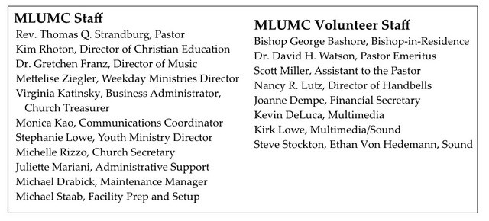

Keep in Prayer

Hospitalized
Sandra Clarke, St. Clair

Convalescing in Care Facilities
Bishop George Bashore, Asbury Heights
Bonnie Amos, Providence Point
Ed Clarke, Asbury Heights
Isabella (Langston) Field, St. Alphonsus Medical Center, Boise
John Katshir, Asbury Heights
Pat Seitz, Concordia
Doris Trimble, Providence Point
Olivia Woods, Baptist Manor
Ezra Gibson, Memorial Sloan-Kettering
Cancer Center, New York City

Convalescing at Home
Jean Boyer,
Mary Caldwell, John Dean,
Joseph Festor, Leon Grant, Jr., Dave Lewis,
Susan Lichtenfels, George Lindow,
Carol Van Sickle, Jinny Sheppard, Ruth Seip, Arlene Stewart

In the Military

Jason Boyer, SPC Natalie Brown,
Maj. Zachary Allen Finch, USMC,
James Iantelli, 1st Lt. Jaskiewicz,
S. Sgt. Keith Kimmell,
Sgt. Brendan Lamport,
Sgt. Matthew McConahan, Thomas Orda,
David Poncel, Sgt. Steven Reitz,
Capt. Scott B. Rushe, Pastor Rick Townes,
Maj. Azizi Wesmiller,

Maj. Matthew C. Wesmiller,
Sgt. Keith Scott Winkowski,

Sgt Michael Zimmerman

Looking to send a card?
Here are some helpful addresses:

Asbury Heights
700 Bower Hill Road
Pittsburgh, PA 15243

Baptist Homes

493 Castle Shannon Boulevard

Pittsburgh, PA 15234

Concordia Health Center
1300 Bower Hill Road
Pittsburgh, PA 15243

ManorCare, Whitehall

505 Weyman Rd.

Pittsburgh, PA 15236

Providence Point

500 Providence Point Boulevard

Pittsburgh, PA 15243

St. Clair Hospital
1000 Bower Hill Road
Pittsburgh, PA 15243

CALENDAR – SUNDAY, SEPTEMBER 22 THRU SATURDAY, SEPTEMBER 28

SUNDAY 9/22
8:30 am Worship Sanner Chapel
10:45 am Worship Sanctuary
10:45 am Kids Praise Welcome Center
11:45 am Youth Choir Choir Room
5 pm Youth Group Wesley
7 pm Discussion on Suicide Among Veterans Asbury

MONDAY 9/23
7 pm Chapel Bells Bell Room

TUESDAY 9/24
6 pm Terrific Tuesday Resumes Asbury
7 pm Board of Reviews Network
7 pm Boy Scout Meeting Wesley

WEDNESDAY 9/25
7 pm Bear, Tiger, & Wolf Den Meetings Various

THURSDAY 9/26
6:30 pm Promise Bells Bell Room
7:30 pm Choir Rehearsal Choir Room

