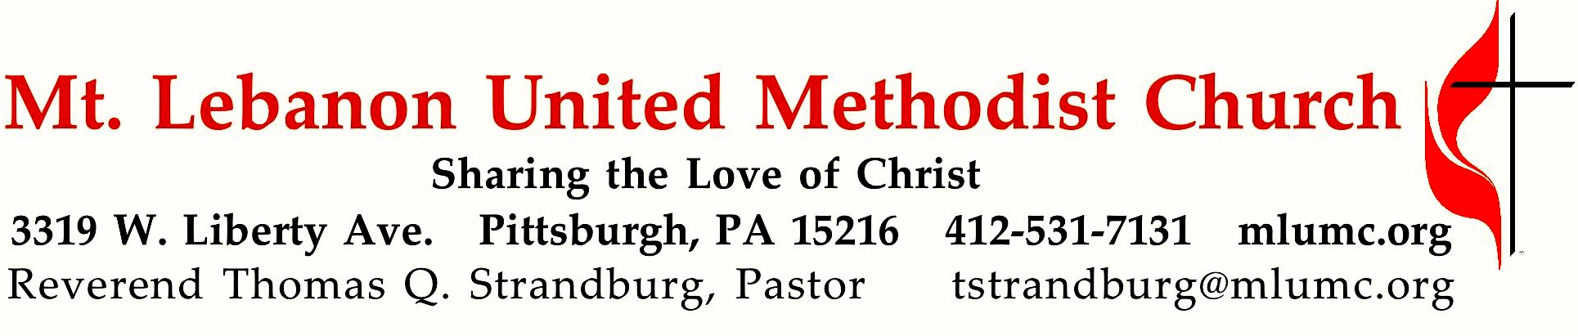
18th Sunday After Pentecost

We welcome Pittsburgh District Superintendent Dawn Hand back to our church this morning! She will be preaching at the 10:45 a.m. service, and leading our Unity Conversation afterward. At 8:30 a.m., Pastor Tom will preach on the Parable of the Good Samaritan in Luke 17, which was prompted by the question that was asked of Jesus, “Who is our neighbor?”

October 13, 2019 8:30 & 10:45

WE GATHER IN GOD’S NAME …

*Asterisk indicates to rise in body or spirit
Gathering Music 8:30 Hymnal 674 See the morning sun ascending Unser Herrscher
10:45 Festive Praise Susan E. Geschke
Promise Bells
Greeting
Leader: I was glad when they said unto me,
People: Let us go into the house of the Lord!
Psalm 122:1
Announcements

*Call to Worship

Pastor: You are the salt of the earth.
People: May we season the world with faithfulness, O God.
Pastor: You are the light of the world.
People: May your love shine through us, O Christ our Savior.
Pastor: You are a city built on a hill.
People: May your vigor make us bold witnesses, O Spirit of the living God.
Worship & Song

… TO GIVE PRAISE TO GOD …

*Hymnal 66 Praise, my soul, the King of heaven Lauda anima
*Opening Prayer (in unison)
O God, our Guide and Guardian,
you have led us apart from the busy world into the quiet of your house.
Grant us grace to worship you in Spirit and in truth,
to the comfort of our souls
and the upbuilding of every good purpose and holy desire.
Enable us to do more perfectly the work to which you have called us,
that we may not fear the coming of night,
when we shall resign into your hands
the tasks which you have committed to us.
So may we worship you not only with our lips at this hour,
but in word and deed all the days of our lives;
through Jesus Christ our Savior. Amen.
Karl Ludvig Reichelt

*Silent Prayer

*Worship & Song 3146 O Breath of Life (stanza 3) Adieu
O Breath of love, come breathe within us,
renewing thought and will and heart.
Come, love of Christ, afresh to win us;
revive your church in every part.

TO CELEBRATE THE FAMILY OF FAITH …

*The Sign of Peace
Leader: The peace of Christ be with you.
People: And also with you.

Gathering Song
This, this is where children belong,
welcomed as part of the worshiping throng.
Water, God’s Word, bread and cup, prayer and song:
This is where children belong. words and music: James Ritchie ©1999 Abingdon Press

Message for Young Disciples
All children are invited. Please sing as children come forward. After the children’s message at the 10:45 service, children ages 3 - 3rd grade may attend Kids Praise in the Welcome Center. Children will be escorted to and from Kids Praise by teachers. They will return to the sanctuary near the end of the service.

8:30 Hymnal 263 When Jesus the healer (stanzas 1, 5-7) Healer
10:45 Handbell Anthem: Glorious things of Thee are spoken Haydn, arr. D. Linda McKechnie
Chapel Bells

… TO HEAR GOD’S WORD PROCLAIMED …

Scripture Reading 8:30 Betsy Harkins 10:45 Linda Minnotte
A Lesson from the New Testament
10:45 Romans 15: 4-7; 13 A Spirit of Unity and Hope

Response
Leader: Hear what the Spirit is saying to God’s people.
People: Thanks be to God.

Pastoral Prayer

The Lord’s Prayer
Our Father, who art in heaven, hallowed be thy name. Thy kingdom come, thy will be done, on earth as it is in heaven. Give us this day our daily bread. And forgive us our trespasses, as we forgive those who trespass against us. Lead us not into temptation, but deliver us from evil. For thine is the kingdom, the power, and the glory forever. Amen.

*Celtic Alleluia: Alleluia. (sing 4 times) James J. Chepponis

Scripture Reading
*A Lesson from the Gospel
Luke 17:11-19 Parable of the Good Samaritan

Response
Leader: The Word of the Lord.
People: Thanks be to God.

… TO OFFER OUR GIFTS AND TO DEDICATE OUR LIVES …

8:30 Offertory solo Elijah: If with all your hearts Felix Mendelssohn
10:45 Offertory anthem Chaz Bowers
1. O breathe on me, O Breath of God, fill me with life anew,
that I may love the things you love and do what you would do.
2. O breathe on me, O Breath of God, until my heart is pure in you;
until my will is one with yours, to do and to endure.
3. O breathe on me, O Breath of God, my will to yours incline,
until this selfish part of me glows with your fire divine.
4. O breathe on me, O Breath of God, so I shall never die, but live,
but live with you the perfect life for all eternity. Amen.

*Hymnal 94 Praise God, from whom all blessings flow (standing) Lasst uns erfreuen
Praise God, from whom all blessings flow;
Praise God, all creatures here below; Alleluia! Alleluia!
Praise God, the source of all our gifts!
Praise Jesus Christ, whose power uplifts!
Praise the Spirit, Holy Spirit! Alleluia! Alleluia! Alleluia!
adapt. © 1989 The U. Methodist Publishing House

Prayer of Dedication

Sermon 8:30 “Who is my Neighbor?” Rev. Thomas Q. Strandburg, Pastor
10:45 “Have Hope” Rev. Dawn M. Hand, Superintendent

TO GO REJOICING IN GOD’S NAME!

*Hymnal 265 When Christ, the healer (stanzas 1-4) Erhalt Uns Herr

*Benediction

*Hymnal 265 When Christ, the healer (stanza 5) Erhalt Uns Herr

Today’s Services

The flowers on the altar are given by Rob and Jane Spicher in celebration of their 5th wedding anniversary.

The flowers in the chancel are given in loving memory of Neil Birks.

The flowers in the narthex are given by Michael Alexander to his wife Dovey in celebration of their wedding anniversary today.

Acolytes Xavier Sanchez and Vivienne Volek

Greeters 8:30 Fran Travis 10:45 Jane Casey

Special Music at 8:30 is provided by tenor Robert Richards, a member of the Chancel Choir.
Special music at 10:45 is provided by the Chancel Choir conducted by Richard Minnotte. Chaz Bowers, the composer of the offertory anthem, is Director of Music at our neighboring St. Bernard’s Church. Handbell music is provided by the Promise Bells and the Chapel Bells, directed by Nancy R. Lutz.

Worship options for children We encourage children to participate in the Children’s Sermon at both services, and in Kids Praise during the 10:45 service. Nursery services are offered in Room 204 of the Education Building. Ask ushers or greeters and follow signs for direction.

Podcasts of Sunday Sermons Catch up on messages from MLUMC with a podcast of Pastor Tom’s and others’ Sunday sermons. Sermons can be found at http://mlumc.buzzsprout.com or navigate to the site from the link on our webpage, www.mlumc.org. Sermons also will be posted to iTunes. Full recordings of the service are available upon request.

Honor or remember a loved one with a flower donation. The flowers that grace the sanctuary each week are generously donated by our church family members. This is a great way to honor or memorialize a special person, event, or milestone in your personal life or in the life of the church. If you are interested in donating flowers on a particular Sunday, contact Lizzie Diller , 412-860-3614. The cost is $33 for the altar, narthex, or columbarium arrangements, and $66 for the chancel flowers.

Today’s Scripture

Romans 15: 4-7; 13
⁴For whatever was written in former days was written for our instruction, so that by steadfastness and by the encouragement of the scriptures we might have hope.
⁵May the God of steadfastness and encouragement grant you to live in harmony with one another, in accordance with Christ Jesus, ⁶so that together you may with one voice glorify the God and Father of our Lord Jesus Christ.
⁷Welcome one another, therefore, just as Christ has welcomed you, for the glory of God.
¹³May the God of hope fill you with all joy and peace in believing, so that you may abound in hope by the power of the Holy Spirit.

Luke 17:11-19
¹¹On the way to Jerusalem Jesus was going through the region between Samaria and Galilee. ¹²As he entered a village, ten lepers approached him. Keeping their distance, ¹³they called out, saying, “Jesus, Master, have mercy on us!” ¹⁴When he saw them, he said to them, “Go and show yourselves to the priests.” And as they went, they were made clean. ¹⁵Then one of them, when he saw that he was healed, turned back, praising God with a loud voice. ¹⁶He prostrated himself at Jesus’ feet and thanked him. And he was a Samaritan. ¹⁷Then Jesus asked, “Were not ten made clean? But the other nine, where are they? ¹⁸Was none of them found to return and give praise to God except this foreigner?” ¹⁹Then he said to him, “Get up and go on your way; your faith has made you well.”

Keep in Prayer

Convalescing in Care Facilities
Bonnie Amos, Providence Point
Ed Clarke, Asbury Heights
Isabella (Langston) Field, St. Alphonsus Medical Center, Boise
Steve Howard, Loma Linda University Hospital, Loma Linda, CA
John Katshir, Asbury Heights
Pat Seitz, Concordia
Doris Trimble, Providence Point
Olivia Woods, Baptist Manor
Ezra Gibson, Memorial Sloan-Kettering
Cancer Center, New York City

Convalescing at Home
Bishop George Bashore,
Jean Boyer, Mary Caldwell,
John Dean, Joseph Festor,
Leon Grant, Jr., Dave Lewis,
Susan Lichtenfels, George Lindow,
Bob Mallery, Carol Van Sickle,
Jinny Sheppard, Arlene Stewart

In the Military
Matt Lewis, USMC,

Jason Boyer, SPC Natalie Brown,
Maj. Zachary Allen Finch, USMC,
James Iantelli, 1st Lt. Jaskiewicz,
S. Sgt. Keith Kimmell,
Sgt. Brendan Lamport,
Sgt. Matthew McConahan, Thomas Orda,
David Poncel, Sgt. Steven Reitz,
Capt. Scott B. Rushe, Pastor Rick Townes,
Maj. Azizi Wesmiller,

Maj. Matthew C. Wesmiller,
Sgt. Keith Scott Winkowski,

Sgt Michael Zimmerman

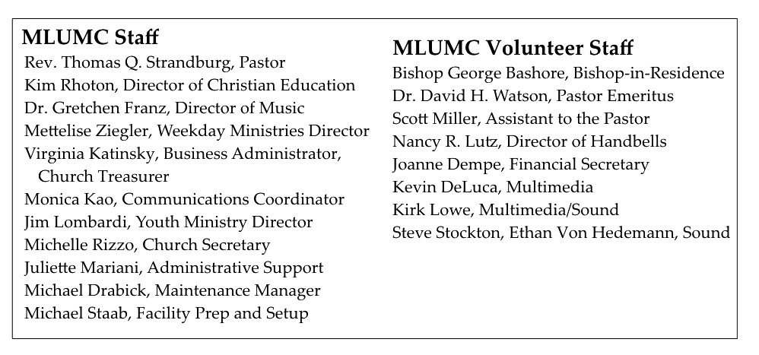
CALENDAR – SUNDAY, OCTOBER 13 THRU SATURDAY, OCTOBER 19

SUNDAY 10/13
8:30 am Worship Sanner Chapel
9:30 am Sunday School Various
10:45 am Worship Sanctuary
10:45 am Kids Praise Welcome Center
11:45 am Youth Choir Choir Room
12 pm Unity Conversation Asbury
5 pm Youth Group Wesley

MONDAY 10/14
8 am Zwickau Team Wesley
7 pm Chapel Bells Bell Room

TUESDAY 10/15
8 am Zwickau Team Wesley
6 pm Terrific Tuesday Asbury
7 pm Boy Scout Meeting Wesley

WEDNESDAY 10/16
7 pm Trustees Meeting Welcome Center
7 pm Cub Scout Pack Meeting Wesley

THURSDAY 10/17
6:30 pm Promise Bells Bell Room
7:30 pm Chancel Choir Rehearsal Choir Room

SATURDAY 10/19
4 pm Community Fall Festival Upper Lot

