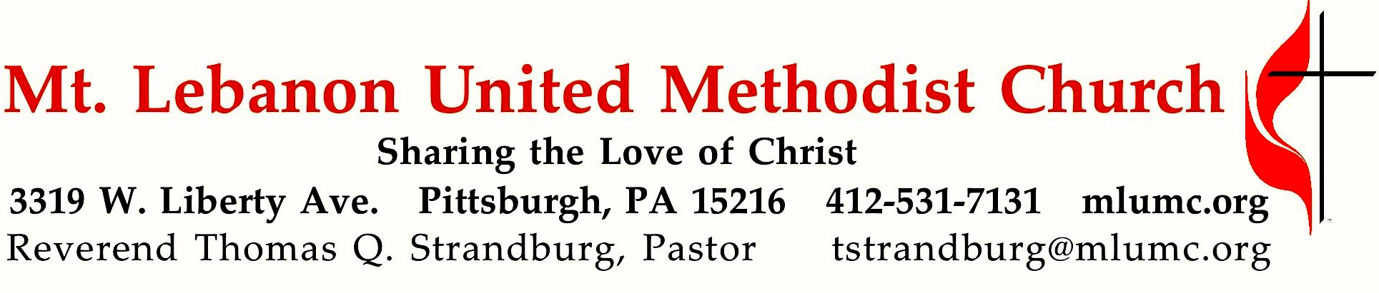
2019 Fall Worship Series
Six Practices of Faithful Followers

We’re nearing the end of our fall worship series. What are the essential practices of a faithful follower of Jesus Christ? To date, our list is as follows:
- Talk to God through prayer.
- Be present with and for others.
- Give generously.
- Serve with humility.
- Share your faith.
- Show your gratitude.

November 17, 2019 8:30 & 10:45

WE GATHER IN GOD’S NAME …

*Asterisk indicates to rise in body or spirit

Gathering Music Hymnal 149 Let’s sing unto the Lord Rosas
Greeting
Leader: O magnify the Lord with me,
People: and let us exalt God’s name together! Psalm 34:3

Announcements

*10:45 Introit Douglas E. Wagner
Open to me the gates, O Lord; that I may enter in and come before thy presence, Lord!
And into thy courts with praise!
© 1978 The Sacred Music Press

*Call to Worship
Leader: Come to God’s house with your songs and prayers.
People: We lift our voices to God.
Leader: Come to God’s house with your hopes and joys.
People: We bring our thanks and praise.
Leader: Come to God’s house with your needs and fears.
People: We lay down our burdens before Christ.
Leader: Come to God’s house with your gifts and treasures.
People: We offer our lives to Christ.
Leader: Come to God’s house with all that you have and with all that you are.
People: Let us worship together this day.
The Abingdon Worship Annual

… TO GIVE PRAISE TO GOD …

*Hymnal 88 Maker, in whom we live Diademata
*Opening Prayer (in unison)
God of abundant love, pour your love and your Spirit upon us, that we may recognize our abundance and give our love and our lives completely and freely to you. Help us to follow the example of the widow, whose offering in the Temple was noticed by Jesus. She offered her best gift, and in doing so she displayed her total commitment to you. In a similar manner, enable us to respond to your call with resolute hearts and committed lives. In Christ’s holy name, we pray.

*Silent Prayer

*Worship & Song 3022 Peace of our praying (stanza 1) Pahoa
Peace of our praying, song of our singing, truth of our telling, love of all loves,
health of our healing, gift of our giving, life of our living, light of all lights.
© 2004 Abingdon Press, admin. The Copyright Co.

TO CELEBRATE THE FAMILY OF FAITH …

*The Sign of Peace
Leader: The peace of Christ be with you.
People: And also with you.

Gathering Song
This, this is where children belong,
welcomed as part of the worshiping throng.
Water, God’s Word, bread and cup, prayer and song:
This is where children belong. words and music: James Ritchie ©1999 Abingdon Press

Message for Young Disciples
All children are invited. Please sing as children come forward. After the children’s message at the 10:45 service, children ages 3 - 3rd grade may attend Kids Praise in the Welcome Center. Children will be escorted to and from Kids Praise by teachers. They will return to the sanctuary near the end of the service.

Hymnal 650 Give me the faith which can remove Carey’s

… TO HEAR GOD’S WORD PROCLAIMED …
Scripture Reading 8:30 Kathy Tremblay 10:45 Joyce Magill
A Lesson from the New Testament
Colossians 3:12-17 Put on love

Response
Leader: Hear what the Spirit is saying to God’s people.
People: Thanks be to God.

Pastoral Prayer

The Lord’s Prayer
Our Father, who art in heaven, hallowed be thy name. Thy kingdom come, thy will be done, on earth as it is in heaven. Give us this day our daily bread. And forgive us our trespasses, as we forgive those who trespass against us. Lead us not into temptation, but deliver us from evil. For thine is the kingdom, the power, and the glory forever. Amen.

*Celtic Alleluia: Alleluia. (sing 4 times) James J. Chepponis

Scripture Reading
*A Lesson from the Gospels
Luke 17:11-19 Jesus heals ten men with leprosy

Response
Leader: The Word of the Lord.
People: Thanks be to God.

… TO OFFER OUR GIFTS AND TO DEDICATE OUR LIVES …

Celebrating Our Church’s Mission

Invitation to Commitment

8:30 Offertory Solo I feel the spirit movin’ Spirituals, arranged by Mark Hayes

10:45 Offertory anthem W. S. Weeden, arranged by Joel Raney
All to Jesus I surrender, all to him I freely give. I will ever love and trust him,
in his presence daily live.
Refrain: I surrender all; all to thee, my blessed Savior, I surrender all.
All to Jesus I surrender, Lord, I give myself to thee; fill me with your love and power,
let your blessings fall on me. Refrain
© 2014, 2017 Hope Publishing Co.

*Hymnal 94 Praise God, from whom all blessings flow (standing) Lasst uns erfreuen
Praise God, from whom all blessings flow;
Praise God, all creatures here below; Alleluia! Alleluia!
Praise God, the source of all our gifts!
Praise Jesus Christ, whose power uplifts!
Praise the Spirit, Holy Spirit! Alleluia! Alleluia! Alleluia!
adapt. © 1989 The U. Methodist Publishing House

Prayer of Dedication

Sermon “Discipleship Practice #6: Show your gratitude” Rev. Thomas Q. Strandburg

TO GO REJOICING IN GOD’S NAME!

*Hymnal 87 What gift can we bring (stanzas 1-3) Anniversary Song
*Benediction

*Hymnal 87 What gift can we bring (stanza 4) Anniversary Song

Today’s Services
The flowers on the altar are given by Pete, Beth, and Trevor Santore with thanks for the McKendry and Santore families.

The flowers in the chancel are given in celebration of Gayle Radnich's 80th birthday by her family.

Acolytes Cameron Grabowski and Luke Grabowski

Greeters 8:30 Rob and Jane Spicher 10:45 Martha Banyas

Special Music at 8:30 is provided by Robert Richards, a member of our Chancel Choir.

Special Music at 10:45 is provided by the Chancel Choir and Cori DeLuca, piano; Alyssa Pysola, flute; and Kaylyn Shearer, oboe. The presence of our guest instrumentalists is made possible through contributions made to the Friends of Music Fund.

Worship options for children We encourage children to participate in the Children’s Sermon at both services, and in Kids Praise during the 10:45 service. Nursery services are offered in Room 204 of the Education Building. Ask ushers or greeters and follow signs for direction.
Today’s Scripture

Colossians 3:12-17
¹²As God’s chosen ones, holy and beloved, clothe yourselves with compassion, kindness, humility, meekness, and patience. ¹³Bear with one another and, if anyone has a complaint against another, forgive each other; just as the Lord has forgiven you, so you also must forgive. ¹⁴Above all, clothe yourselves with love, which binds everything together in perfect harmony. ¹⁵And let the peace of Christ rule in your hearts, to which indeed you were called in the one body. And be thankful. ¹⁶Let the word of Christ dwell in you richly; teach and admonish one another in all wisdom; and with gratitude in your hearts sing psalms, hymns, and spiritual songs to God. ¹⁷And whatever you do, in word or deed, do everything in the name of the Lord Jesus, giving thanks to God the Father through him.

Luke 17:11-19
¹¹On the way to Jerusalem Jesus was going through the region between Samaria and Galilee. ¹²As he entered a village, ten lepers approached him. Keeping their distance, ¹³they called out, saying, “Jesus, Master, have mercy on us!” ¹⁴When he saw them, he said to them, “Go and show yourselves to the priests.” And as they went, they were made clean. ¹⁵Then one of them, when he saw that he was healed, turned back, praising God with a loud voice. ¹⁶He prostrated himself at Jesus’ feet and thanked him. And he was a Samaritan. ¹⁷Then Jesus asked, “Were not ten made clean? But the other nine, where are they? ¹⁸Was none of them found to return and give praise to God except this foreigner?” ¹⁹Then he said to him, “Get up and go on your way; your faith has made you well.”
Keep in Prayer

Convalescing in Care Facilities
Bonnie Amos, Providence Point
Ed Clarke, Asbury Heights
John Katshir, Asbury Heights
Pat Seitz, Concordia
Doris Trimble, Providence Point
Olivia Woods, Baptist Manor
Woody Kimmel, Providence Point

Convalescing at Home
Bishop George Bashore,
Jean Boyer, Mary Caldwell,
John Dean, Joseph Festor,
Ezra Gibson, Leon Grant, Jr.,
Steve Howard, Dave Lewis,
Susan Lichtenfels, George Lindow,
Bob Mallery, Jinny Sheppard,
Carol Van Sickle, Arlene Stewart,
Peyton Wisterman
In the Military
Matt Lewis, USMC,

Jason Boyer, SPC Natalie Brown,
Maj. Zachary Allen Finch, USMC,
James Iantelli, 1st Lt. Jaskiewicz,
S. Sgt. Keith Kimmell,
Sgt. Brendan Lamport,
Sgt. Matthew McConahan, Thomas Orda,
David Poncel, Sgt. Steven Reitz,
Capt. Scott B. Rushe, Pastor Rick Townes,
Maj. Azizi Wesmiller,

Maj. Matthew C. Wesmiller,
Sgt. Keith Scott Winkowski,

Sgt Michael Zimmerman

Youth Group Events

Sun, Nov. 17 Youth Group from 5:00 - 6:30 p.m. Dinner, Games/Activities,
Middle School/High School Groups
Sun, Nov. 24 Youth Group from 5:00 - 6:30 p.m. Friendsgiving Dinner, Games/Activities, Middle School/High School Groups
Sun, Dec. 1 No Youth Group

Kerygma Adult Sunday School 9:30 - 10:30 am The Library
,
11/17 Sara Mercer, “Predestination/ Free Will—Romans 8”
11/24 David Seitz, “Knowledge of the Holy”
12/1 Pastor Don Cook, “Unfinished Business” Part 1
12/8 Pastor Don Cook, “Unfinished Business” Part 2

The Gathering
A fresh expression and experience in worship, beginning December 1
Mt. Lebanon United Methodist Church is starting a new modern worship service to take place on Sundays from 8:30 to 9:30 am in Asbury Center. The Gathering will be launched on December 1, the first Sunday of Advent.

The primary preacher for the service will be current Assistant to the Pastor Scott Miller. By the time The Gathering is launched, Bishop Cynthia Moore Koikoi will have appointed him as a part-time local pastor, serving as an associate pastor at MLUMC. He and Pastor Tom Strandburg will coordinate the service's message with Pastor Tom's sermons. In this way Mt. Lebanon United Methodist Church will have a unified voice glorifying God during three services each Sunday.

The music for The Gathering will be arranged and performed in a modern style, led by singer and keyboardist B.J. Collins and church member Keith Moorhouse on drums. Eric Palmer on guitar and Michelle Duralia on vocals will also participate.

Worshippers can begin this new fresh expression and experience in worship with a fresh cup of coffee or tea. All are invited to gather at 8:15 am in Asbury for pre-worship refreshments.

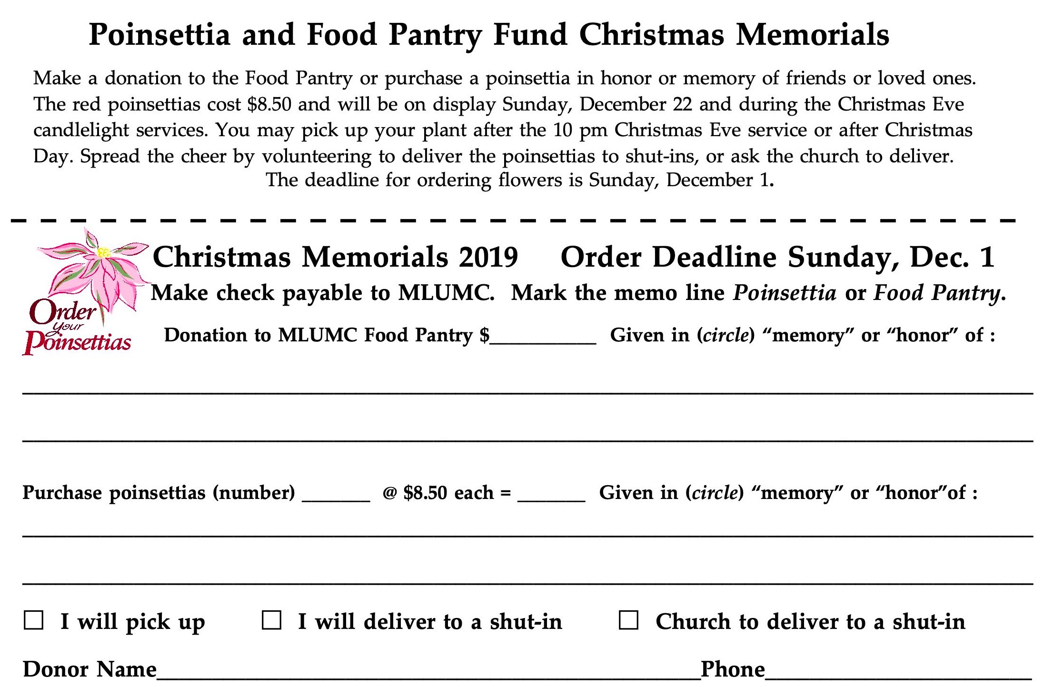
Honor or remember a loved one with a flower donation. The flowers that grace the sanctuary each week are generously donated by our church family members. This is a great way to honor or memorialize a special person, event, or milestone in your personal life or in the life of the church. If you are interested in donating flowers on a particular Sunday, contact Lizzie Diller , 412-860-3614. The cost is $33 for the altar, narthex, or columbarium arrangements, and $66 for the chancel flowers.

Podcasts of Sunday Sermons Catch up on messages from MLUMC with a podcast of Pastor Tom’s and others’ Sunday sermons. Sermons can be found at http://mlumc.buzzsprout.com or navigate to the site from the link on our webpage, www.mlumc.org. Sermons also will be posted to iTunes. Full recordings of the service are available upon request.

CALENDAR – SUNDAY, NOVEMBER 17 THRU SATURDAY, NOVEMBER 23

SUNDAY 11/17
8:30 am Worship Sanner Chapel
9:30 am Sunday School Various
10:45 am Worship Sanctuary
10:45 am Kids Praise Welcome Center
11:45 am Youth Choir Choir Room
5 pm Youth Group Wesley
6:30 pm Eagle Board of Review Various
7 pm Suicide Awareness Discussion Asbury

MONDAY 11/18
7 pm Chapel Bells Bell Room
7:30 pm Community Outreach Meeting Wesley

TUESDAY 11/19
11 am Program Staff Meeting Pastor’s Office
6 pm Terrific Tuesday Asbury
7 pm Boy Scout Meeting Wesley

WEDNESDAY 11/20
7 pm Trustees Meeting Welcome Center
7 pm Cub Scout Pack Meeting Wesley
7 pm Three Rivers Ringers Meeting Library

THURSDAY 11/21
6:30 pm Promise Bells Bell Room
7:30 pm Chancel Choir Rehearsal Choir Room

