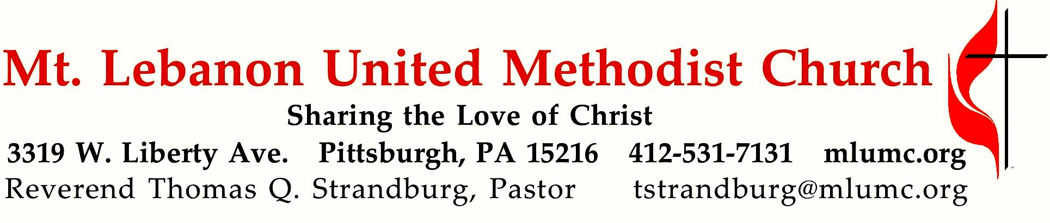

January 12, 2020 8:30 & 10:45
Baptism of the Lord

Did you think that the season of gift giving and gift receiving was over? Think again, as we enter our three-week sermon series – “Unwrapping the Spiritual Gifts.” Today we consider the “motivational gifts,” which are given by God to shape one's perspective on life and to motivate one's words and actions. They include the gifts of (1) prophecy, (2) serving/helps, (3) teaching, (4) exhortation, (5) giving, (6) administration/organizing, and (7) mercy.

WE GATHER IN GOD’S NAME …

*Asterisk indicates to rise in body or spirit

Gathering Music Hymnal 601 Thy word is a lamp Thy Word
Hymnal 518 O Thou, in whose presence (stanzas 1-2) Davis

Greeting
Leader: Sing to the Lord a new song! Sing to the Lord, all the earth!
People: Declare God’s glory among the nations; declare his wondrous works among all people. Psalm 96:1, 3

Announcements

*10:45 Introit Psalm 19: 14 Karle Erickson
Let the words of our mouths and the meditations of our hearts
be acceptable in thy sight, O Lord, our rock and our salvation.

*Call to Worship
Leader: The One who created us, formed and made us, calls to us.
People: We are here to listen and respond.
Leader: God has claimed us and named us beloved.
People: We rejoice in this transforming identity.
Leader: Touched by the Spirit, washed in the renewing water, and set aflame with God’s love, let us worship and praise our beloved God.
Joanne Carlson Brown

… TO GIVE PRAISE TO GOD …

* Hymnal 518 O Thou, in whose presence Davis

*Opening Prayer (in unison)
Loving and caring God, you call us out of the waters, out of the fire, and through the breath of the Spirit. You call us to embrace our identity as your beloved, to let this identity shape our worship, and indeed our very lives. In trust, we open ourselves during this time of worship, that we might receive your transforming Spirit, and be touched by your never-ending love. As we are brought into intimate experience of you, help us embrace our identity in you – that the world will know we are yours. Amen
Joanne Carlson Brown

Silent Prayer

*Response Come and find the quiet center (stanza 2) Beach Spring
Silence is a friend who claims us, cools the heat and slows the pace,
God it is who speaks and names us, knows our being, touches base,
making space within our thinking, lifting shades to show the sun,
raising courage when we’re shrinking, finding scope for faith begun.
Shirley Erena Murray © 1992 Hope Publishing Co.

… TO CELEBRATE THE FAMILY OF FAITH …

The Sign of Peace Please pass the peace to your neighbors as a sign of reconciliation and love.
Leader: The peace of Christ be with you.
People: And also with you.

Gathering Song James Ritchie
This, this is where children belong,
welcomed as part of the worshiping throng.
Water, God’s Word, bread and cup, prayer and song:
This is where children belong. WORDS & MUSIC: James Ritchie ©1999 Abingdon Press

Message for Young Disciples Rev. Thomas Q. Strandburg
All children are invited. Please sing as children come forward. After the children’s message at the 10:45 service, children ages 3 - 3rd grade may attend Kids Praise in the Welcome Center. Children will be escorted to and from Kids Praise by teachers. They will return to the sanctuary near the end of the service.
Hymnal 252 When Jesus came to Jordan Complainer
… TO HEAR GOD’S WORD PROCLAIMED …

Scripture Reading 8:30 Joeta D’Este 10:45 Judy Moeller
A Lesson from the New Testament
1 Corinthians 12:1-11 The gifts of the Spirit

Response
Leader: Hear what the Spirit is saying to God’s people.
People: Thanks be to God.

Pastoral Prayer

The Lord’s Prayer
Our Father, who art in heaven, hallowed be thy name. Thy kingdom come, thy will be done, on earth as it is in heaven. Give us this day our daily bread. And forgive us our trespasses, as we forgive those who trespass against us. Lead us not into temptation, but deliver us from evil. For thine is the kingdom, the power, and the glory forever. Amen.

*Celtic Alleluia: Alleluia (sing 4 times) James J. Chepponis

*Scripture Reading 8:30 Liz DiPietro 10:45 Sara Mercer
A Lesson from the Gospel
Matthew 3:13-17 The baptism of the Lord

Response
Leader: The Word of the Lord.
People: Thanks be to God.

… TO OFFER OUR GIFTS AND TO DEDICATE OUR LIVES …

10:45 Offertory Anthem This is my beloved Son Dan Uhl
When John baptized the Christ, our Lord, the heavens opened wide.
The Spirit from on high came down, descending like a dove.
Assuring those on Jordan's banks a voice proclaimed these words:
'This is my beloved Son with whom I am well pleased.'
Come Holy Spirit heavenly dove. Come now in visitation.
Renew in us baptismal grace throughout each day, in every place.
You are the way, the truth, the light. Lead us to our salvation.

*Hymnal 94 Praise God, from whom all blessings flow (standing) Lasst uns erfreuen
Praise God, from whom all blessings flow;
Praise God, all creatures here below; Alleluia! Alleluia!
Praise God, the source of all our gifts!
Praise Jesus Christ, whose power uplifts!
Praise the Spirit, Holy Spirit! Alleluia! Alleluia! Alleluia!
adapt. © 1989 The U. Methodist Publishing House

Prayer of Dedication

Sermon “Unwrapping the Spiritual Gifts: Motivational” Rev. Thomas Q. Strandburg

… TO GO REJOICING IN GOD’S NAME!

*Hymnal 336 Of all the Spirit’s gifts to me (stanzas 1-2) Meyer
Benediction

*Hymnal 336 Of all the Spirit’s gifts to me (stanza 5) Meyer

Today’s Services

The flowers on the altar are given by Courtney and Eric Schmidt in loving memory of Toni and Chuck Kratz and Monica Kratz.

The flowers in the chancel are given by John and Ruth Ann Esaias in loving memory of John's parents, The Rev. John and Ruth Esaias.

Greeters 8:30 Bob and Beverly Festor 10:45 Alan Chesleigh

Special music for the 10:45 service is provided by the Chancel Choir conducted by Ian Hughes, son of choir member Dave, and Vera. Ian teaches elementary and middle school band and jazz band at Shady Side Academy in Fox Chapel. He lives in Stanton Heights with his wife, Lindsey; son, Benji and two cats.

Acolytes Frieda Lasch and Lydia Slater

Worship options for children We encourage children to participate in the Children’s Sermon at both services, and in Kids Praise during the 10:45 service. Nursery services are offered in Room 204 of the Education Building. Ask ushers or greeters and follow signs for direction.
Podcasts of Sunday Sermons Catch up on messages from MLUMC with a podcast of Pastor Tom’s and others’ Sunday sermons. Sermons can be found at http://mlumc.buzzsprout.com or navigate to the site from the link on our webpage, www.mlumc.org. Sermons also will be posted to iTunes. Full recordings of the service are available upon request.

Today’s Scriptures

1 Corinthians 12:1-11
12Now concerning spiritual gifts, brothers and sisters, I do not want you to be uninformed. ²You know that when you were pagans, you were enticed and led astray to idols that could not speak. ³Therefore I want you to understand that no one speaking by the Spirit of God ever says “Let Jesus be cursed!” and no one can say “Jesus is Lord” except by the Holy Spirit. ⁴Now there are varieties of gifts, but the same Spirit; ⁵and there are varieties of services, but the same Lord; ⁶and there are varieties of activities, but it is the same God who activates all of them in everyone. ⁷To each is given the manifestation of the Spirit for the common good. ⁸To one is given through the Spirit the utterance of wisdom, and to another the utterance of knowledge according to the same Spirit, ⁹to another faith by the same Spirit, to another gifts of healing by the one Spirit, ¹⁰to another the working of miracles, to another prophecy, to another the discernment of spirits, to another various kinds of tongues, to another the interpretation of tongues. ¹¹All these are activated by one and the same Spirit, who allots to each one individually just as the Spirit chooses.

Matthew 3:13-17
¹³Then Jesus came from Galilee to John at the Jordan, to be baptized by him. ¹⁴John would have prevented him, saying, “I need to be baptized by you, and do you come to me?” ¹⁵But Jesus answered him, “Let it be so now; for it is proper for us in this way to fulfill all righteousness.” Then he consented. ¹⁶And when Jesus had been baptized, just as he came up from the water, suddenly the heavens were opened to him and he saw the Spirit of God descending like a dove and alighting on him. ¹⁷And a voice from heaven said, “This is my Son, the Beloved, with whom I am well pleased.”

Keep in Prayer

Convalescing in Care Facilities
Bonnie Amos, Providence Point
Ed Clarke, Asbury Heights
May Frederick, Baptist Home
John Katshir, Asbury Heights
Woody Kimmel, Providence Point
Pat Seitz, Concordia
Doris Trimble, Providence Point
Olivia Woods, Baptist Manor
Anne Hoffman, Providence Point

Convalescing at Home
Bishop George Bashore,
Jean Boyer, Mary Caldwell,
John Dean, Joseph Festor,
Ezra Gibson, Leon Grant, Jr.,
Steve Howard, Dave Lewis,
Susan Lichtenfels, George Lindow,
Bob Mallery, Jinny Sheppard, Carol Van Sickle, Arlene Stewart, Peyton Wisterman

In the Military
Matt Lewis, USMC,

Jason Boyer, SPC Natalie Brown,
Maj. Zachary Allen Finch, USMC,
James Iantelli, 1st Lt. Jaskiewicz,
S. Sgt. Keith Kimmell,
Sgt. Brendan Lamport,
Sgt. Matthew McConahan, Thomas Orda,
David Poncel, Sgt. Steven Reitz,
Capt. Scott B. Rushe, Pastor Rick Townes,
Maj. Azizi Wesmiller,

Maj. Matthew C. Wesmiller,
Sgt. Keith Scott Winkowski,

Sgt Michael Zimmerman

Honor or remember a loved one with a flower donation. The flowers that grace the sanctuary each week are generously donated by our church family members. This is a great way to honor or memorialize a special person, event, or milestone in your personal life or in the life of the church. If you are interested in donating flowers on a particular Sunday, contact Lizzie Diller , 412-860-3614. The cost is $33 for the altar, narthex, or columbarium, and $66 for the chancel.

From the Pittsburgh District of the W PA Conference of the UMC:

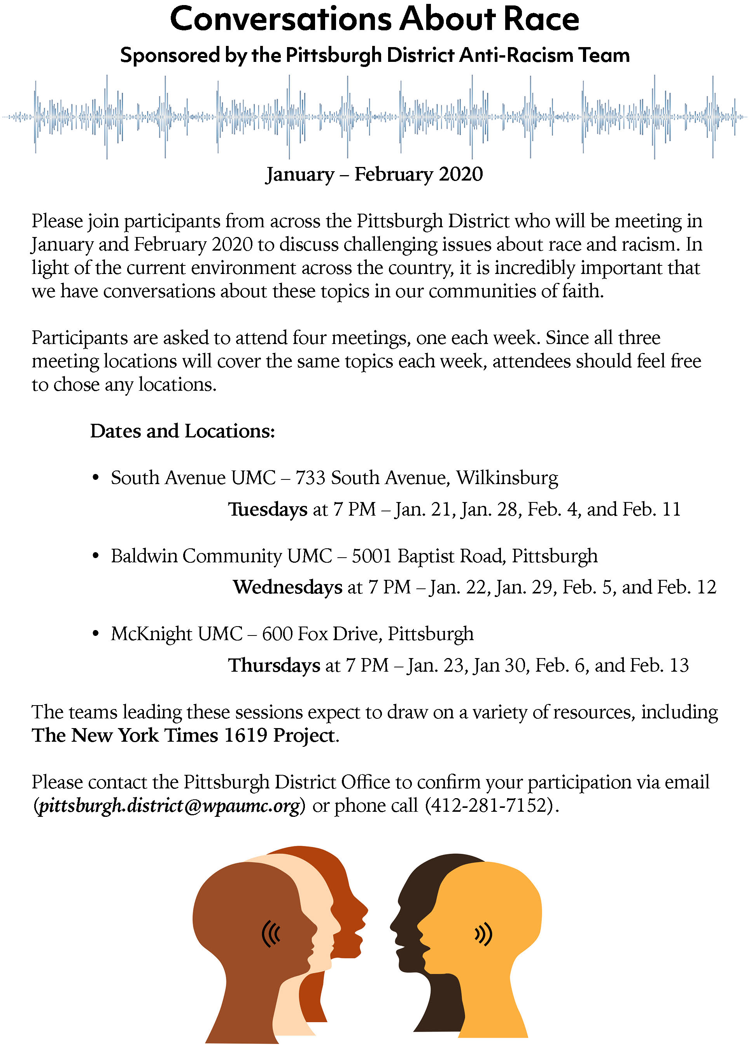

CALENDAR – SUNDAY JANUARY 12 THRU SATURDAY, JANUARY 18

SUNDAY 1/12
8:30 am Worship Sanner Chapel
8:30 am The Gathering Asbury
9:30 am Sunday School Various
10:45 am Worship Sanctuary
10:45 am Kids Praise Welcome Center
12 pm Zwickau Lunch Asbury
5 pm Youth Group Wesley

MONDAY 1/13
7 pm Chapel Bells Rehearsal Bell Room

TUESDAY 1/14
10 am Weekday Ministries Chapel Sanner Chapel
6:30 pm Family Promise Board of Directors Library
7 pm Boy Scout Meeting Wesley
7 pm Cub Scout Planning Committee Meeting Epworth

WEDNESDAY 1/15
7 pm Trustees Meeting Welcome Center
7 pm Cub Scout Pack Meeting Wesley

THURSDAY 1/16
6:30 pm Promise Bells Rehearsal Bell Room
7:30 pm Chancel Choir Rehearsal Choir Room

SATURDAY 1/18
10 am Food Pantry/Food Lift Free Market Food Pantry

