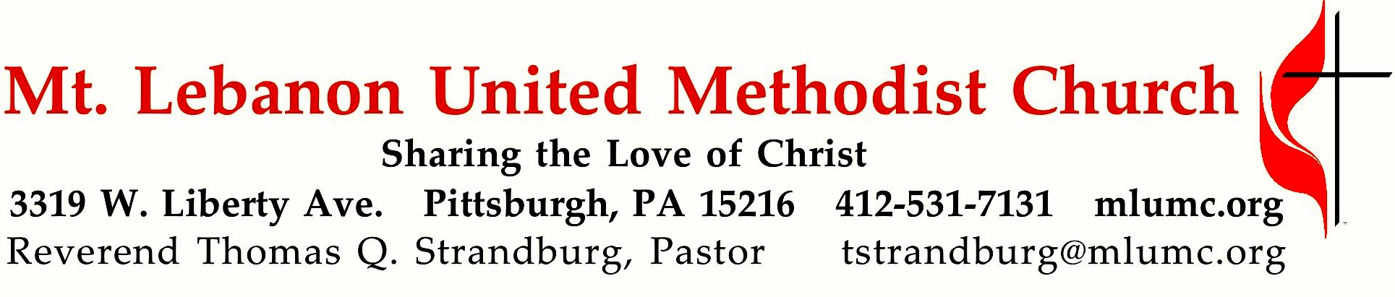

January 19, 2020 8:30 & 10:45
2nd Sunday After Epiphany
Unwrapping the Spiritual Gifts

Our three-week sermon series “Unwrapping the Spiritual Gifts” continues. Today we consider the “ministry gifts,” which are given by God to serve and meet the needs of others. They include the gifts of the apostle (establishes churches), the prophet (speaks God's message), the evangelist (preaches the Gospel), the pastor (shepherds the believers), the teacher (instructs in the faith), and the host/hostess (extends hospitality to all).

WE GATHER IN GOD’S NAME …

*Asterisk indicates to rise in body or spirit

Gathering Music Hymnal 436 The voice of God is calling Meirionydd
Greeting
Leader: Sing to the Lord a new song! Sing to the Lord, all the earth!
People: Declare God’s glory among the nations; declare his wondrous works among all people. Psalm 96:1, 3

Announcements

*10:45 Introit Psalm 19: 14 Karle Erickson
Let the words of our mouths and the meditations of our hearts
be acceptable in thy sight, O Lord, our rock and our salvation.

*Call to Worship

Leader: We gather to worship God,
People: Who creates us and loves us;
Leader: Who gifts us with diversity and makes us for community;
People: Who gives Jesus Christ to show us how to live;
Leader: Who inspires children, youth, young adults, and people of all ages,
People: To seek justice, share power, and live together in love and equality;
Leader: Who invites us to join the struggle for wholeness and wellbeing for all,
People: And whose presence, grace, and love sustain us in our living.
Leader: We gather to worship God.
People: To God be all glory, honor, and praise!
Presbyterian Peacemaking Program

… TO GIVE PRAISE TO GOD …

* Hymnal 579 Lord God, your love has called us here (stanzas 1-3, 5) Carey’s (Surrey)

*Opening Prayer (in unison)
Just and loving God, you call us to live in community. We know that you grant us the opportunities and the strength to be the “headlights not the taillights of society.” Yet, in our sinfulness, we become separated from one another through the wrongs we commit or allow to happen. Through your forgiveness and grace, we ask that you empower us to work toward restoring justice for all people as shown to us in the life, death, and resurrection of Jesus Christ. We pray in the name of the one that came that we might have life abundant. Amen. Presbyterian Peacemaking Program

Silent Prayer

*Response Come and find the quiet center (stanza 2) Beach Spring
Silence is a friend who claims us, cools the heat and slows the pace,
God it is who speaks and names us, knows our being, touches base,
making space within our thinking, lifting shades to show the sun,
raising courage when we’re shrinking, finding scope for faith begun.
Shirley Erena Murray © 1992 Hope Publishing Co.

… TO CELEBRATE THE FAMILY OF FAITH …

The Sign of Peace Please pass the peace to your neighbors as a sign of reconciliation and love.
Leader: The peace of Christ be with you.
People: And also with you.

Gathering Song James Ritchie
This, this is where children belong,
welcomed as part of the worshiping throng.
Water, God’s Word, bread and cup, prayer and song:
This is where children belong. WORDS & MUSIC: James Ritchie ©1999 Abingdon Press

Message for Young Disciples Rev. Thomas Q. Strandburg
All children are invited. Please sing as children come forward. After the children’s message at the 10:45 service, children ages 3 - 3rd grade may attend Kids Praise in the Welcome Center. Children will be escorted to and from Kids Praise by teachers. They will return to the sanctuary near the end of the service.

Hymnal 463 Lord, speak to me Canonbury

… TO HEAR GOD’S WORD PROCLAIMED …

Scripture Reading 8:30 Kathy Tremblay 10:45 Jessica Langston

A Lesson from the New Testament
Ephesians 4:11-16 Unity of the Body of Christ

Response
Leader: Hear what the Spirit is saying to God’s people.
People: Thanks be to God.

Pastoral Prayer

The Lord’s Prayer
Our Father, who art in heaven, hallowed be thy name. Thy kingdom come, thy will be done, on earth as it is in heaven. Give us this day our daily bread. And forgive us our trespasses, as we forgive those who trespass against us. Lead us not into temptation, but deliver us from evil. For thine is the kingdom, the power, and the glory forever. Amen.

*Celtic Alleluia: Alleluia (sing 4 times) James J. Chepponis

*Scripture Reading
A Lesson from the Gospel
John 1:29-42 Jesus calls his disciples

Response
Leader: The Word of the Lord.
People: Thanks be to God.

… TO OFFER OUR GIFTS AND TO DEDICATE OUR LIVES …

10:45 Offertory Anthem Negro Spiritual arranged by Raymond Wise
Listen, somebody’s knocking at your door. Listen!
O sinner, why don’t you answer? Somebody’s knocking at your door.
Sounds like Jesus. Can’t you hear Him?
*Hymnal 94 Praise God, from whom all blessings flow (standing) Lasst uns erfreuen
Praise God, from whom all blessings flow;
Praise God, all creatures here below; Alleluia! Alleluia!
Praise God, the source of all our gifts!
Praise Jesus Christ, whose power uplifts!
Praise the Spirit, Holy Spirit! Alleluia! Alleluia! Alleluia!
adapt. © 1989 The U. Methodist Publishing House

Prayer of Dedication

Sermon “Unwrapping the Spiritual Gifts: Ministry Gifts” Rev. Thomas Q. Strandburg

… TO GO REJOICING IN GOD’S NAME!

*Hymnal 336 Of all the Spirit’s gifts to me (stanzas 1, 3) Meyer
Benediction

*Hymnal 336 Of all the Spirit’s gifts to me (stanza 5) Meyer

Today’s Services

The flowers on the altar are given by Keith Douglass Will, Cheryl Lynn Graunke and Cynthia E. Argyle in loving memory of their parents, Ralph Doll Will and Ethel Gloria Smith Will.

The flowers in the chancel are given by Laura and Nate Ward in celebration of the birthdays of their twins, Silas and Asher, who turn 9 today, and Laura's mom Martha Roberts, who turns 69 today.
Greeters 8:30 Erma Henry 10:45 Chuck and Brenda Vogel

Special music for the 10:45 service is provided by the Chancel Choir with Timmi Williams, soloist.

Acolytes Luke Grabowski and Cameron Grabowski

Worship options for children We encourage children to participate in the Children’s Sermon at both services, and in Kids Praise during the 10:45 service. Nursery services are offered in Room 204 of the Education Building. Ask ushers or greeters and follow signs for direction.

Today’s Scriptures

Ephesians 4:11-16
¹¹The gifts he gave were that some would be apostles, some prophets, some evangelists, some pastors and teachers, ¹²to equip the saints for the work of ministry, for building up the body of Christ, ¹³until all of us come to the unity of the faith and of the knowledge of the Son of God, to maturity, to the measure of the full stature of Christ. ¹⁴We must no longer be children, tossed to and fro and blown about by every wind of doctrine, by people’s trickery, by their craftiness in deceitful scheming. ¹⁵But speaking the truth in love, we must grow up in every way into him who is the head, into Christ, ¹⁶from whom the whole body, joined and knit together by every ligament with which it is equipped, as each part is working properly, promotes the body’s growth in building itself up in love.

John 1:29-42
²⁹The next day he saw Jesus coming toward him and declared, “Here is the Lamb of God who takes away the sin of the world! ³⁰This is he of whom I said, ‘After me comes a man who ranks ahead of me because he was before me.’ ³¹I myself did not know him; but I came baptizing with water for this reason, that he might be revealed to Israel.” ³²And John testified, “I saw the Spirit descending from heaven like a dove, and it remained on him. ³³I myself did not know him, but the one who sent me to baptize with water said to me, ‘He on whom you see the Spirit descend and remain is the one who baptizes with the Holy Spirit.’ ³⁴And I myself have seen and have testified that this is the Son of God.” ³⁵The next day John again was standing with two of his disciples, ³⁶and as he watched Jesus walk by, he exclaimed, “Look, here is the Lamb of God!”
³⁷The two disciples heard him say this, and they followed Jesus. ³⁸When Jesus turned and saw them following, he said to them, “What are you looking for?” They said to him, “Rabbi” (which translated means Teacher), “where are you staying?” ³⁹He said to them, “Come and see.” They came and saw where he was staying, and they remained with him that day. It was about four o’clock in the afternoon. ⁴⁰One of the two who heard John speak and followed him was Andrew, Simon Peter’s brother. ⁴¹He first found his brother Simon and said to him, “We have found the Messiah” (which is translated Anointed). ⁴²He brought Simon to Jesus, who looked at him and said, “You are Simon son of John. You are to be called Cephas” (which is translated Peter).

Podcasts of Sunday Sermons Catch up on messages from MLUMC with a podcast of Pastor Tom’s and others’ Sunday sermons. Sermons can be found at http://mlumc.buzzsprout.com or navigate to the site from the link on our webpage, www.mlumc.org. Sermons also will be posted to iTunes. Full recordings of the service are available upon request.

Honor or remember a loved one with a flower donation. The flowers that grace the sanctuary each week are generously donated by our church family members. This is a great way to honor or memorialize a special person, event, or milestone in your personal life or in the life of the church. If you are interested in donating flowers on a particular Sunday, contact Lizzie Diller , 412-860-3614. The cost is $33 for the altar, narthex, or columbarium, and $66 for the chancel.

Keep in Prayer

Convalescing in Care Facilities
Bonnie Amos, Providence Point
Ed Clarke, Asbury Heights
May Frederick, Baptist Home
John Katshir, Asbury Heights
Woody Kimmel, Providence Point
Pat Seitz, Concordia
Doris Trimble, Providence Point
Olivia Woods, Baptist Manor
Anne Hoffman, Providence Point

Convalescing at Home
Bishop George Bashore,
Jean Boyer, Mary Caldwell,
John Dean, Joseph Festor,
Ezra Gibson, Leon Grant, Jr.,
Steve Howard, Dave Lewis,
Susan Lichtenfels, George Lindow,
Bob Mallery, Carol Van Sickle, Arlene Stewart, Peyton Wisterman

In the Military
Matt Lewis, USMC,

Jason Boyer, SPC Natalie Brown,
Maj. Zachary Allen Finch, USMC,
James Iantelli, 1st Lt. Jaskiewicz,
S. Sgt. Keith Kimmell,
Sgt. Brendan Lamport,
Sgt. Matthew McConahan, Thomas Orda,
David Poncel, Sgt. Steven Reitz,
Capt. Scott B. Rushe, Pastor Rick Townes,
Maj. Azizi Wesmiller,

Maj. Matthew C. Wesmiller,
Sgt. Keith Scott Winkowski,

Sgt Michael Zimmerman

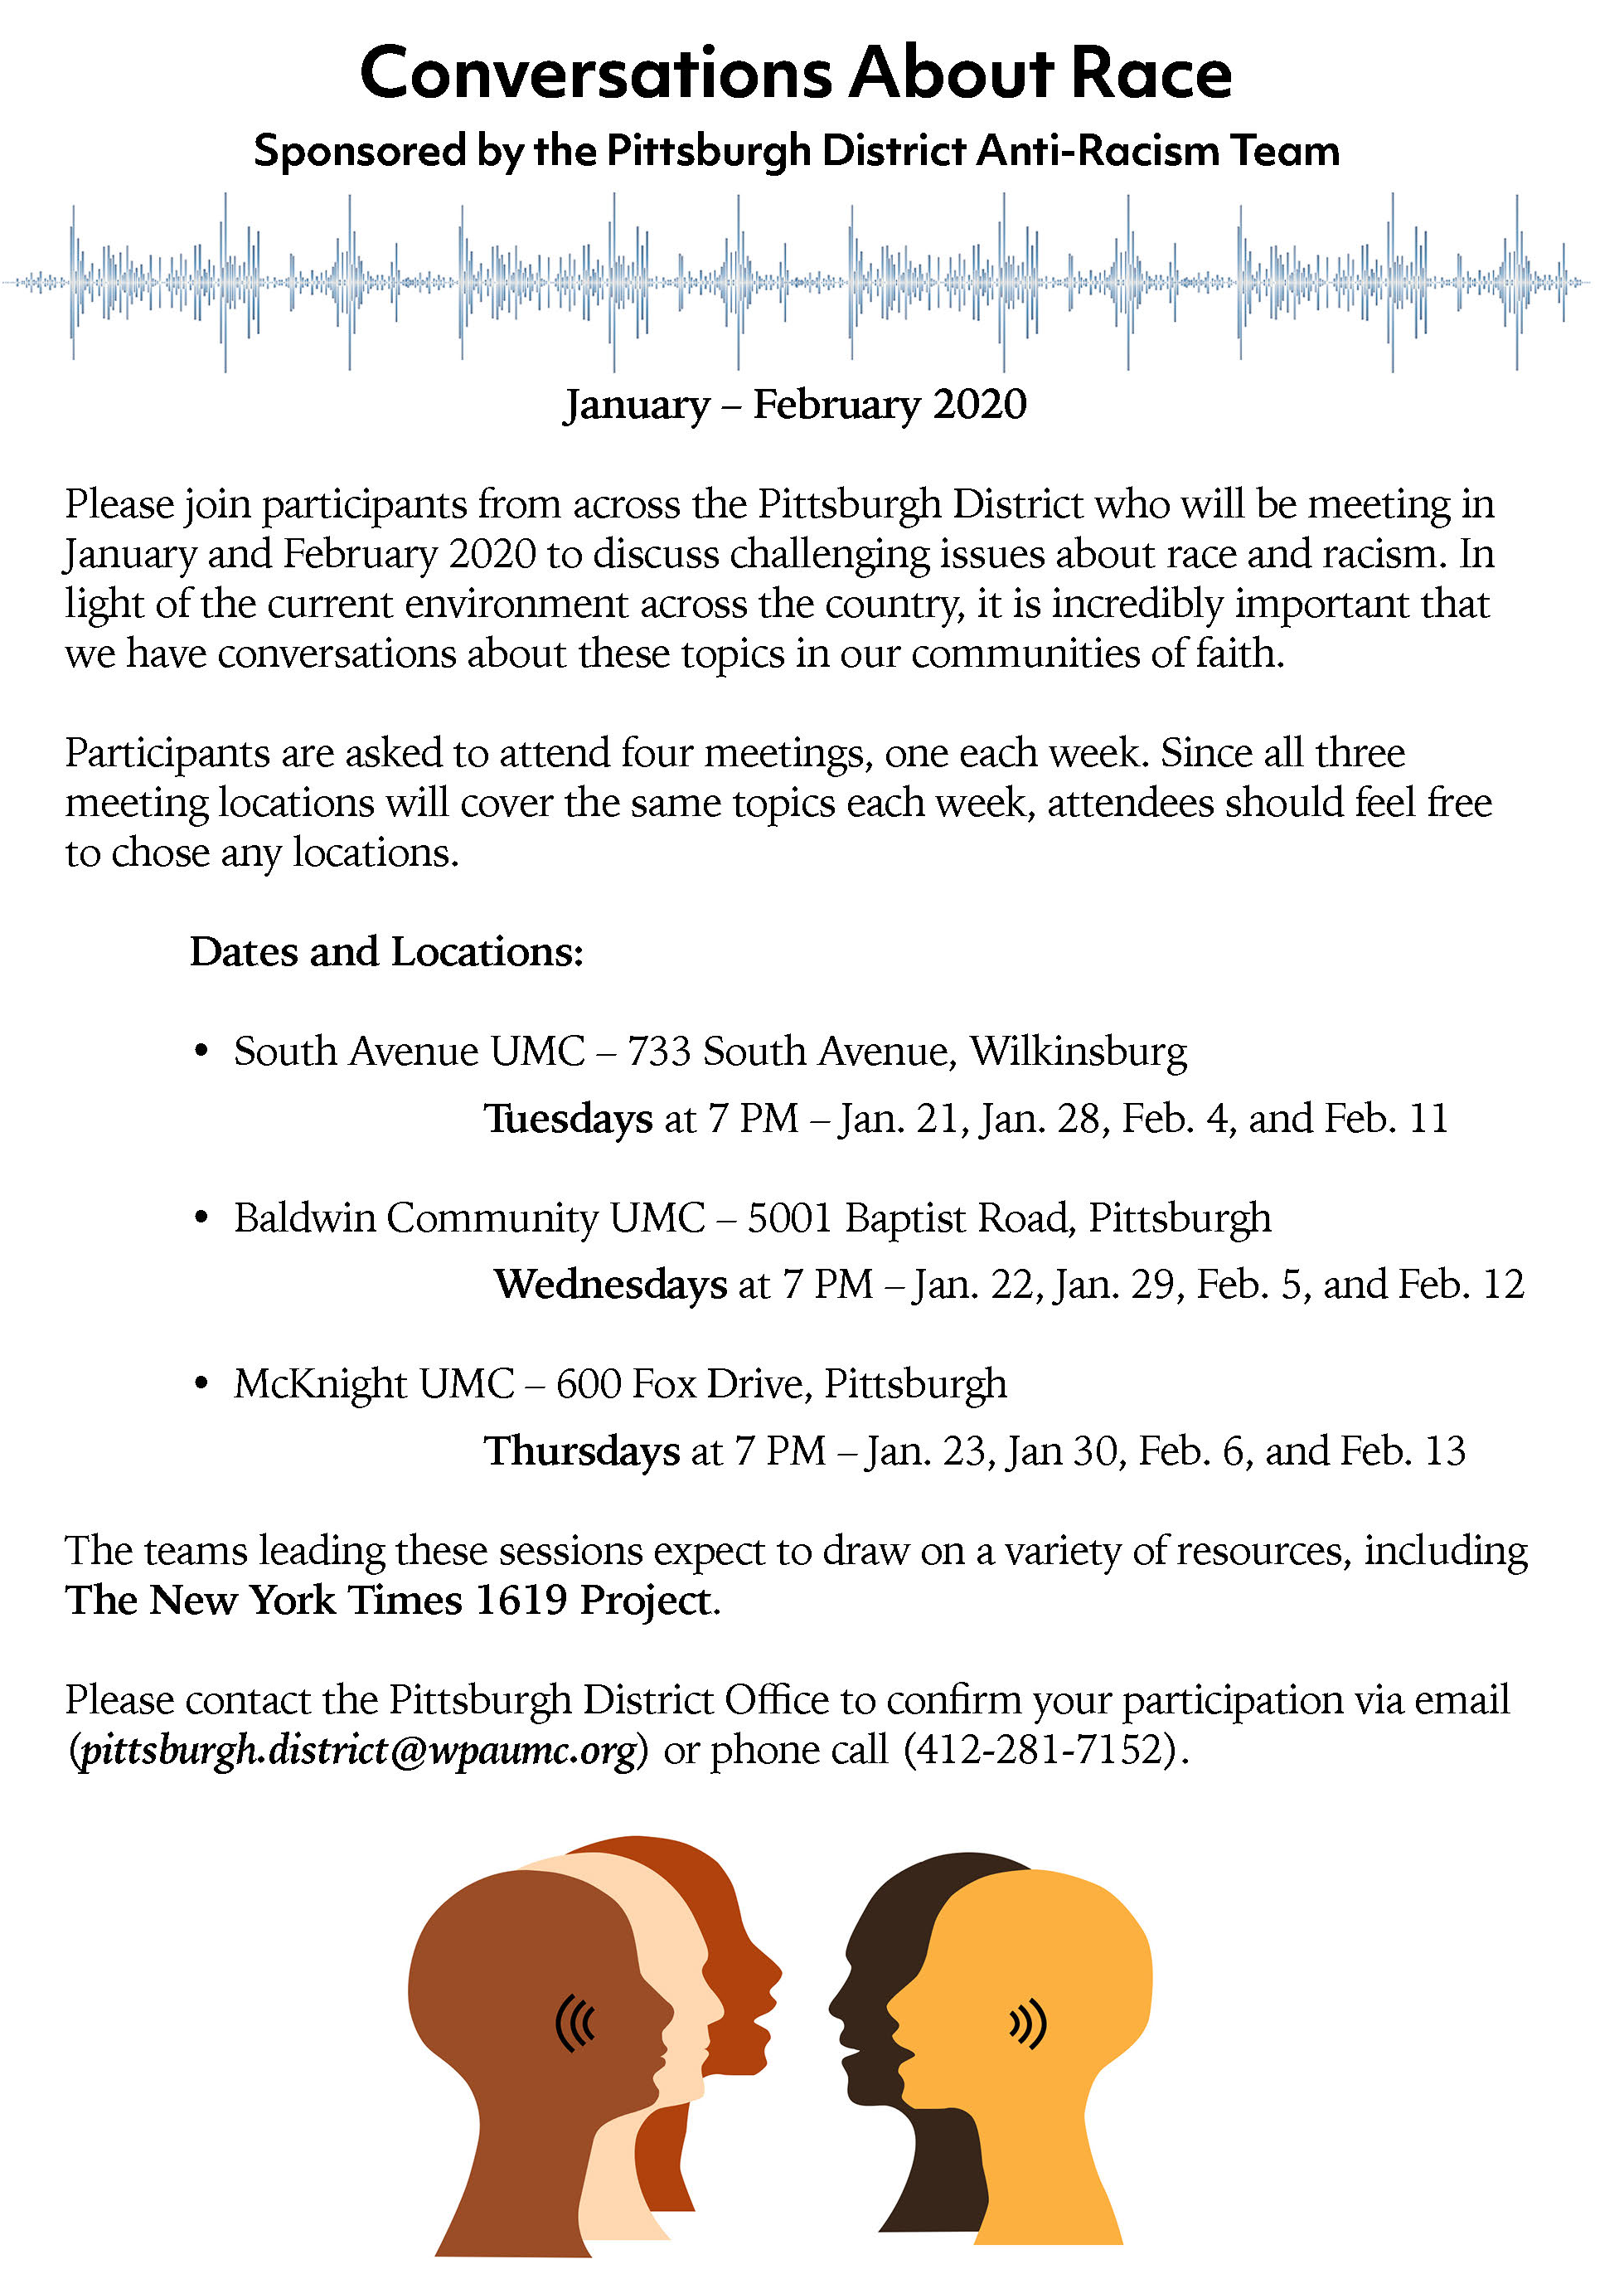

CALENDAR – SUNDAY, JANUARY 19 THRU SATURDAY, JANUARY 25

SUNDAY 1/19
8:30 am Worship Sanner Chapel
8:30 am The Gathering Asbury
9:30 am Sunday School Various
10:45 am Worship Sanctuary
10:45 am Kids Praise Welcome Center
11:45 am Youth Choir Choir Room
NO YOUTH GROUP
6:30 pm Eagle Board of Review Various
7 pm Do No Harm Welcome Center

MONDAY 1/20
OFFICE CLOSED
7 pm Chapel Bells Rehearsal Bell Room

TUESDAY 1/21
11 am Program Staff Meeting Pastor’s Office
7 pm Boy Scout Meeting Wesley

WEDNESDAY 1/22
7 pm Bear, Tiger, & Wolf Den meetings Various

THURSDAY 1/23
6:30 pm Promise Bells Rehearsal Bell Room
7:30 pm Chancel Choir Rehearsal Choir Room

SATURDAY 1/25
4 pm Troop 23 Spaghetti Dinner Asbury

