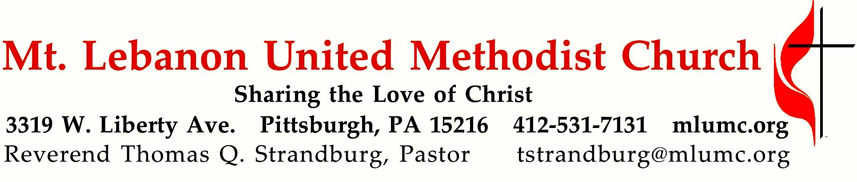

January 5, 2020 8:30 & 10:45
Epiphany Sunday
We continue our communion Sunday sermon series, “Those Whom Christ Commended,” with the meeting between Jesus and the expert in the law (Scribe) in Mark 12. Jesus commends him by saying, “you are not far from the Kingdom of God.”(Mark 12:34) The people of our time have never seen Jesus in the flesh, but they can see his reflection in us, through lives made loving by our contact with him.

WE GATHER IN GOD’S NAME …

*Asterisk indicates to rise in body or spirit
Gathering Music
Hymnal 237 Sing we now of Christmas French Carol
Announcements

*Choral Introit Thomas Keesecker
Arise, shine; for your light has come,
and the glory of the Lord has risen upon you.

*Call to Worship
Leader: Christ is born, give him glory!
People: Christ has come down from heaven, receive him! Christ is now on earth; exalt him!
Leader: O you earth, sing to the Lord!
People: O you nations, praise him in joy, for he has been glorified!
Traditional Byzantine Christmas Prayer

… TO GIVE PRAISE TO GOD …

*Hymnal 245 The first Noel The first Noel

*Lighting of the Christ Candle

*Opening Prayer (in unison)
O God, you made of one blood all nations, and, by a star in the East, revealed to all peoples him whose name is Emmanuel. Enable us who know your presence with us so to proclaim his unsearchable riches that all may come to his light and bow before the brightness of his rising, who lives and reigns with you and the Holy Spirit, now and forever. Amen. Laurence Hull Stookey

Silent Prayer

*Response Come and find the quiet center (stanza 2) Beach Spring
Silence is a friend who claims us, cools the heat and slows the pace,
God it is who speaks and names us, knows our being, touches base,
making space within our thinking, lifting shades to show the sun,
raising courage when we’re shrinking, finding scope for faith begun.
Shirley Erena Murray © 1992 Hope Publishing Co.

… TO CELEBRATE THE FAMILY OF FAITH …

The Sign of Peace Please pass the peace to your neighbors as a sign of reconciliation and love.
Leader: The peace of Christ be with you.
People: And also with you.

Gathering Song James Ritchie
This, this is where children belong,
welcomed as part of the worshiping throng.
Water, God’s Word, bread and cup, prayer and song:
This is where children belong.
WORDS & MUSIC: James Ritchie ©1999 Abingdon Press

Message for Young Disciples Rev. Thomas Q. Strandburg
All children are invited. Please sing as children come forward. After the children’s message at the 10:45 service, children ages 3 - 3rd grade may attend Kids Praise in the Welcome Center. Children will be escorted to and from Kids Praise by teachers. They will return to the sanctuary near the end of the service.

… TO HEAR GOD’S WORD PROCLAIMED …

Scripture Reading 8:30 Joeta D’Este 10:45 Judy Moeller
A Lesson from the Hebrew Scriptures
Deuteronomy 6:4-9 Love the Lord your God

Response
Leader: Hear what the Spirit is saying to God’s people.
People: Thanks be to God.

Pastoral Prayer

Prayer for the New Year
2020 New Year’s Prayer for the Congregations of the Eastern Germany Annual Conference and the Western Pennsylvania Conference (See the church website, mlumc.org, for text.)

The Lord’s Prayer
Our Father, who art in heaven, hallowed be thy name. Thy kingdom come, thy will be done, on earth as it is in heaven. Give us this day our daily bread. And forgive us our trespasses, as we forgive those who trespass against us. Lead us not into temptation, but deliver us from evil. For thine is the kingdom, the power, and the glory forever. Amen.

*Celtic Alleluia: Alleluia (sing 4 times) James J. Chepponis

*Scripture Reading
A Lesson from the Gospel
Mark 12:28-34 The greatest commandment

Response
Leader: The Word of the Lord.
People: Thanks be to God.

… TO OFFER OUR GIFTS AND TO DEDICATE OUR LIVES …

10:45 Offertory Anthem Howard Helvey

What star is this, with beams so bright, more lovely than the noonday light?
‘Tis sent to announce a newborn king, glad tidings of our God to bring.
‘Tis now fulfilled what God decreed, ‘From Jacob shall a star proceed;’
and lo! the Eastern sages stand to read in heaven the Lord’s command.
While outward signs the star displays, and inward light the Lord conveys
and urges them, with tender might, to seek the giver of the light.
O Jesus, fount of boundless grace, your star calls us to seek your face;
prepare our hearts to fully shine and share your light and love divine.

* Hymnal 219 What child is this (stanza 3) Greensleeves
So bring him incense, gold, and myrrh, come, peasant, king, to own him;
the King of kings salvation brings, let loving hearts enthrone him.
This, this is Christ the King, whom shepherds guard and angels sing;
haste, haste to bring him laud, the babe, the son of Mary.

Prayer of Dedication

Sermon “Those Whom Christ Commended: The Scribe in Mark 12” Rev. Thomas Q. Strandburg

Sacrament of Holy Communion Rev. Kimberly Greway
During communion, join the choir singing the first 2 stanzas of hymns beginning with #223. For text, see under Today’s Services.
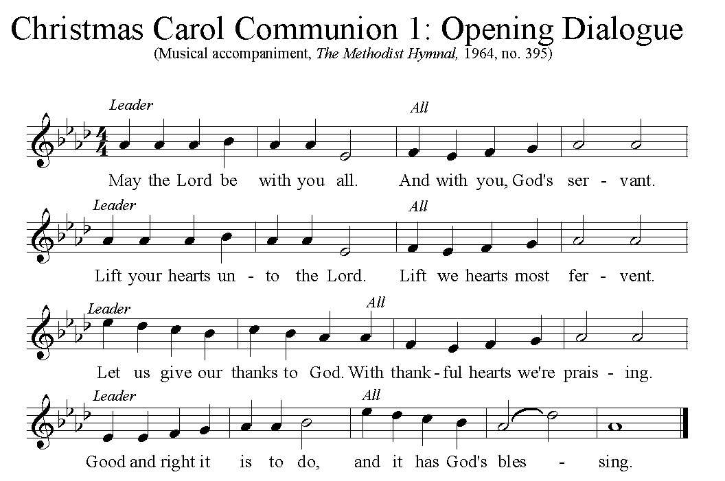

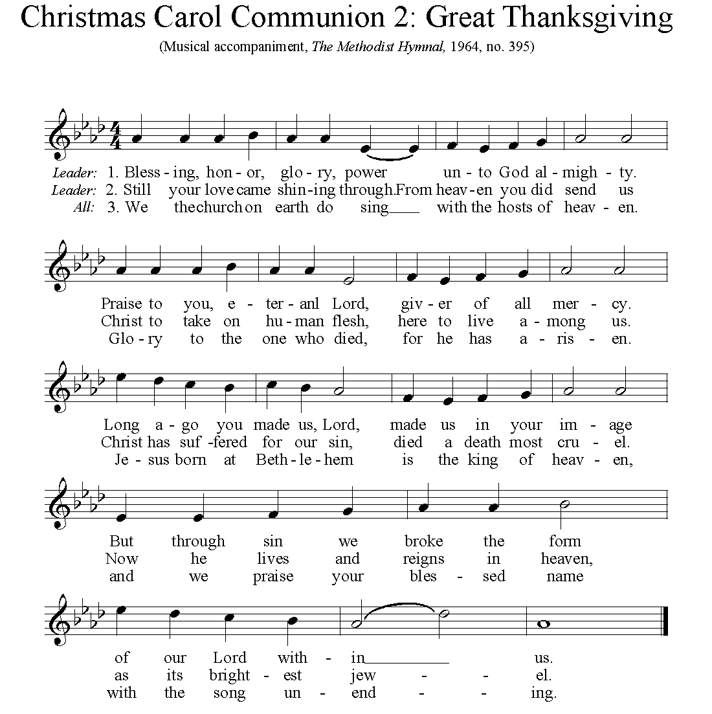

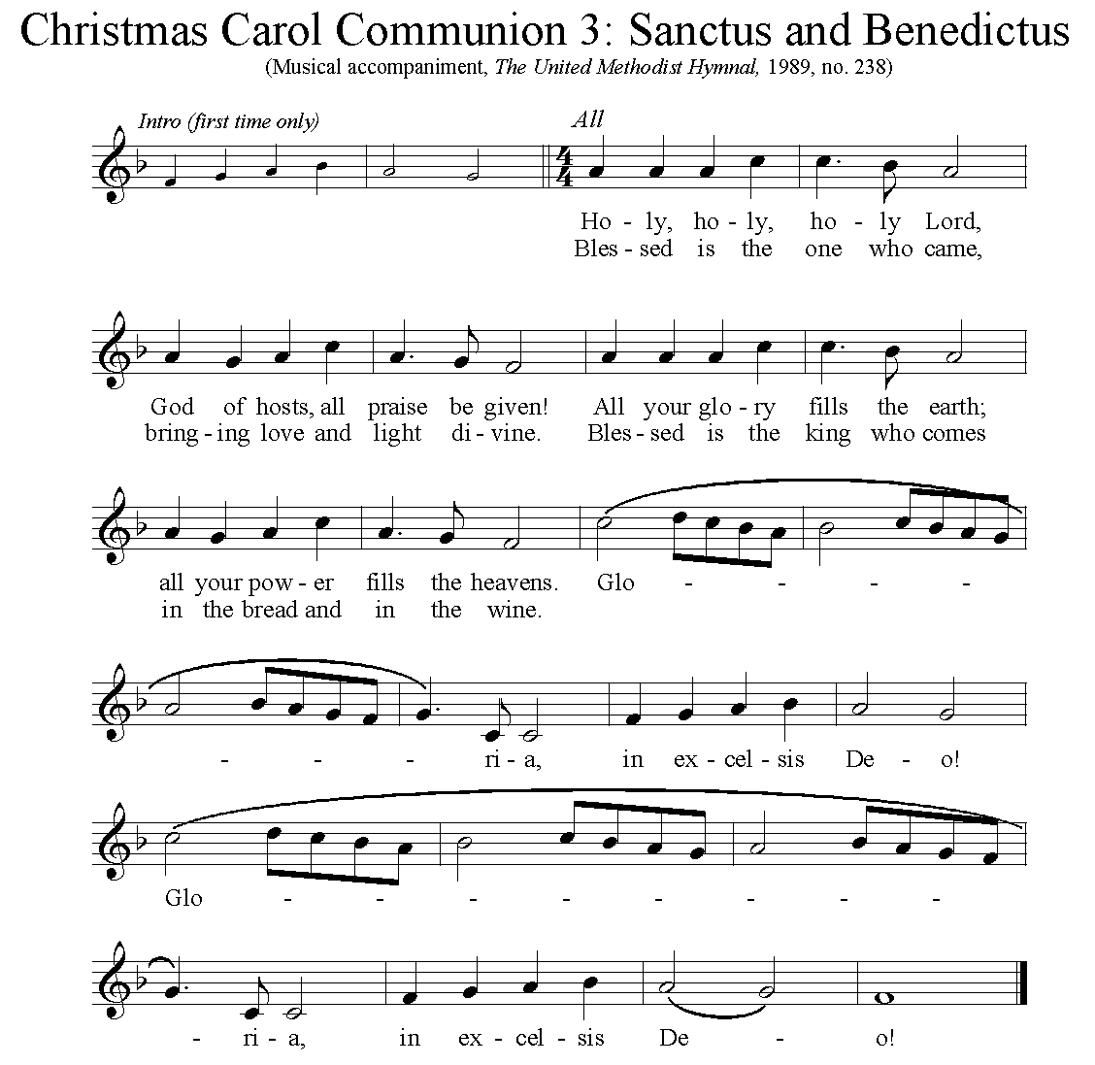

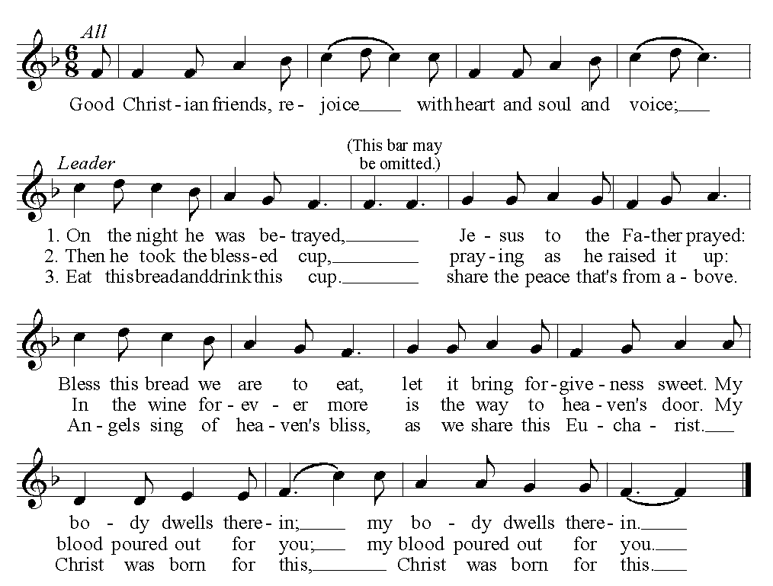

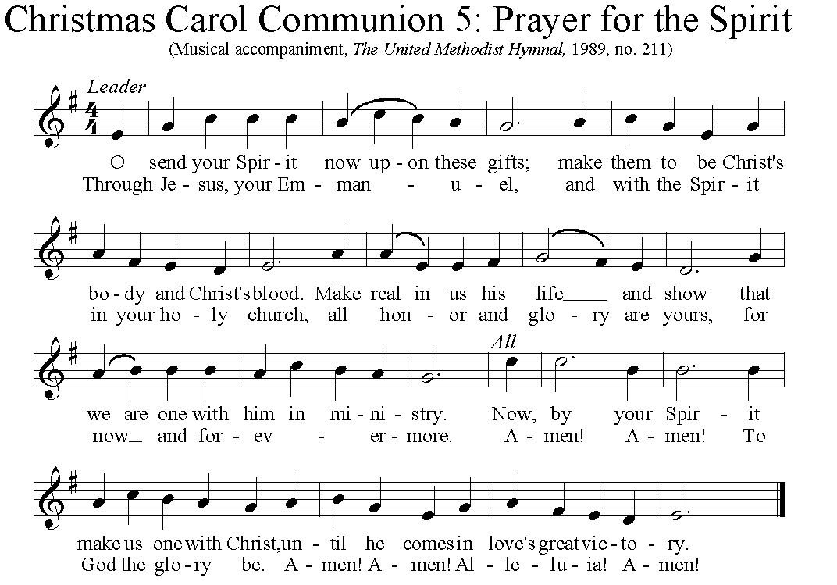

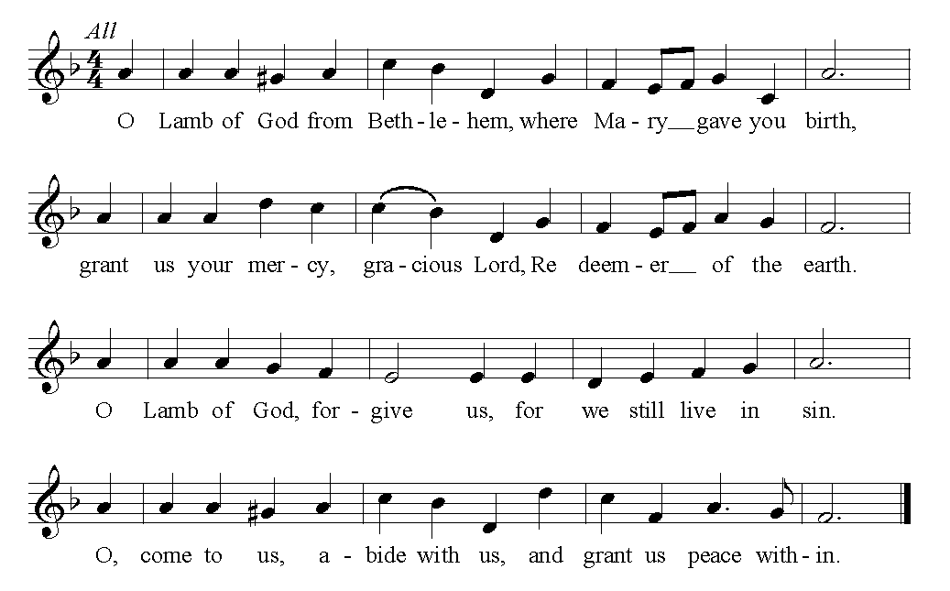

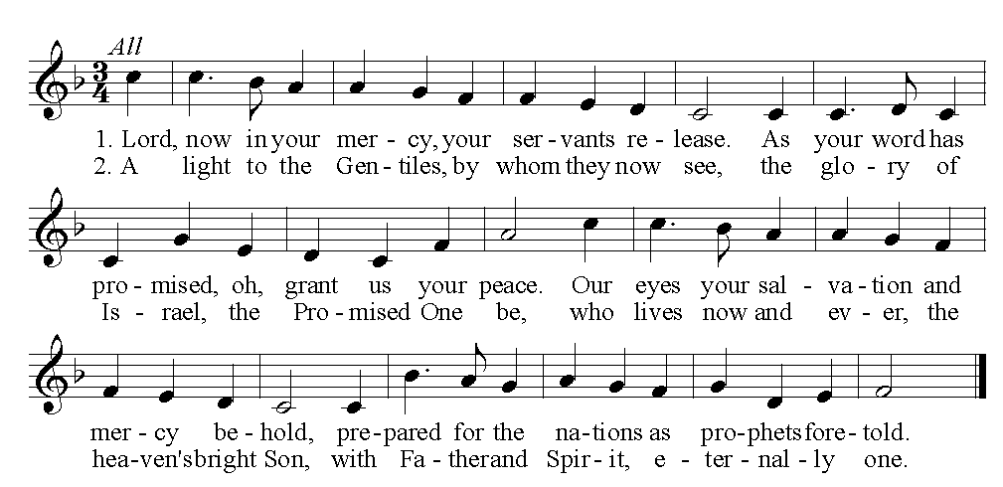

… TO GO REJOICING IN GOD’S NAME!

*Hymnal 254 We three kings (stanzas 1-4) Kings of Orient

Benediction

*Hymnal 254 We three kings (stanza 5) Kings of Orient

Today’s Services
Rev. Kimberly Greway, formerly our Associate Pastor from 2006-2010, is the Director of Chaplaincy Services at the Allegheny County Jail and Chief Operating Officer of the Foundation of HOPE which serves inmates and ex-offenders in Allegheny County.

The flowers on the altar are given in honor of all of the musicians who make our holiday music so beautiful.

The flowers in the chancel are given in gratitude for the generous volunteerism of Rob Spicher, who led the Thanksgiving meal delivery, and everyone who gave of their time to help.

Special music for the 10:45 service is provided by the Chancel Choir with pianist Cori DeLuca and violinist Ashley Freeburn.
During the distribution of the elements the choir will sing “How shall we approach”
by Carl Schalk and this thoughtful text:

How shall we approach this wonder? Should we bend the knee or stand?
This is Christ, the world’s redeemer! Dare we touch his tiny hands?
Can we hide our hearts’ short-comings from his gentle newborn eyes?
What words can we offer to him, while the angels fill the skies?
How shall we consider others gathered round his manger here?
Will we favor robes and riches and to those with gold draw near?
Do we see the earthy shepherds, wond’ring how they think it right
that they stand before the Savior, least of these, to share his light?
How shall we depart that evening? Will our hearts be changed and free?
Would we know God’s manger purpose – Grace for all borne on a tree!
Come as paupers, kings, or shepherds; come however you can come.
Bring your empty lives with longing, then return full-hearted home.
text © 2015 Kris Kuhn, admin. Augsburg Fortress.

Acolytes Abby Purtill and Emily Shoff

Worship options for children We encourage children to participate in the Children’s Sermon at both services, and in Kids Praise during the 10:45 service. Nursery services are offered in Room 204 of the Education Building. Ask ushers or greeters and follow signs for direction.

Podcasts of Sunday Sermons Catch up on messages from MLUMC with a podcast of Pastor Tom’s and others’ Sunday sermons. Sermons can be found at http://mlumc.buzzsprout.com or navigate to the site from the link on our webpage, www.mlumc.org. Sermons also will be posted to iTunes. Full recordings of the service are available upon request.

Honor or remember a loved one with a flower donation. The flowers that grace the sanctuary each week are generously donated by our church family members. This is a great way to honor or memorialize a special person, event, or milestone in your personal life or in the life of the church. If you are interested in donating flowers on a particular Sunday, contact Lizzie Diller , 412-860-3614. The cost is $33 for the altar, narthex, or columbarium, and $66 for the chancel.

Today’s Scriptures

Deuteronomy 6:4-9
⁴Hear, O Israel: The Lord is our God, the Lord alone. ⁵You shall love the Lord your God with all your heart, and with all your soul, and with all your might. ⁶Keep these words that I am commanding you today in your heart. ⁷Recite them to your children and talk about them when you are at home and when you are away, when you lie down and when you rise. ⁸Bind them as a sign on your hand, fix them as an emblem on your forehead, ⁹and write them on the doorposts of your house and on your gates.

Mark 12:28-34
²⁸One of the scribes came near and heard them disputing with one another, and seeing that he answered them well, he asked him, “Which commandment is the first of all?” ²⁹Jesus answered, “The first is, ‘Hear, O Israel: the Lord our God, the Lord is one; ³⁰you shall love the Lord your God with all your heart, and with all your soul, and with all your mind, and with all your strength.’ ³¹The second is this, ‘You shall love your neighbor as yourself.’ There is no other commandment greater than these.” ³²Then the scribe said to him, “You are right, Teacher; you have truly said that ‘he is one, and besides him there is no other’; ³³and ‘to love him with all the heart, and with all the understanding, and with all the strength,’ and ‘to love one’s neighbor as oneself,’ —this is much more important than all whole burnt offerings and sacrifices.” ³⁴When Jesus saw that he answered wisely, he said to him, “You are not far from the kingdom of God.” After that no one dared to ask him any question.

Each year the W PA Conference and Eastern German Conference create daily Advent and Christmas devotionals for use in our homes and churches. We have chosen devotionals from each week

Donnerstag, 26. Dezember; Jesaja 52, 7
Verona Lasch, Zwickau
How beautiful are good news
Confidence in difficult times
Joy that God can make salvation

How beautiful are good news
Cheer for the ruins of life
Comfort and salvation with God

How beautiful are good news
someone who sees light in darkness
... Darkness has its time.

How beautiful are good news
... The dark valleys
Confidence at the right time

How beautiful are good news
Your God is King
Peace - Good – Salvation

How beautiful are good news
There rejoices the place of destruction
My Jerusalem rises from the ruins

Tell me good news

Keep in Prayer

Convalescing in Care Facilities
Bonnie Amos, Providence Point
Ed Clarke, Asbury Heights
May Frederick, Baptist Home
John Katshir, Asbury Heights
Woody Kimmel, Providence Point
Pat Seitz, Concordia
Doris Trimble, Providence Point
Olivia Woods, Baptist Manor
Anne Hoffman, Providence Point

Convalescing at Home
Bishop George Bashore,
Jean Boyer, Mary Caldwell,
John Dean, Joseph Festor,
Ezra Gibson, Leon Grant, Jr.,
Steve Howard, Dave Lewis,
Susan Lichtenfels, George Lindow,
Bob Mallery, Jinny Sheppard, Carol Van Sickle, Arlene Stewart, Peyton Wisterman
In the Military
Matt Lewis, USMC,

Jason Boyer, SPC Natalie Brown,
Maj. Zachary Allen Finch, USMC,
James Iantelli, 1st Lt. Jaskiewicz,
S. Sgt. Keith Kimmell,
Sgt. Brendan Lamport,
Sgt. Matthew McConahan, Thomas Orda,
David Poncel, Sgt. Steven Reitz,
Capt. Scott B. Rushe, Pastor Rick Townes,
Maj. Azizi Wesmiller,

Maj. Matthew C. Wesmiller,
Sgt. Keith Scott Winkowski,

Sgt Michael Zimmerman

CALENDAR – SUNDAY JANUARY 5 THRU SATURDAY, JANUARY 11

SUNDAY 1/5
8:30 am Worship Sanner Chapel
8:30 am The Gathering Asbury
9:30 am Sunday School Various
10:45 am Worship Sanctuary
10:45 am Kids Praise Welcome Center
11:45 am Youth Choir Choir Room
12 pm Blood Pressure Screening Brookline Parlor
5 pm Youth Group Asbury

MONDAY 1/6
7:00 pm Church Council Meeting Wesley
7:00 pm Chapel Bells Rehearsal Bell Room

TUESDAY 1/7
11 am Staff Meeting and Lunch Welcome Center
7:00 pm Boy Scout Meeting Wesley

WEDNESDAY 1/8
7 pm Finance Committee Meeting Welcome Center
7 pm Bear, Tiger, Wolf, Lion, & Webelos Den Meeting Various

THURSDAY 1/9
6:30 pm Promise Bells Rehearsal Bell Room
7:00 pm Education Committee Meeting Brookline Parlor
7:30 pm Chancel Choir Rehearsal Choir Room

FRIDAY 1/10
7:00 pm Pk 870 Arrow of Light Meeting Epworth

