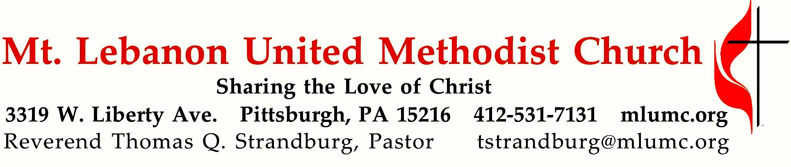

February 16, 2020 8:30 & 10:45
6th Sunday after Epiphany
What’s your relationship status?

In this month of February, a lot of people are wondering about the “status” of their relationship. In this second of our three-week series on relationships, we’ll examine the relationships between parents and their children. The church’s mission of making disciples of Jesus Christ for the transformation of the world begins with the most important work of raising our own children in the faith.

WE GATHER IN GOD’S NAME …

*Asterisk indicates to rise in body or spirit

Gathering Music Hymnal 445 Happy the home when God is there St. Agnes

Greeting
Leader: O magnify the Lord with me,
People: and let us exalt God’s name together! Psalm 34:3

Announcements

*10:45 Introit Psalm 19: 14 Karle Erickson
Let the words of our mouths and the meditations of our hearts
be acceptable in thy sight, O Lord, our rock and our salvation.

*Call to Worship
Leader: When the world divides us:
People: Come, Holy Spirit, make us one.
Leader: When the world calls us orphaned:
People: Come, Holy Spirit, make us family.
Leader: When the world leads us astray:
People: Come, Holy Spirit, call us home.
Come, Holy Spirit, come! Come and fill this place!

… TO GIVE PRAISE TO GOD …

* Hymnal 679 O splendor of God’s glory bright Wareham

*Opening Prayer (in unison)
O gracious and holy God, give us diligence to seek you, wisdom to perceive you, and patience to wait for you. Grant us, O God, a mind to meditate on you, eyes to behold you, ears to listen for your Word, a heart to love you, and a life to proclaim you, through the power of the spirit of Jesus Christ, our Lord. Amen.
Attributed to Benedict of Nurnia, 6th Century

Silent Prayer

*Worship & & Song 3119 Take, O take me Take, O take
Take, O take me as I am; summon out what I shall be;
set your seal upon my heart and live in me.
John Bell © 1995 The Iona Community, admin. GIA Publications Inc.

… TO CELEBRATE THE FAMILY OF FAITH …

*The Sign of Peace Please pass the peace to your neighbors as a sign of reconciliation and love.
Leader: The peace of Christ be with you.
People: And also with you.

10:45 Gathering Song James Ritchie
This, this is where children belong,
welcomed as part of the worshiping throng.
Water, God’s Word, bread and cup, prayer and song:
This is where children belong. James Ritchie ©1999 Abingdon Press

10:45 Message for Young Disciples
All children are invited. Please sing as children come forward. After the children’s message at the 10:45 service, children ages 3 - 3rd grade may attend Kids Praise in the Welcome Center. Children will be escorted to and from Kids Praise by teachers. They will return to the sanctuary near the end of the service.

Hymnal 141 Children of the heavenly Father Tryggare kan ingen vara

… TO HEAR GOD’S WORD PROCLAIMED …

Scripture Reading 8:30 Judi Phelps 10:45 Barbara Watson

A Lesson from the New Testament
1 Timothy 3:1-5 Qualifications for bishops

Response
Leader: Hear what the Spirit is saying to God’s people.
People: Thanks be to God.

Pastoral Prayer

The Lord’s Prayer
Our Father, who art in heaven, hallowed be thy name. Thy kingdom come, thy will be done, on earth as it is in heaven. Give us this day our daily bread. And forgive us our trespasses, as we forgive those who trespass against us. Lead us not into temptation, but deliver us from evil. For thine is the kingdom, the power, and the glory forever. Amen.

*Celtic Alleluia: Alleluia (sing 4 times) James J. Chepponis

*Scripture Reading
A Lesson from the Gospels
Matthew 19:13-15 Jesus blesses little children

Response
Leader: The Word of the Lord.
People: Thanks be to God.

… TO OFFER OUR GIFTS AND TO DEDICATE OUR LIVES …

10:45 Offertory anthem Spiritual, arr. Brazeal W. Dennard
Refrain: Hush! Somebody’s callin’ my name. Oh, my Lord, what shall I do?
1. I’m so glad that trouble don’t last always. Refrain
2. I’m so glad I got my ‘ligion in time. Refrain
3. Soon one mornin’ death come creepin’ in my room. Refrain

*Hymnal 94 Praise God, from whom all blessings flow (standing) Lasst uns erfreuen
Praise God, from whom all blessings flow;
Praise God, all creatures here below; Alleluia! Alleluia!
Praise God, the source of all our gifts!
Praise Jesus Christ, whose power uplifts!
Praise the Spirit, Holy Spirit! Alleluia! Alleluia! Alleluia!
adapt. © 1989 The U. Methodist Publishing House

Prayer of Dedication

Sermon “To Such as These Belongs the Kingdom” Rev. Thomas Q. Strandburg

… TO GO REJOICING IN GOD’S NAME!

*Hymnal 447 Our Parent, by whose name (stanzas 1-2) Rhosymedre

*Benediction

*Hymnal 447 Our Parent, by whose name (stanza 3) Rhosymedre

Today’s Services
The flowers on the altar are given by Beth, Pete, and Trevor Santore in loving memory of Beth's sister, Linda McKendry.

The flowers in the chancel are given by James and Jennifer Mazzocco in loving memory of James' mother, Linda Mazzocco.

Greeters 8:30 Judy Phelps 10:45 David and Vicki Danielson

Special Music at 10:45 is provided by the Chancel Choir.

Acolytes Vivienne Volek and Addison Alexander

Worship options for children We encourage children to participate in the Children’s Sermon at both services, and in Kids Praise during the 10:45 service. Nursery services are offered in Room 204 of the Education Building. Ask ushers or greeters and follow signs for direction.

Today’s Scriptures

1 Timothy 3:1-5
3The saying is sure: whoever aspires to the office of bishop desires a noble task. ²Now a bishop must be above reproach, married only once, temperate, sensible, respectable, hospitable, an apt teacher, ³not a drunkard, not violent but gentle, not quarrelsome, and not a lover of money. ⁴He must manage his own household well, keeping his children submissive and respectful in every way— ⁵for if someone does not know how to manage his own household, how can he take care of God’s church?

Matthew 19:13-15
¹³Then little children were being brought to him in order that he might lay his hands on them and pray. The disciples spoke sternly to those who brought them; ¹⁴but Jesus said, “Let the little children come to me, and do not stop them; for it is to such as these that the kingdom of heaven belongs.” ¹⁵And he laid his hands on them and went on his way.

Keep in Prayer

Convalescing in Care Facilities
Bonnie Amos, Providence Point
Ed Clarke, Asbury Heights
May Frederick, Baptist Home
John Katshir, Asbury Heights
Woody Kimmel, Providence Point
Pat Seitz, Concordia
Doris Trimble, Providence Point
Olivia Woods, Baptist Manor
Anne Hoffman, Providence Point

Convalescing at Home
Bishop George Bashore,
Jean Boyer, Mary Caldwell,
John Dean, Joseph Festor,
Ezra Gibson, Steve Howard,
Dave Lewis, Susan Lichtenfels,
George Lindow, Bob Mallery,
Carol Van Sickle, Arlene Stewart,
Peyton Wisterman

In the Military
Matt Lewis, USMC,

Jason Boyer, SPC Natalie Brown,
Maj. Zachary Allen Finch, USMC,
James Iantelli, 1st Lt. Jaskiewicz,
S. Sgt. Keith Kimmell,
Sgt. Brendan Lamport,
Sgt. Matthew McConahan, Thomas Orda,
David Poncel, Sgt. Steven Reitz,
Capt. Scott B. Rushe, Pastor Rick Townes,
Maj. Azizi Wesmiller,

Maj. Matthew C. Wesmiller,
Sgt. Keith Scott Winkowski,

Sgt Michael Zimmerman

Resources from Last Sunday’s Unity Lunch Last Sunday at the Unity Lunch, Pastor Tom and church members talked about the denomination’s current and proposed legislation on human sexuality to be discussed at the General Conference in May. Sunday’s conversation also included interpretation of scripture often referenced in this legislation discussion. If you missed the conversation or would like to hear it again, you can listen to a podcast linked to our website. Handouts from the conversation are also available. For these resources, go to the MLUMC website: https://www.mlumc.org/2020/unity-lunch-conversation

Informational Session on the Proposed Protocol for Denomination Separation
We are invited to an informational session on the proposal to split the United Methodist Church which will be discussed at the 2020 General Conference. The session is sponsored by our W PA United Methodist Conference. Participants in the session will include Bishop Cynthia Moore-Koikoi, the Rev. John R. Wilson, Conference Secretary; Donna Vizza, chair of the WPAUMC Connectional Leadership Table, and Rev. Alyce Weaver Dunn, Director of Connectional Ministries.

While there are five sessions scheduled, the session most convenient from our church takes place:
Wednesday, March 25 @ Crossroads UMC in Oakdale from 6:30 pm – 9 pm

MLUMC will provide a carpool for this session, leaving from our parking lot on March 25 at 5:45 pm. To sign up for the carpool to the briefing, call Michelle at the church office, 412-531-7131. Also one must register with the W PA Conference online at
https://wpa-reg.brtapp.com/PreGeneralConference2020

Discussion at the informational meeting will focus on the “Protocol of Separation Through Grace and Reconciliation” because those who signed it represent advocacy groups who proposed other plans, but now unanimously support the protocol. They have agreed to work together for passage of the Protocol at the May 5-15, 2020 General Conference.
There will be an opportunity for questions to provide clarification about the Protocol and how our Conference will respond if it is passed. Our Conference is creating a process for discernment regarding our future together in Christ. The WPA Delegation has been invited to attend to listen and prepare for their participation in the upcoming General and Jurisdictional Conferences.

Podcasts of Sunday Sermons Catch up on messages from MLUMC with a podcast of Pastor Tom’s and others’ Sunday sermons. Sermons can be found at http://mlumc.buzzsprout.com or navigate to the site from the link on our webpage, www.mlumc.org. Sermons also will be posted to iTunes. Full recordings of the service are available upon request.

Honor or remember a loved one with a flower donation. The flowers that grace the sanctuary each week are generously donated by our church family members. This is a great way to honor or memorialize a special person, event, or milestone in your personal life or in the life of the church. If you are interested in donating flowers on a particular Sunday, contact Lizzie Diller , 412-860-3614. The cost is $33 for the altar, narthex, or columbarium, and $66 for the chancel.

Interested in Church Membership? The church is organizing its next new members’ orientation class. If interested, please ssend an email to Pastor Strandburg at tstrandburg@mlumc.org .

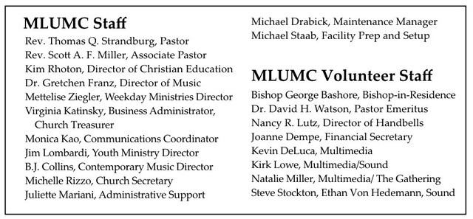

CALENDAR – SUNDAY, FEBRUARY 16 THRU SATURDAY, FEBRUARY 22

SUNDAY 2/16
8:30 am Worship Sanner Chapel
8:30 am The Gathering Asbury
9:30 am Sunday School Various
10:45 am Worship Sanctuary
10:45 am Kids Praise Welcome Center
11:45 am Youth Choir Choir Room
6:30 pm Eagle Board of Review Various
NO YOUTH GROUP - YOUTH JUMONVILLE WINTER BLAST 2/14 – 2/16

MONDAY 2/17 OFFICE CLOSED - Presidents’ Day - Weekday Ministries training
7 pm Chapel Bells Rehearsal Bell Room
7:30 pm Community Events & Outreach Meeting Wesley

TUESDAY 2/18
11 am Program Staff Meeting Pastor’s Office
6 pm Terrific Tuesday Asbury
7 pm Boy Scout Meeting Wesley
7 pm Three Rivers Ringers Meeting Library

WEDNESDAY 2/19
7 pm Trustees Meeting Welcome Center
7 pm Cub Scout Pack Meeting Wesley

THURSDAY 2/20
6:30 pm Promise Bells Rehearsal Bell Room
7:30 pm Chancel Choir Rehearsal Choir Room

SATURDAY 2/22
8 am Men’s Reveille Breakfast Asbury

