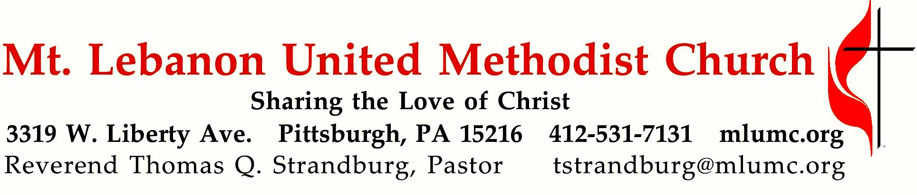

February 9, 2020 8:30 & 10:45
5th Sunday after Epiphany
What’s your relationship status?

In this month of February, a lot of couples are wondering about the “status” of their relationship. In our three-week series on relationships, we’ll examine three important relationships that are mentioned in the Bible – the spousal relationship, the parental relationship, and our relationship with God. The first two have a great deal to teach us about the third.

WE GATHER IN GOD’S NAME …

*Asterisk indicates to rise in body or spirit

Gathering Music Hymnal 593 Here I am, Lord Here I am, Lord
Greeting
Leader: O magnify the Lord with me,
People: and let us exalt God’s name together!
Psalm 34:3

Announcements

*10:45 Introit Psalm 19: 14 Karle Erickson
Let the words of our mouths and the meditations of our hearts
be acceptable in thy sight, O Lord, our rock and our salvation.

*Call to Worship

Leader: We, who live in the shelter of the Most High . . .
People: Let us come and trust in our God. God’s word is near us, on our lips and in our hearts.
Leader: We, who trust in God’s promises . . . let us come and rejoice in the power of the Spirit.
People: The Holy One is our refuge and our strength. We have come to worship the One who calls us!

… TO GIVE PRAISE TO GOD …

* Hymnal 150 God, who stretched the spangled heavens Holy Manna

*Opening Prayer (in unison)
O God, whose love like rolling ocean waves is never ceasing, yet ever refreshing, wash us in the clear, calm waters of your mercy and grace so that we may be made new, clean, bathed in the tides of your forgiveness. Through Christ in whom we are refreshed. Amen.

Silent Prayer

*Worship & & Song 3119 Take, O take me Take, O take
Take, O take me as I am; summon out what I shall be;
set your seal upon my heart and live in me.
John Bell © 1995 The Iona Community, admin. GIA Publications Inc.

… TO CELEBRATE THE FAMILY OF FAITH …

*The Sign of Peace Please pass the peace to your neighbors as a sign of reconciliation and love.
Leader: The peace of Christ be with you.
People: And also with you.

Gathering Song James Ritchie
This, this is where children belong,
welcomed as part of the worshiping throng.
Water, God’s Word, bread and cup, prayer and song:
This is where children belong. James Ritchie ©1999 Abingdon Press

Message for Young Disciples
All children are invited. Please sing as children come forward. After the children’s message at the 10:45 service, children ages 3 - 3rd grade may attend Kids Praise in the Welcome Center. Children will be escorted to and from Kids Praise by teachers. They will return to the sanctuary near the end of the service.

Hymnal 585 This little light of mine Lattimer

… TO HEAR GOD’S WORD PROCLAIMED …

Scripture Reading 8:30 Kathy Tremblay 10:45 JJ Knabb

A Lesson from the Hebrew Scriptures
Song of Solomon 8:6-7 Love is stronger than death
Response
Leader: Hear what the Spirit is saying to God’s people.
People: Thanks be to God.

Pastoral Prayer

The Lord’s Prayer
Our Father, who art in heaven, hallowed be thy name. Thy kingdom come, thy will be done, on earth as it is in heaven. Give us this day our daily bread. And forgive us our trespasses, as we forgive those who trespass against us. Lead us not into temptation, but deliver us from evil. For thine is the kingdom, the power, and the glory forever. Amen.

*Scripture Reading
A Lesson from the New Testament
Ephesians 5:21-33 Mutual submission in the family of God
Response
Leader: The Word of the Lord.
People: Thanks be to God.

… TO OFFER OUR GIFTS AND TO DEDICATE OUR LIVES …

Ministry Moment Finding our Spiritual Gifts John Esaias

10:45 Offertory anthem Cathy Pino, arr. Benjamin Kornelis
You are the light of the world, so shine where you are.
You are a city on a hill, so shine where you are.
You are a candle in the dark, so shine where you are.
You are a star in the night, so shine where you are.
You are the light of the world, so shine where you are.
Cathy Pino © 2000 arr. © 2019 Augsburg Fortress

*Hymnal 94 Praise God, from whom all blessings flow (standing) Lasst uns erfreuen
Praise God, from whom all blessings flow;
Praise God, all creatures here below; Alleluia! Alleluia!
Praise God, the source of all our gifts!
Praise Jesus Christ, whose power uplifts!
Praise the Spirit, Holy Spirit! Alleluia! Alleluia! Alleluia!
adapt. © 1989 The U. Methodist Publishing House

Prayer of Dedication

Sermon “What’s the status of your relationship?” Rev. Thomas Q. Strandburg

… TO GO REJOICING IN GOD’S NAME!

*Hymnal 586 Let my people seek their freedom (stanzas 1-3) Ebenezer
*Benediction

*Hymnal 586 Let my people seek their freedom (stanza 4) Ebenezer

Today’s Services
The flowers on the altar are given by Dolores Kortlandt in loving memory of her parents, loved ones, and her son, Fred Kortlandt, Jr.

The flowers in the chancel are given by Kathy and Rich Tremblay and family in loving memory of Dorothy and Dan Nesbit, Kathy's parents.
Greeters 8:30 Jeffrey Thayer 10:45 David Seitz

Special Music at 10:45 is provided by the Youth Choir and the Chancel Choir with Richard Minnotte and Jim Lombardi playing percussion.

Acolytes Xavier Sanchez and Addison Alexander

Worship options for children We encourage children to participate in the Children’s Sermon at both services, and in Kids Praise during the 10:45 service. Nursery services are offered in Room 204 of the Education Building. Ask ushers or greeters and follow signs for direction.

Today’s Scriptures

Song of Solomon 8:6-7
⁶Set me as a seal upon your heart, as a seal upon your arm; for love is strong as death, passion fierce as the grave. Its flashes are flashes of fire, a raging flame. ⁷Many waters cannot quench love, neither can floods drown it. If one offered for love all the wealth of his house, it would be utterly scorned.

Ephesians 5:21-33
²¹Be subject to one another out of reverence for Christ. ²²Wives, be subject to your husbands as you are to the Lord. ²³For the husband is the head of the wife just as Christ is the head of the church, the body of which he is the Savior. ²⁴Just as the church is subject to Christ, so also wives ought to be, in everything, to their husbands. ²⁵Husbands, love your wives, just as Christ loved the church and gave himself up for her, ²⁶in order to make her holy by cleansing her with the washing of water by the word, ²⁷so as to present the church to himself in splendor, without a spot or wrinkle or anything of the kind—yes, so that she may be holy and without blemish. ²⁸In the same way, husbands should love their wives as they do their own bodies. He who loves his wife loves himself. ²⁹For no one ever hates his own body, but he nourishes and tenderly cares for it, just as Christ does for the church, ³⁰because we are members of his body. ³¹“For this reason a man will leave his father and mother and be joined to his wife, and the two will become one flesh.” ³²This is a great mystery, and I am applying it to Christ and the church. ³³Each of you, however, should love his wife as himself, and a wife should respect her husband.

Keep in Prayer

Convalescing in Care Facilities
Bonnie Amos, Providence Point
Ed Clarke, Asbury Heights
May Frederick, Baptist Home
John Katshir, Asbury Heights
Woody Kimmel, Providence Point
Pat Seitz, Concordia
Doris Trimble, Providence Point
Olivia Woods, Baptist Manor
Anne Hoffman, Providence Point

Convalescing at Home
Bishop George Bashore,
Jean Boyer, Mary Caldwell,
John Dean, Joseph Festor,
Ezra Gibson, Steve Howard,
Dave Lewis, Susan Lichtenfels,
George Lindow, Bob Mallery,
Carol Van Sickle, Arlene Stewart,
Peyton Wisterman

In the Military
Matt Lewis, USMC,

Jason Boyer, SPC Natalie Brown,
Maj. Zachary Allen Finch, USMC,
James Iantelli, 1st Lt. Jaskiewicz,
S. Sgt. Keith Kimmell,
Sgt. Brendan Lamport,
Sgt. Matthew McConahan, Thomas Orda,
David Poncel, Sgt. Steven Reitz,
Capt. Scott B. Rushe, Pastor Rick Townes,
Maj. Azizi Wesmiller,

Maj. Matthew C. Wesmiller,
Sgt. Keith Scott Winkowski,

Sgt Michael Zimmerman

Podcasts of Sunday Sermons Catch up on messages from MLUMC with a podcast of Pastor Tom’s and others’ Sunday sermons. Sermons can be found at http://mlumc.buzzsprout.com or navigate to the site from the link on our webpage, www.mlumc.org. Sermons also will be posted to iTunes. Full recordings of the service are available upon request.

Honor or remember a loved one with a flower donation. The flowers that grace the sanctuary each week are generously donated by our church family members. This is a great way to honor or memorialize a special person, event, or milestone in your personal life or in the life of the church. If you are interested in donating flowers on a particular Sunday, contact Lizzie Diller , 412-860-3614. The cost is $33 for the altar, narthex, or columbarium, and $66 for the chancel.

Saturday, March 14, 2020 at 9 AM to 3:30 PM

Crossroads UM Church - N. Fayette Campus
1000 Crossroads Dr. North Fayette, PA 15071

Cost $10 per person, lunch included

Register online at wpaumc.org
or by calling Jessica Speer 724-699-4885.
WPAUMC's Global Mission Network will host this opportunity to learn more about our Conference's various global partnerships,
explore the importance and impact of our global connections, and consider how God might be calling churches and individuals to get more involved.
Keynote speakers: the Rev. Ron & Bonnie Hipwell
Contact Jessica Speer, chair of the Global Mission Network at jessicaspeer83@gmail.com or Sandra Matoushaya, Mission Engagement Coordinator at sandra.matoushaya@wpaumc.org or 724-776-2300, ext. 249

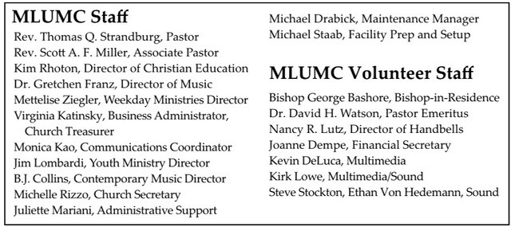

CALENDAR – SUNDAY, FEBRUARY 9 THRU SATURDAY, FEBRUARY 15

SUNDAY 2/9
8:30 am Worship Sanner Chapel
8:30 am The Gathering Asbury
9:30 am Sunday School Various
10:45 am Worship Sanctuary
10:45 am Kids Praise Welcome Center
12 pm Unity Conversation Asbury
5 pm Youth Group Wesley

MONDAY 2/10
7 pm Chapel Bells Rehearsal Bell Room

TUESDAY 2/11
10 am Weekday Ministries Chapel Sanner Chapel
6 pm Terrific Tuesday Asbury
6:30 pm Family Promise Board of Directors Library
7 pm Board of Reviews Network
7 pm Boy Scout Meeting Wesley
7 pm Cub Scout Committee Planning Meeting Epworth

WEDNESDAY 2/12
6:30 pm Finance Committee Meeting Welcome Center
7 pm Bear, Lion, Webelos, Tiger, & Wolf Den Meetings Various

THURSDAY 2/13
6:30 pm Promise Bells Rehearsal Bell Room
7 pm Education Committee Meeting Brookline
7:30 pm Chancel Choir Rehearsal Choir Room

FRIDAY 2/14
YOUTH WINTER BLAST JUMONVILE RETREAT 2/14-2/16
7 pm PK870 Arrow of Light Epworth

SATURDAY 2/15
10 am Food Pantry/Food Lift Free Market Food Pantry

