Sunday School from Home!
Week of March 29

The Bible story for this week is Matthew 26:57-58, 69-75. Read the story from any Bible you have at home or online.
- Let one person read the story out loud while the others each assume a character in the story and act it out.
- Talk about it: Why did Peter deny that he knew Jesus? How do you think he was feeling at the time? How do you think he felt when he heard the rooster crow?
- Watch the story of Peter on You Tube: https://www.youtube.com/watch?v=p5DSUKiocsE
- Use a disposable plate, paper, paints, or other materials you have at home to create a rooster like the one in the story. Here are some ideas from Google:
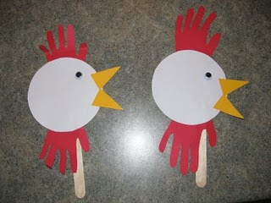
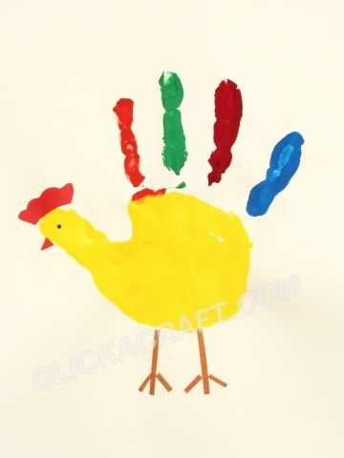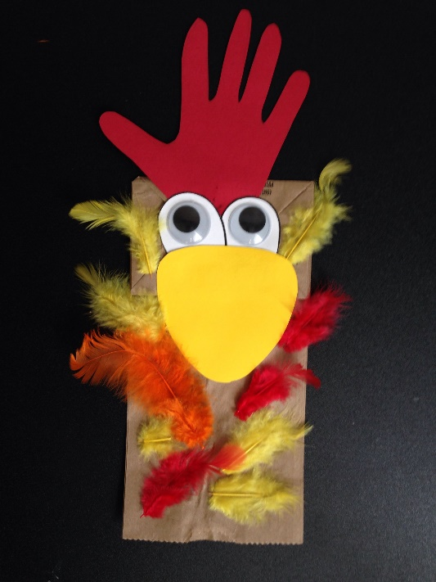
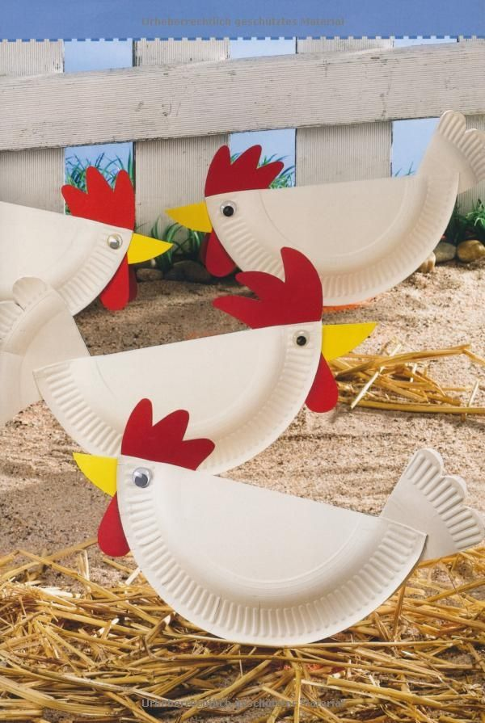

- Sing a song about Peter (tune of Do You Know the Muffin Man?)
Peter, do you know this man, know this man, know this man?
Peter, do you know this man, He is your friend.

No, I do not know this man, know this man, know this man.
No, I do not know this man, He’s not my friend.

Peter heard the rooster crow, rooster crow, rooster crow.
Peter heard the rooster crow. Cock-a-doodle-doo!

- Play Let’s Catch a Rooster! You can modify the rules to suit the number of people in your family and the ages of the children. Here are two basic ways to play. Or, try hiding the “rooster” and after singing the song everyone gets up to look for it. The person who finds it is the next one to hide it.
https://www.youtube.com/watch?v=KYGOT9oBZIg
https://www.youtube.com/watch?v=yIANa3fdGuw

- God can take our mistakes and forgive us. God takes something that seems worthless and makes it into something beautiful! Try making something beautiful out of scraps of paper or other items around the house that seem unusable. During family prayer time, make sure to say thank you to Jesus for forgiving us when we do something wrong.

- Ready for some spring décor? Create your own window paintings! Mix washable kid paint with some dish soap. Paint on your windows. I promise it comes off with a damp rag even after it dries! On a warm day you can paint from the outside and then use the hose to clean it off. The kids have fun and you have clean windows – everybody wins! Or for fun during bath time, mix a little kid paint with white shaving foam and finger paint the shower walls. Hand the kids a sponge to clean it off after they finish. Some window painting ideas are here: https://www.craftymorning.com/paint-your-own-stained-glass-windows/?fbclid=IwAR0y1YcUYRh7ckcezJAuErrzmPLERARFi3orq6LvMlP7RLjav3rrKTTt0as
And here: https://www.whatdowedoallday.com/window-painting/

- Still nervous? Dry erase markers work on windows just like a white board, and wipe off with a dry rag.

Have fun!

