Sunday School from Home
Week of May 31
This Sunday is Pentecost, which happens 50 days after Easter. The scripture lesson is Acts chapter 2. This is a longer scripture with several important events. Adults will want to read the entire passage carefully, but parents of younger children might want to summarize.

Adults and older kids might want to use a study Bible or other resources to research the following:
- The Pentecost as we know it began as a Jewish festival of thanksgiving after the harvest, which is why so many Jews of other nations were in Jerusalem. Learn more about this and other major Jewish festivals.
- Pentecost is one of several stories in the Bible that involve fire. What are some others? What does fire symbolize in these stories?
- In the story of Pentecost, the Holy Spirit comes as a “fire” and “great wind,” but God appears to Elijah as a “whisper” (I Kings 19:10-13). You may want to search your Bible for other examples. Why do you think God uses these different vehicles to reach us? When have you experienced God as either a “fire” or a “whisper,” and how did you respond?
- While preaching to the crowd, Peter references two other scriptures (Joel 2:28-32 and Psalm 16:8-11). Read these original passages for context. Who is speaking, to whom are they speaking, and what is the purpose? Why do you think Peter selects these verses in particular?

For younger children:
- Here is a video that tells the story of Pentecost: https://www.youtube.com/watch?v=OMQKy1Mx49M
- One of the elements of the story is the appearance of flames on the heads of the disciples. This can be hard for children to imagine (be sure to note they were not hurt or burned by the flames). Try making a headband out of paper, and have children draw and cut out flames to attach to the front. Here is a sample:
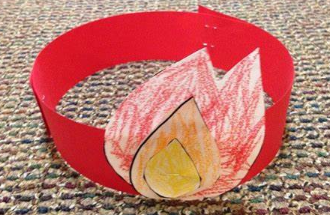

- Another craft option is to create streamers to represent the wind and the flames in the story. Use straws, chopsticks, paper, streamers, etc. Send the kids on a scavenger hunt to find materials around the house that would work! Once the streamers are made, read the story from your Bible or watch the video linked above. Have the kids wave the streamers when the wind or flames are mentioned. Here is an example:
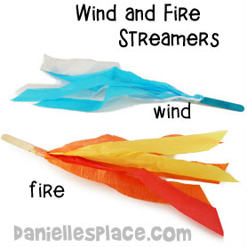

- Play a version of Simon Says, but instead of Simon, try the Spirit Says. Take turns being the leader until everyone has had a chance.
- Print out and color the attached coloring page!

