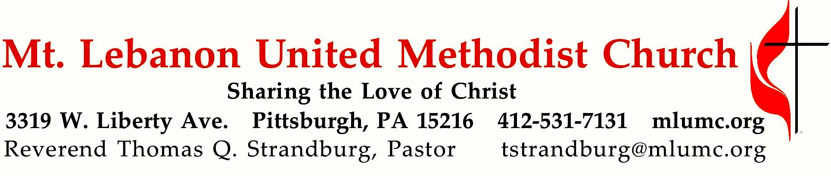

**June 21, 2020 8:30 & 10:45**

**3rd Sunday After Pentecost**

*Father’s Day*

The words of Jesus to his disciples in Matthew 10 are not what you would call your average Father’s Day message – *“For I have come to set a man against his father, and a daughter against her mother.”(verse 35)* These hard words offer to us a valuable lesson in Christian discipleship.

**WE GATHER IN GOD’S NAME …**

*Asterisk indicates to stand as able

**Prelude**  Two Short Preludes (p. 101. Set One: 1, 4)  *Charles V. Stanford*

**Announcements**

**Call to Worship**

Leader: In the midst of the congregation I will praise you.

**People: Rejoice in the Lord, O you righteous, and give thanks to God's holy name!**

Leader: I will extol you, my God and King, and bless your name for ever and ever.

**People**: **Great is the Lord, and greatly to be praised, and God's greatness is**

**unsearchable.**

**… TO GIVE PRAISE TO GOD …**

\***Hymnal 185 When Morning Gilds the Skies** (stanzas 1 & 4, standing)  *Laudes Domini*

**When morning gilds the skies my heart awaking cries: May Jesus Christ be praised! Alike at work and prayer, to Jesus I repair: May Jesus Christ be praised!**

**Be this, while life is mine, my canticle divine: May Jesus Christ be praised!**

**Be this th’eternal song through all the ages long: May Jesus Christ be praised!**

**\*Opening Prayer (in unison)**

**God of wind, word, and fire, we bless your name this day**

**for sending the light and strength of your Holy Spirit.**

**We give you thanks for all the gifts, great and small,**

**that you have poured out upon your children.**

**Accept us with our gifts**

**to be living praise and witness to your love throughout all the earth;**

**through Jesus Christ, who lives with you in the unity of the Holy Spirit,**

**one God, for ever.** *Don E. Saliers, 20th Century*

**\*Silent Prayer**

**\*Hymnal 393 Spirit of the living God**   *Living God*

**Spirit of the living God, fall afresh on me.**

**Spirit of the living God, fall afresh on me.**

**Melt me, mold me, fill me, use me.**

**Spirit of the living God, fall afresh on me.**

©1935, 1963 Moody Bible Institute

**TO CELEBRATE THE FAMILY OF FAITH …**

**Message for Young Disciples** (10:45)

Children will remain seated with their families. Due to the challenges posed by COVID-19, Kids Praise cannot be held as usual. We look forward to its return as soon as conditions will allow.

**Special Music Solo** (10:45) How excellent is thy name (Psalm 8) *Don McAfee*

O Lord our Lord, how excellent is thy name in all the earth!

who hast set thy glory above the heavens.

When I consider thy heavens, the work of thy fingers,

the moon and the stars, which thou hast ordained;

What is man? What is man, that thou art mindful of him?

And the son of man, that thou visitest him?

For thou hast made him a little lower than the angels,

and hast crowned him with glory and honor.

Thou madest him to have dominion over the works of thy hands;

Thou hast put all things under his feet:

All sheep and oxen, yea, and the beasts of the field;

The fowl of the air, and the fish of the sea,

and whatsoever passeth through the paths of the seas.

O Lord our Lord, how excellent is thy name in all the earth! How excellent is thy name!

**… TO HEAR GOD’S WORD PROCLAIMED …**

*Scripture Reading

**A Lesson from the Gospels**

Matthew 10:34-39 The cost of discipleship

**\*Response**

Leader: The Word of the Lord.

**People: Thanks be to God**.

**Pastoral Prayer**

**The Lord’s Prayer**

**Our Father, who art in heaven, hallowed be thy name. Thy kingdom come, thy will be done, on earth as it is in heaven. Give us this day our daily bread. Forgive us our trespasses, as we forgive those who trespass against us. Lead us not into temptation, but deliver us from evil. For thine is the kingdom, the power, and the glory forever. Amen.**

**Sermon** “Not Your Average Father’s Day Message” Rev. Thomas Q. Strandburg

**… TO OFFER OUR GIFTS AND TO DEDICATE OUR LIVES …**

**A Word About the Offering**

*For hygienic reasons, the offering plates will not be passed through the congregation. You are invited to place your offering in the plates at the entrance as you leave, or take advantage of one of our many options for giving – by mail, automatic debit (forms are available from the table in the Narthex), or online.*

**Prayer of Dedication**

**… TO GO REJOICING IN GOD’S NAME!**

\***Hymnal 710 Faith of our fathers** (stanzas 1 & 3, standing) *St. Catherine*

**Faith of our fathers, living still, in spite of dungeon, fire, and sword;**

**O how our hearts beat high with joy whene’er we hear that glorious word!**

**Faith of our fathers, holy faith! We will be true to thee till death.**

**Faith of our fathers, we will love both friend and foe in all our strife;**

**And preach thee, too, as love knows how by kindly words and virtuous life.**

**Faith of our fathers, holy faith! We will be true to thee till death.**

\***Benediction**

\***Postlude**

**Today’s Services**

**The flower arrangement provided for worship today** is given by Chuck and Brenda Vogel in loving memory of their parents, Walter and Margaretta Vogel and Maynard and Mabel Turner.

**Special Music at 10:45** is provided by tenor soloist Kirby Dilworth.

**Today’s Scriptures**

**Matthew 10:34-39**

**34**“Do not think that I have come to bring peace to the earth; I have not come to bring peace, but a sword.

**35**For I have come to set a man against his father, and a daughter against her mother,  
and a daughter-in-law against her mother-in-law;  
**36**and one’s foes will be members of one’s own household.

**37**Whoever loves father or mother more than me is not worthy of me; and whoever loves son or daughter more than me is not worthy of me; **38**and whoever does not take up the cross and follow me is not worthy of me. **39**Those who find their life will lose it, and those who lose their life for my sake will find it.

**Keep in Prayer**

**Convalescing in Care Facilities**

Bonnie Amos, Providence Point

Ed Clarke, Asbury Heights

May Frederick, Baptist Home

John Katshir, Asbury Heights

Woody Kimmel, Providence Point

Pat Seitz, Concordia

Doris Trimble, Providence Point

Olivia Woods, Baptist Manor

Anne Hoffman, Friendship Village

Dave Lewis, Manor Care Whitehall

**Convalescing at Home**

Bishop George Bashore,

Jean Boyer, Mary Caldwell,

Joseph Festor, Ezra Gibson,

Steve Howard, Susan Lichtenfels,

George Lindow, Carol Van Sickle,

Arlene Stewart, Peyton Wisterman

**In the Military**

Jason Boyer, SPC Natalie Brown,

**Maj. Zachary Allen Finch, USMC,**James Iantelli, 1st Lt. Jaskiewicz,   
S. Sgt. Keith Kimmell,

Sgt. Brendan Lamport,

Matt Lewis, USMC,

Sgt. Matthew McConahan, Thomas Orda,  
David Poncel, Sgt. Steven Reitz,   
Capt. Scott B. Rushe, Pastor Rick Townes,   
Maj. Azizi Wesmiller,

Maj. Matthew C. Wesmiller,  
Sgt. Keith Scott Winkowski,

Sgt Michael Zimmerman

**New Interim Director of Music is Hired** The Staff-Parish Relations Committee is pleased to announce the hiring of Mr. Mitchell Stecker as our new Interim Director of Music, to succeed Dr. Gretchen Franz, whose retirement becomes effective this summer. Mr. Stecker has earned his Master's Degree in Historical Musicology, with a concentration in sacred music, from the University of Florida. He currently serves as the Director of Chapel Music and Carillonneur at The Citadel: The Military College of South Carolina. Among his many accolades, Mr. Stecker was profiled in *The Diapason's*May 2019list of "20 under 30," an annually compiled list of 20 individuals under 30 years of age, recognizing “young talents in the fields of organ and harpsichord performance, organ and harpsichord building, carillon, and church music." He is in the process of relocating to the Pittsburgh area to begin his new life with his fiancé, Sarah Boyce. We look forward to welcoming him to our church staff.

**Podcasts of Sunday Sermons**  Catch up on messages from MLUMC. Pastor Tom Strandburg and Pastor Scott Miller will be contributing podcasts of Sunday sermons on a rotating basis. Sermons can be found at http://mlumc.buzzsprout.com or navigate to the site from the link on our webpage, [www.mlumc.org](http://www.mlumc.org). Sermons also will be posted to iTunes. Full recordings of the service are available upon request.

**Honor or remember a loved one with a flower donation.** The flowers that grace the sanctuary each week are generously donated by our church family members. This is a great way to honor or memorialize a special person, event, or milestone in your personal life or in the life of the church. If you are interested in donating flowers on a particular Sunday, contact Lizzie Diller , 412-860-3614. The cost is $33 for the altar, narthex, or columbarium arrangements, and $66 for the chancel flowers.

**Worship at MLUMC During the “Green Phase” of**

**Allegheny County’s Recovery from the COVID-19 Pandemic**

* **We request that no one attend worship while experiencing symptoms of illness.** Join our “online congregation” and worship from home.
* **All worshipers must wear a facial covering (mask)** to protect against the asymptomatic spread of disease. For those who do not have a mask, one will be provided.
* **Worship leaders will not be masked while speaking or singing.** However, they will be positioned at a safe physical distance from the rest of the congregation.
* **Proper hand hygiene practices will be encouraged**, with hand washing and sanitizing areas readily available.
* **Worship attendance will be recorded** to enable us to notify persons in the event of the appearance of a COVID-19 case within the worshiping congregation. Please be sure to notify the church if you become ill following attendance at worship.
* **Household groups will be seated together in worship,** with others seated at an appropriate physical distance (at least 6 feet away).
* **No “common items” will be used in worship or passed through the congregation,** such as hymnals, fellowship pads, offering plates, communion trays, or any other items.
* **There will be no passing of the offering plates.** Your offering may be placed in the stationary plates at the conclusion of the service, or sent to the church by mail, electronically, or by automatic debit from your bank account. (form available at the church.)
* **Our usual children’s ministry cannot be offered at this time.** Since it is not safe to congregate members from different households in close physical proximity, children’s Sunday School, Kidz Praise, & Nursery cannot be offered at this time. A “children’s message” will be offered during the 10:45 a.m. worship service, but children will remain seated with their families.
* **Music will be offered in worship, but congregational singing will be discouraged.** Music will be performed by instrumentalists, vocal soloists, and small ensembles, from a safe physical distance from the rest of the congregation. Hymns will be sung by a single voice, with congregants encouraged to meditate upon the lyrics. All of this is regrettably due to the fact that the COVID-19 virus has been known to spread through the aerosolized droplets that are inevitably produced during the act of singing and speaking.
* **The Chancel Choir will unfortunately not be able to perform in worship,** due to the challenge of maintaining the proper physical distance.
* **Worship bulletins will be provided at each of the places in the congregational seating plan.** There will be no need to receive one from an usher.
* **Appropriate “physical distancing” will be maintained.** The traditional “Passing of the Peace” will be suspended for a season, as will greeting lines before and after worship.

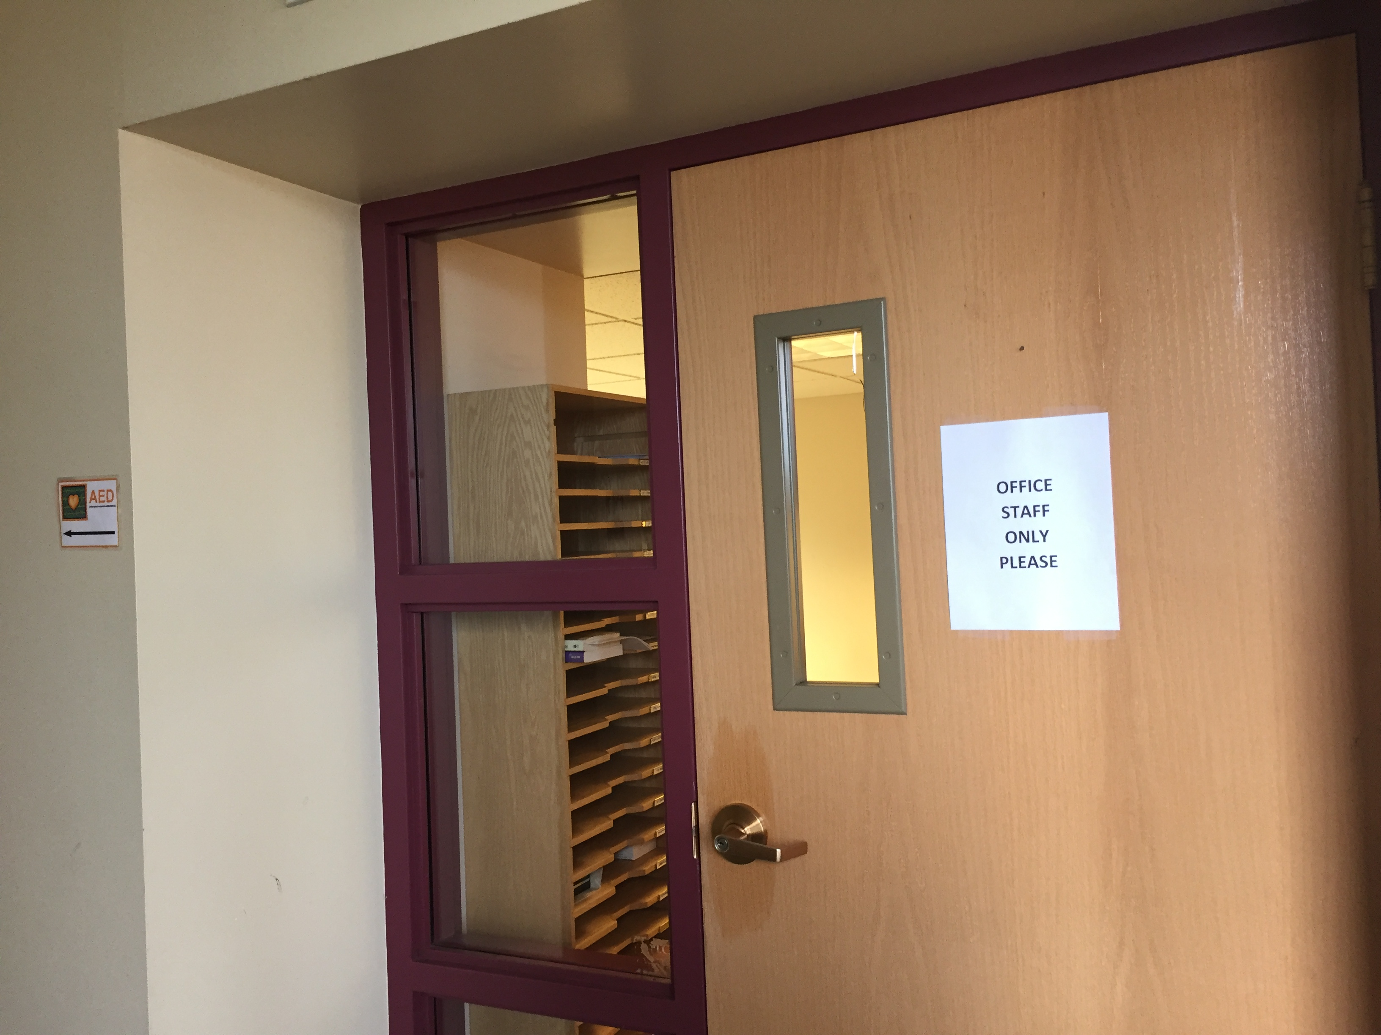**Summer Office Hours**

As part of the phased reopening of our church building, we are pleased to report that our Weekday Ministries program has been up and running since June 1st. God continues to bless the lives of area children and their families through this wonderful program. We have also reopened our church office for in-person work, as of June 15th. Any in-person business may be transacted in the Church Office on Mondays, Wednesdays, and Fridays, between the hours of 8:30 a.m. and Noon. Our office staff continues to be available to you remotely at other times during the work day (8:30 a.m. – 4:30 p.m.). You may always reach our Church Secretary by calling the main church line (412-531-7131) or by e-mail ([churchsecretary@mlumc.org](mailto:churchsecretary@mlumc.org)). Our business administrator may be reached via e-mail at [vkatinsky@mlumc.org](mailto:vkatinsky@mlumc.org).



Please note that we are following all CDC and PA Department of Health protocols while in the church building. Facial coverings should be worn, and proper physical distance between persons should be observed. If you are coming to the church on church business, please use the main office entrance which is located off our upper parking lot, closest to West Liberty Avenue. We are reserving the entrance to the Educational Building for Weekday Ministry access. We look forward to seeing you in the coming weeks and months!

Pastor Tom Strandburg

**Faith for Today**

**Summer Speaker Series**

**9:30 -10:30 am Sundays**

**Asbury Ctr. June 28 -Aug. 30**

 Our Faith for Today’s 66th season will begin next Sunday, June 28, in Asbury Center at 9:30 am.

**June 28** Dr. Dan Aleshire, “What is Happening to American Religion?”

**July 5** John Esaias, “Gifts of the Spirit 2.0”

**July 12** Make a Joyful Noise 3.0 - Musical program featuring popular hymns

**July 19** Kim Tillotson Fleming, “Getting back more than you give – Discovering the joy of giving

**July 26** TBA

**August 2** TBA

**August 9** Tracy Merrick, “Wrestling with Racism in 2020”

**August 16** The Rev. Bob Zilhaver, “The Future of the UMC”

**August 23** “MLUMC Thrived during Covid -19” Members will share stories of our church’s ministries during the Covid -19 shutdown.

**August 30** Pastor Scott Miller will share his experiences of our new worship service, The Gathering, and musical selections will be featured

