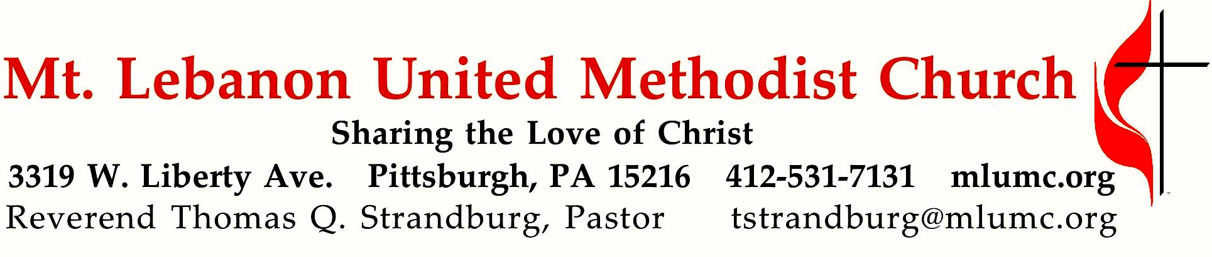

June 28, 2020 8:30 & 10:45
4th Sunday After Pentecost
As Jesus began calling his first disciples, he heard a lot of excuses. There were many reasons for not affirming the call to discipleship. His response to these excuses tells us that his disciples need to be focused on what lies ahead, not what is behind. What's more, it says a lot about priorities and unconditional commitment.

WE GATHER IN GOD’S NAME …
*Asterisk indicates to stand as able

Prelude O for a thousand tongues to sing settings by Lynn A. Koch and Marilyn Biery

Announcements

10:45 Introit Hal H. Hopson
Come and worship the Lord our God. Alleluia, alleluia.
Praise God on the holy mountain. Alleluia, alleluia.
© 2012 Birnamwood Publications (ASCAP)

Call to Worship
Leader: You are the salt of the earth.
People: May we season the world with faithfulness, O God.
Leader: You are the light of the world.
People: May your love shine through us, O Christ our Savior.
Leader: You are a city built on a hill.
People: May your vigor make us bold witnesses, O Spirit of the living God.
Worship & Song

… TO GIVE PRAISE TO GOD …

Hymnal 57 O for a thousand tongues to sing Azmon
- O for a thousand tongues to sing my great Redeemer’s praise,
the glories of my God and King, the triumphs of his grace!
7. In Christ, your head, you then shall know, shall feel your sins forgiven;
anticipate your heaven below, and own that love is heaven.

*Opening Prayer (in unison)
Days pass and the years vanish, and we walk sightless among miracles. Lord, fill our eyes with seeing and our minds with knowing; let there be moments when your presence, like lightning, illumines the darkness in which we walk. Help us to see, wherever we gaze, that the bush burns unconsumed. And we, clay touched by God, will reach out for holiness, and exclaim in wonder: How filled with awe is this place, and we did not know it: “Blessed is the Eternal One, the holy God!” Amen. Worship & Song

*Silent Prayer

*Hymnal 393 Spirit of the living God Living God
Spirit of the living God, fall afresh on me.
Spirit of the living God, fall afresh on me.
Melt me, mold me, fill me, use me.
Spirit of the living God, fall afresh on me.
©1935, 1963 Moody Bible Institute

TO CELEBRATE THE FAMILY OF FAITH …

Message for Young Disciples (10:45)
Children will remain seated with their families. Due to the challenges posed by COVID-19, Kids Praise cannot be held as usual. We look forward to its return as soon as conditions will allow.

10:45 Anthem Twila Paris, arr. Craig Courtney
How beautiful the hands that served the wine and the bread and the sons of the earth.
How beautiful the feet that walked the long dusty roads and the hill to the cross.
Refrain: How beautiful is the body of Christ.
How beautiful the heart that bled, that took all my sin and bore it instead.
How beautiful the tender eyes that choose to forgive and never despise. Refrain
And as He laid down His life, we offer this sacrifice:
that we will live just as He died, willing to pay the price.
How beautiful the radiant Bride who waits for her Groom with His light in her eyes,
How beautiful when humble hearts give the fruit of pure lives so that others may live.

Refrain
How beautiful the feet that bring the sound of good news and the love of the King.
How beautiful the hands that serve the wine and the bread and the sons of the earth. Refrain
© 2002 Ariose Music, admin. EMI Christian Music Publishing
Permission to reprint and podcast/stream the music and text in this service
obtained from ONELICENSE: A-700887 All rights reserved

… TO HEAR GOD’S WORD PROCLAIMED …

*Scripture Reading
A Lesson from the Gospel
Luke 9:51-62 Jesus sends messengers to prepare the way
*Response
Leader: The Word of the Lord.
People: Thanks be to God.

Pastoral Prayer

The Lord’s Prayer
Our Father, who art in heaven, hallowed be thy name. Thy kingdom come, thy will be done, on earth as it is in heaven. Give us this day our daily bread. Forgive us our trespasses, as we forgive those who trespass against us. Lead us not into temptation, but deliver us from evil. For thine is the kingdom, the power, and the glory forever. Amen.

Sermon “No Ifs, Ands, or Buts” Rev. Thomas Q. Strandburg

… TO OFFER OUR GIFTS AND TO DEDICATE OUR LIVES …

A Word About the Offering
For hygienic reasons, the offering plates will not be passed through the congregation. You are invited to place your offering in the plates at the entrance as you leave, or take advantage of one of our many options for giving – by mail, automatic debit (forms are available from the table in the Narthex), or online.

Prayer of Dedication

… TO GO REJOICING IN GOD’S NAME!

Hymnal 569 We’ve a story to tell to the nations Message
1. We’ve a story to tell to the nations,
that shall turn their hearts to the right,
a story of truth and mercy, a story of peace and light,
a story of peace and light.
Refrain: For the darkness shall turn to dawning,
and the dawning to noonday bright;
and Christ’s great kingdom shall come on earth,
the kingdom of love and light.

4. We’ve a Savior to show to the nations,
who the path of sorrow hath trod,
that all of the world’s great peoples
might come to the truth of God,
might come to the truth of God. Refrain

*Benediction

Postlude Postlude on ‘Azmon’ setting by Carl G. Gläser

Today’s Services
The flower arrangement provided for worship today is given by Mary Garber in celebration of our East German and Latvian United Methodist brothers and sisters in overcoming the current virus pandemic. We pray for you and salute you. God bless you.

Special Music at 10:45 is provided by Kathy Whittaker, Timmi Williams and Kirby Dilworth.

Today’s Scriptures

Luke 9:51-62
⁵¹When the days drew near for him to be taken up, he set his face to go to Jerusalem. ⁵²And he sent messengers ahead of him. On their way they entered a village of the Samaritans to make ready for him; ⁵³but they did not receive him, because his face was set toward Jerusalem. ⁵⁴When his disciples James and John saw it, they said, “Lord, do you want us to command fire to come down from heaven and consume them?” ⁵⁵But he turned and rebuked them. ⁵⁶Then they went on to another village.
⁵⁷As they were going along the road, someone said to him, “I will follow you wherever you go.” ⁵⁸And Jesus said to him, “Foxes have holes, and birds of the air have nests; but the Son of Man has nowhere to lay his head.” ⁵⁹To another he said, “Follow me.” But he said, “Lord, first let me go and bury my father.” ⁶⁰But Jesus said to him, “Let the dead bury their own dead; but as for you, go and proclaim the kingdom of God.” ⁶¹Another said, “I will follow you, Lord; but let me first say farewell to those at my home.” ⁶²Jesus said to him, “No one who puts a hand to the plow and looks back is fit for the kingdom of God.”

Keep in Prayer

Convalescing in Care Facilities
Bonnie Amos, Providence Point
Ed Clarke, Asbury Heights
May Frederick, Baptist Home
John Katshir, Asbury Heights
Woody Kimmel, Providence Point
Pat Seitz, Concordia
Doris Trimble, Providence Point
Olivia Woods, Baptist Manor
Anne Hoffman, Friendship Village
Dave Lewis, Manor Care Whitehall

Convalescing at Home
Bishop George Bashore,
Jean Boyer, Mary Caldwell,
Joseph Festor, Ezra Gibson,
Steve Howard, Susan Lichtenfels,
George Lindow, Carol Van Sickle,
Arlene Stewart, Peyton Wisterman
In the Military

Jason Boyer, SPC Natalie Brown,
Maj. Zachary Allen Finch, USMC,
James Iantelli, 1st Lt. Jaskiewicz,
S. Sgt. Keith Kimmell,
Sgt. Brendan Lamport,
Matt Lewis, USMC,
Sgt. Matthew McConahan, Thomas Orda,
David Poncel, Sgt. Steven Reitz,
Capt. Scott B. Rushe, Pastor Rick Townes,
Maj. Azizi Wesmiller,

Maj. Matthew C. Wesmiller,
Sgt. Keith Scott Winkowski,

Sgt Michael Zimmerman

New Interim Director of Music is Hired The Staff-Parish Relations Committee is pleased to announce the hiring of Mr. Mitchell Stecker as our new Interim Director of Music, to succeed Dr. Gretchen Franz, whose retirement becomes effective this summer. Mr. Stecker has earned his Master's Degree in Historical Musicology, with a concentration in sacred music, from the University of Florida. He currently serves as the Director of Chapel Music and Carillonneur at The Citadel: The Military College of South Carolina. Among his many accolades, Mr. Stecker was profiled in The Diapason's May 2019 list of "20 under 30," an annually compiled list of 20 individuals under 30 years of age, recognizing “young talents in the fields of organ and harpsichord performance, organ and harpsichord building, carillon, and church music." He is in the process of relocating to the Pittsburgh area to begin his new life with his fiancé, Sarah Boyce. We look forward to welcoming him to our church staff.

Podcasts of Sunday Sermons Catch up on messages from MLUMC. Pastor Tom Strandburg and Pastor Scott Miller will be contributing podcasts of Sunday sermons on a rotating basis. Sermons can be found at http://mlumc.buzzsprout.com or navigate to the site from the link on our webpage, www.mlumc.org. Sermons also will be posted to iTunes. Full recordings of the service are available upon request.
Worship at MLUMC During the “Green Phase” of
Allegheny County’s Recovery from the COVID-19 Pandemic

- We request that no one attend worship while experiencing symptoms of illness. Join our “online congregation” and worship from home.
- All worshipers must wear a facial covering (mask) to protect against the asymptomatic spread of disease. For those who do not have a mask, one will be provided.
- Worship leaders will not be masked while speaking or singing. However, they will be positioned at a safe physical distance from the rest of the congregation.
- Proper hand hygiene practices will be encouraged, with hand washing and sanitizing areas readily available.
- Worship attendance will be recorded to enable us to notify persons in the event of the appearance of a COVID-19 case within the worshiping congregation. Please be sure to notify the church if you become ill following attendance at worship.
- Household groups will be seated together in worship, with others seated at an appropriate physical distance (at least 6 feet away).
- No “common items” will be used in worship or passed through the congregation, such as hymnals, fellowship pads, offering plates, communion trays, or any other items.
- There will be no passing of the offering plates. Your offering may be placed in the stationary plates at the conclusion of the service, or sent to the church by mail, electronically, or by automatic debit from your bank account. (form available at the church.)
- Our usual children’s ministry cannot be offered at this time. Since it is not safe to congregate members from different households in close physical proximity, children’s Sunday School, Kidz Praise, & Nursery cannot be offered at this time. A “children’s message” will be offered during the 10:45 a.m. worship service, but children will remain seated with their families.
- Music will be offered in worship, but congregational singing will be discouraged. Music will be performed by instrumentalists, vocal soloists, and small ensembles, from a safe physical distance from the rest of the congregation. Hymns will be sung by a single voice, with congregants encouraged to meditate upon the lyrics. All of this is regrettably due to the fact that the COVID-19 virus has been known to spread through the aerosolized droplets that are inevitably produced during the act of singing and speaking.
- The Chancel Choir will unfortunately not be able to perform in worship, due to the challenge of maintaining the proper physical distance.
- Worship bulletins will be provided at each of the places in the congregational seating plan. There will be no need to receive one from an usher.
- Appropriate “physical distancing” will be maintained. The traditional “Passing of the Peace” will be suspended for a season, as will greeting lines before and after worship.

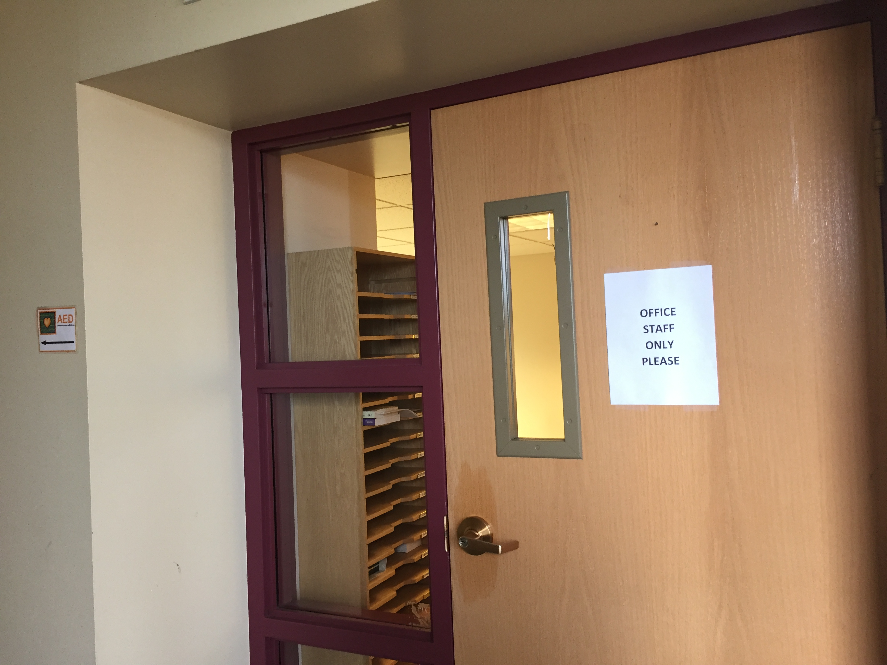
Summer Office Hours
As part of the phased reopening of our church building, we are pleased to report that our Weekday Ministries program has been up and running since June 1st. God continues to bless the lives of area children and their families through this wonderful program. We have also reopened our church office for in-person work, as of June 15th. Any in-person business may be transacted in the Church Office on Mondays, Wednesdays, and Fridays, between the hours of 8:30 a.m. and Noon. Our office staff continues to be available to you remotely at other times during the work day (8:30 a.m. – 4:30 p.m.). You may always reach our Church Secretary by calling the main church line (412-531-7131) or by e-mail (churchsecretary@mlumc.org). Our business administrator may be reached via e-mail at vkatinsky@mlumc.org.
Please note that we are following all CDC and PA Department of Health protocols while in the church building. Facial coverings should be worn, and proper physical distance between persons should be observed. If you are coming to the church on church business, please use the main office entrance which is located off our upper parking lot, closest to West Liberty Avenue. We are reserving the entrance to the Educational Building for Weekday Ministry access. We look forward to seeing you in the coming weeks and months!
Pastor Tom Strandburg

Honor or remember a loved one with a flower donation. The flowers that grace the sanctuary each week are generously donated by our church family members. This is a great way to honor or memorialize a special person, event, or milestone in your personal life or in the life of the church. If you are interested in donating flowers on a particular Sunday, contact Lizzie Diller , 412-860-3614. The cost is $33 for the altar, narthex, or columbarium arrangements, and $66 for the chancel flowers.

Faith for Today
Summer Speaker Series
9:30 -10:30 am Sundays
Asbury Ctr. June 28 -Aug. 30
Our Faith for Today’s 66th season will begin Sunday, June 28, in Asbury Center at 9:30 am.

June 28 Dr. Dan Aleshire, “What is Happening to American Religion?”

July 5 John Esaias, “Gifts of the Spirit 2.0”

July 12 Make a Joyful Noise 3.0 - Musical program featuring popular hymns

July 19 Kim Tillotson Fleming, “Getting back more than you give – Discovering the joy of giving

July 26 Ron Hollein, David Seitz, “A Call to Ministry”

August 2 TBA

August 9 Tracy Merrick, “Wrestling with Racism in 2020”

August 16 The Rev. Bob Zilhaver, “The Future of the UMC”

August 23 “MLUMC Thrived during Covid -19” Members will share stories of our church’s ministries during the Covid -19 shutdown.

August 30 Pastor Scott Miller will share his experiences of our new worship service, The Gathering, and musical selections will be featured

BOTH 8:30 SERVICES COMBINED NEXT WEEK: On Sunday, July 5th, both of our 8:30 services will meet together in Sanner Chapel, under the leadership of Pastor Scott Miller.

