Sunday School from Home
September 20, 2020
This week we begin a study of Joseph from the book of Genesis. This first story will be familiar to many: Joseph is given the coat of many colors from his father, Jacob.
- Read the story from Genesis 37:1-36
- Note that the story tells us outright that Joseph was his father’s favorite son, and that the other brothers were jealous of him. Make sure children understand that this jealousy was not due simply to the beautiful coat, but because of Jacob’s obvious and ongoing preferential treatment towards Joseph.
- Joseph’s coat was very special because it was colorful, and colored dye was a luxury in Biblical times (we explored this a little bit when we studied Lydia in the book of Acts).
- The coat was also special because it had long sleeves. Most people at that time wore a coat (or cloak) with short sleeves so they stayed out of the way while doing hard work. Since Joseph’s coat had long sleeves, this signaled that he would be excused from the harder and dirtier jobs, further showing how his father favored him. Take a moment to talk about long sleeves vs. short sleeves with your children. Today we usually select sleeve length according to the weather, but if we are wearing long sleeves and must do a job that is dirty or involves water, what do we do with those long sleeves? What saying do we have about sleeves when discussing hard work? (“roll up your sleeves”)
- Use a piece of paper, a white board, or other materials to have children draw a face that shows how Joseph must have felt when his father gave him the coat. Draw another face to show how his brothers felt about this. Ask children to use feeling words to describe each face drawing. Next, briefly describe a situation that would make someone feel similarly to either Joseph or his brothers, and ask children to select the corresponding face and name the emotion. After you have given some examples, have the children give a few of their own. They might relate experiences they have had, or make some up.

- Joseph’s father had a large family with many children – you can read the list of their names in Genesis 35:23-26. Here the names are listed in a family tree:
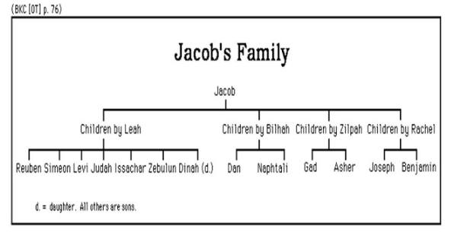
- If appropriate for your children, point out the number of wives that Jacob had, and the fact that this family tree lists only one daughter (Dinah). It is possible that Jacob fathered only the thirteen children listed above. However, it is also quite possible that there were more daughters who are not named (Dinah is the exception because she is part of the narrative in Genesis 34). What do these two facts tell you about the role of women in Joseph’s time?
- Talk about your own family tree with your children, going back as far as you like or are able. Ask children to draw a picture of their family, and older children to create a family tree with names. Point out that all families are unique, just like all people are unique. Ask your children to name some ways your family is special.
- Spend some time looking at family photographs and telling stories about the people in them – including people who your children do not remember or know well. You could also call relatives to talk about these stories with your children. These stories are called an ancestral narrative. Consider writing them down in a special book or making a recording of them as a keepsake.
- For a fun family movie night, watch Joseph and the Amazing Technicolor Dreamcoat (there are some places to stream online, or you could borrow the DVD from the library). If you don’t want to watch the entire musical, here is a song from the beginning about all the brothers: https://www.youtube.com/watch?v=QtpzoGj-1V8

