Sunday School from Home
November 1, 2020

This week’s lesson tells about Moses convincing Pharaoh to let the Israelites leave Egypt. God was with Moses throughout this process, and sent a series of plagues that finally forced Pharaoh to let them go.
- Read the story: Exodus 5:1 – 13:9. This is quite a long passage, although it may already be a familiar narrative to your children. Depending on their ages, you might consider summarizing the story for them. You can also use the attached Sunday school printable.
- Before you begin to read/tell the story, you might want to make sure they understand what a plague is in this context. As you read, have them write or draw the plagues, then once the story is finished have them repeat back the plagues. Explain each one if needed.
- You can watch a cartoon video summary of the story HERE
- We can’t forget to sing Let My People Go! Go HERE for the Louis Armstrong version – you’ll want to have a dance off in the living room and pretend to play trumpets! Or you might prefer this KIDDIE version.

- One of the plagues was frogs. Make an easy frog headband by cutting a piece of green paper into two long strips, and adding two large eyes with white and green paper. Here is a sample:
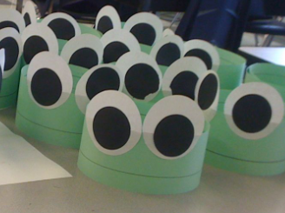

- Older kids and adults might enjoy learning to make an origami frog that jumps! Instructions can be found HERE
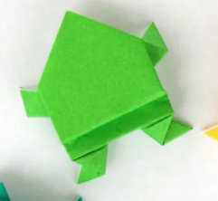

- Play a TRUE/FALSE game based on the events in the story. Children can use their origami frogs or wear their headbands. Tell children if you say something that happened in the story they should HOP up and down (or make their origami frog jump). If you say something that did NOT happen in the story, they should remain still. Here are two examples:
- God was with Moses when he went to talk to Pharaoh (HOP!)
- One of the plagues was that it rained ice cream in Egypt
(STAY STILL!)
Once you have played the game for a few minutes, allow the children to take turns being the leader and making the true and false statements
- Print out the attached cards and cut them apart (it might be helpful to either print this onto cardstock or to glue the cards onto index cards so they are not so flimsy). You should have two of each picture showing the plagues and other important events in this story. Mix the cards up and turn them over. Use the cards to play a game of Memory – in turn, each player turns over two cards and tries to make a match. If the cards match, the player keeps the cards. If they do not match, the player turns them back over and leaves them in place. Play continues until all the cards have been matched. Some children might be upset by a few of the cards, so discard any you think will be problematic for your children.

