Sunday School from Home
November 29, 2020
This week marks the first Sunday of Advent! Our story is one of preparation, as Zechariah and Elizabeth learn they are to have a baby.

- Read the story in Luke 1:5-25
- Here is a short video that summarizes the story.
- You can also use the attached story summary to read instead of your Bible. Teach your children the ASL sign for the letters Z and E, and have them make those signs every time they hear the names Zechariah or Elizabeth.
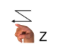

- Zechariah was unable to speak until his son was born. Our vocal chords enable us to make sounds. Let your children experiment with making different sounds while touching their necks to feel the vibrations of the vocal chords.
- Older kids and adults, research more about how our vocal chords work and what can cause them to stop producing sounds.
- Play a game like charades, where one person pretends to be Zechariah when he is unable to speak. Use motions to have the other family members guess a word that comes from the story (such as angel or baby). Take turns until everyone has had a chance. You might also add other Advent and Christmas words to your game.
- Make an angel craft! HERE is one example using muffin liners and a coffee filter (or substitute a piece of white paper cut into a circle). HERE is another option using paper cut into heart shapes.

- Make a tree decoration for your house using handprints (these can go onto the wall or fridge, or can be mounted to poster board. Have each family member trace their hand onto green paper and cut it out. Label each hand with the person’s name. Make two extra handprints and label one John and one Jesus. Arrange your handprints with the fingers pointing down to look like a Christmas tree. If needed, you can make more handprints and add names of loved ones you are thinking about this season. Here are two examples, plus another with painted handprints instead of cutouts:
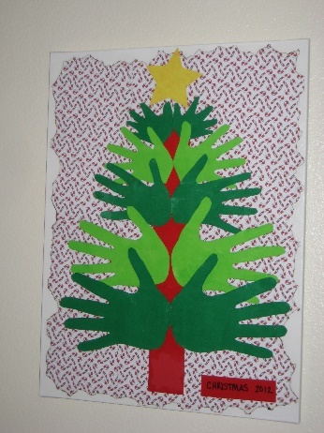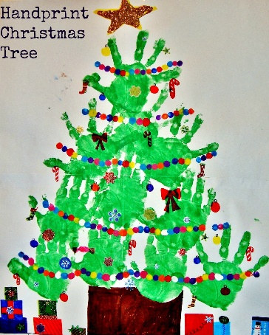
- The name of Zechariah and Elizabeth’s child was so important that the angel told them what he should be called. This is also true for Jesus’ name (see Matthew chapter 1). Older kids and adults might want to research the meaning of these two names.
- The angel who visited Zechariah was Gabriel, who is mentioned by name in two other Bible stories. One is when he appeared to Joseph in Matthew chapter 1. The other is in the Old Testament. Can you find out who Gabriel appeared to and why?

