Sunday School from Home
November 8, 2020
The story this week is God’s final triumph over Pharaoh and the Egyptians. The Israelites escape to freedom, only to be chased down by their captors. God empowers Moses to part the Red Sea so his people could finally begin their journey to the Promised Land.
- Read the story: Exodus 13:17 – 14:31
- You can watch a short video summary HERE
- For and old school video, see the Charlton Heston interpretation HERE
- Throughout this story, the Israelites had many reasons to be afraid. Ask your children what makes them afraid, and what makes them feel safe?
- Sing a silly song about how Moses was called by God to lead his people (to the tune of “Bingo”):
There was a leader called by God
To go and free God’s people.
M-O-S-E-S
M-O-S-E-S
M-O-S-E-S
Oh, Moses freed God’s people.
For each round, replace one letter of Moses’ name with a clap until finally you have five claps instead of letters. You can also let your children pick a sound or motion they can use in place of the claps (such as stomping a foot or jumping up).
- Use the attached activity page to put the events of the story into the correct sequence. Use your Bible if needed. You can cut the strips apart of write numbers in the boxes to the left of each statement.
- For older kids and adults: Use a map in your Bible to trace the path of the Israelites from Egypt to the crossing of the Red Sea on their way to Canaan. It appears they did not take the most direct route. Read your Bible or research online to find out why. Also, find out how the Red Sea got its name.
- Make a snack that reminds of the miracle in this story. Try adding icing to graham crackers or a cupcake, leaving “dry land” in the center. Add other decorations if you like. Here is some inspiration:
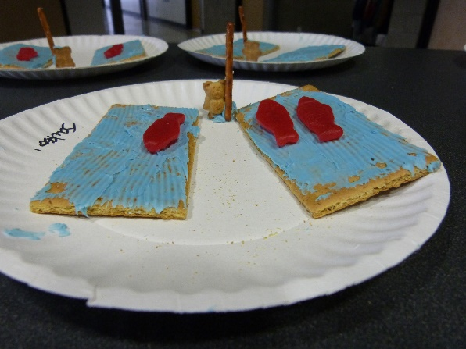

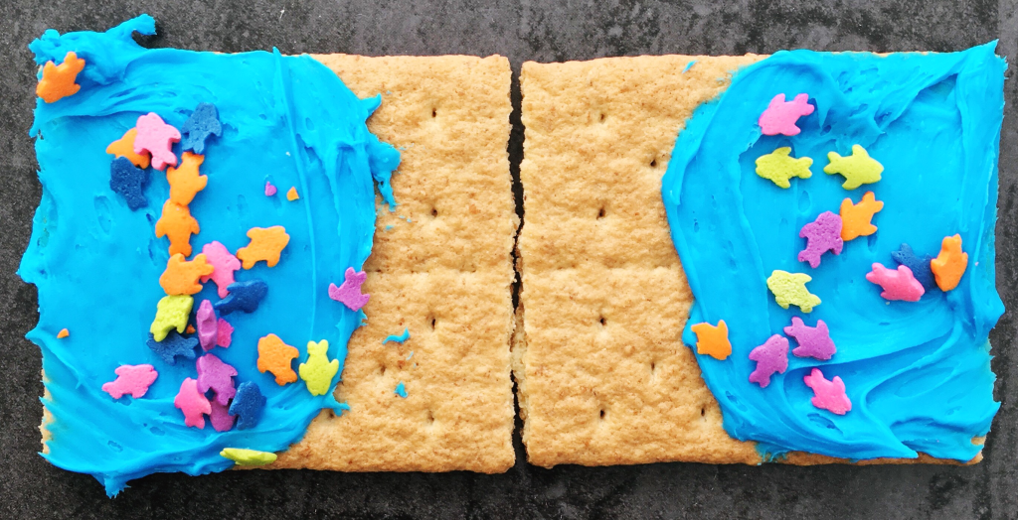

- Make a paper craft that shows the Red Sea parting. You can find an easy one HERE

