Sunday School from Home
December 20, 2020
The reading for this week tells the story of Jesus’ birth in Bethlehem.
- Read the story in Luke 2:1-20
- Watch the video HERE that tells the story
- Print out the page with the pictures of the stable, Mary, Joseph, and baby Jesus. Have your children color the pictures and then cut them out. From here you can use them to help your child retell the story. Or, have them glue the pieces onto a piece of construction paper. Use whatever household craft items you have to decorate the night sky, add the star, etc.
- The shepherds were tending their sheep when they learned of the birth of Jesus. Make a fingerprint picture of one or more sheep. Dip your thumb into white paint and make a series of thumbprints in an oval shape onto dark colored paper. Use construction paper to cut shapes for the legs and head, and give your sheep eyes and ears. You can also reverse the colors and make black sheep! Here is a sample:
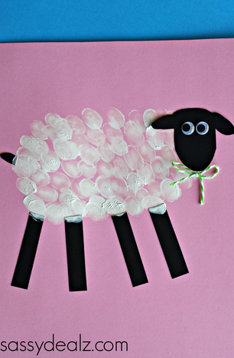
- Print out the attached angel pattern and have your children cut out the four pieces, then glue them together to make an angel. Decorate your angel with glitter glue or other supplies. Ask your children to tell you what the angel said in this story.
- Play a game! Designate two or more corners of the room as “inns.” You should have fewer inn than players. At your signal, all players should run from the center of the room to one of the inns. Each inn can only hold one person, so the players who do not secure a room at the inn will have to go to each “door” and knock to ask if there is any room. Each of the other players will tell them there is no room for them at the inn. Then, have all the players come to the center of the room and play another round. Continue for as long as you like, and you can make the game more challenging by telling players they must hop on one leg, skip, etc. Play this game outside if weather permits.
- Read about Christmas traditions in other parts of the world (see attached information). For older kids and adults, dig a little deeper into international traditions. Or, take a look at the history behind American traditions, and compare them to early Christian celebrations of Christmas.
- Use as many of the attached activity sheets as are helpful to you!

