Sunday School at Home
March 28, 2021
This week we celebrate Jesus’ triumphant entrance to Jerusalem, also known as Palm Sunday.
- Read the story of Palm Sunday in Matthew 21:1-11
- You can watch a video of the story HERE
- Use paper to make a palm leaf at home (or print and cut out the leaf in the attached supplements). Have your own parade to reenact the story of Palm Sunday, shouting “Hosanna!” or similar modern expressions. Depending on the size of your kids, perhaps let one family member be the donkey and another ride him or her while pretending to be Jesus. Other family members can be the crowd waving their palm branches.
- If you want more of an art project, try attaching green streamers to one end of a wooden dowel. You can also use a ruler or a paper towel roll. Use this as your palm for the above activity.
- While reenacting the story, ask your children why so many people were celebrating Jesus’ entry into Jerusalem. Why did they wave palm branches? What might we do today to celebrate Jesus coming to town? What do you think Jesus was thinking when he entered Jerusalem? Was everyone in Jerusalem happy to see him?
- While pretending to greet Jesus, trying singing a simple song to the tune of Goodnight, Ladies:
Sing, Hosanna
Sing, Hosanna,
Sing Hosanna,
Hosanna in the highest!
- Print the “Palm Leaf” and “Palm Leaf Symbols” pages (one set per child). Have your child color the wreath and the symbols, then cut them out and attach the symbols to the wreath with glue or tape. Discuss what each of the symbols are and how they help us to remember today’s story.
- Give each child a “Greeting Jesus” journal page. Have them write or draw how they would greet Jesus if He came to visit our town. Who do you think Jesus would want to visit?

- To help remember the key verse in this week’s story, try making a bigger palm branch and write Matthew 21:9 on it (one word per leaf): 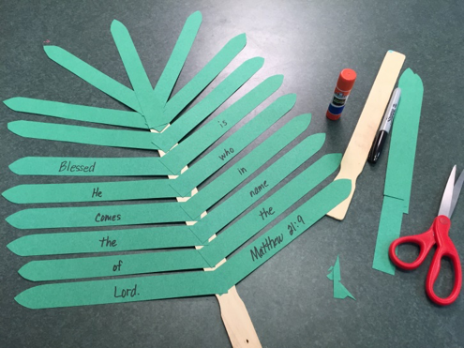

- When attending church this week (or watching the service online) ask your child to listen for the words from Matthew 21:9 or the word Hosanna. How many times do you hear them?

- Here are some music selections to listen to while you learn about Palm Sunday:
Hosanna (Blessed Is He Who Comes In The Name of the Lord) Lyrics - YouTube
Hosanna - Steve Green and Kids (LYRIC VIDEO) Best Kid's Bible Verse Song - YouTube
Hosanna in the Highest, David W. Music - YouTube
Hosanna international - YouTube
Jesus Christ Superstar Film (2000): Hosanna - YouTube

