Sunday School from Home
February 28, 2021
The story this week is about how Zacchaeus went to see Jesus and was forgiven.
- Read the story in Luke 19:1-10
- Watch a video summary of the story HERE or HERE.
- Sing the Bible song about Zacchaeus! You can find a recording HERE.
- Make a craft of Zacchaeus climbing the tree like this:
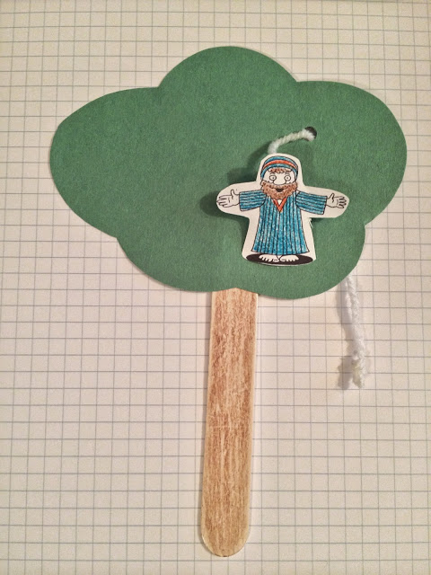
You can find instructions for this craft and other activities related to this story HERE.
- Here is a picture book that tells the story of Zacchaeus from his point of view, then from Jesus’:
Zacchaeus and Jesus (Flipside Stories): Mackall, Dandi Daley, Manuzak, Lisa: 9781496411198: Amazon.com: Books
- Another story that relates to the theme of forgiveness: The Grudge Keeper: Rockliff, Mara, Wheeler, Eliza: 9781561457298: Amazon.com: Books

- Jesus surprised the crowd with his actions toward Zacchaeus, and by forgiving someone who was universally disliked. Ask your children to think about a time when they had to forgive someone, or a time when they were forgiven. Help them to talk about the feelings around forgiveness, and why it is so important. Why did Jesus give Zacchaeus a second chance? Why are second chances important? Let them use the journal page to draw or write their thoughts.
- Make a Zacchaeus snack! Make some Rice Krispie treat mix and dye it green, and form it to the top of a pretzel rod so that it looks like a tree. Affix a teddy graham or gummy bear to the top of the tree to be your Zacchaeus. Here is a picture of a similar creation:
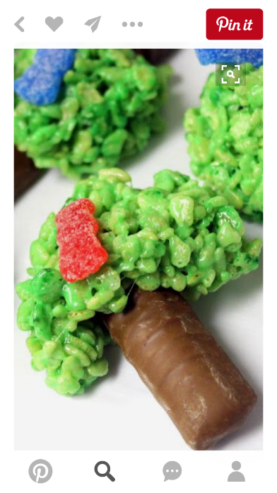
- In our story, we observe Zacchaeus making a positive change in his life. Do a science experiment with “invisible ink” as a reminder of what changes can occur with God! See the instruction page in the attachments.
- Tall Tree game – gather a variety of play building materials from around the house (you could also use supplies such as straws, tape, paper towel tubes, etc.). Divide the family into two teams and race to see who can build the tallest “tree” in two minutes! Play as many rounds as you like, perhaps adding rules to increase the difficulty level.
- Use as many of the attachments as are helpful to you!

