Sunday School from Home
March 14, 2021
The Last Supper

- Read the Bible story in Luke 22:14-20
- You can watch a video summary of the story HERE.
- In the story, Jesus asked his friends to eat the bread and drink from the cup to remember him. What do you think they remembered about him? What do you remember about Jesus? Use the journal page to write or draw your answers, and then share as a family.
- Cup and Plate artwork. You will need a plastic or disposable cup and plate, colored tissue paper, and glue. Tear or cut the tissue paper into small pieces and glue onto the cup and plate to make them “fancy.”
- Once your plates and cups (above) have dried, use them to set a table for Jesus and the disciples. Allow children to use play or real food to prepare a pretend feast for Jesus.
- Alternatively, set a table (or perhaps an indoor picnic) for the family. Serve food that might have been available in Jesus’ time. These may include olives, fruit, pita, hummus, and juice.
- Remind children that Jesus and the disciples were celebrating a special meal for Passover (you can read the story in Exodus 12). Jewish people today still celebrate Passover all over the world. What special meals do we celebrate in our country or in your family?
- Learn more about Passover online or using other resources. Make connections between Passover and communion. Here is a picture of the traditional food served at the Seder with explanations:
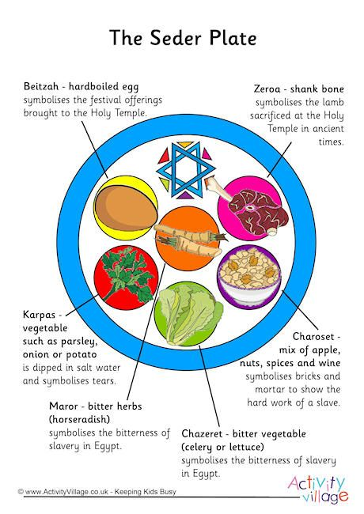
- Since bread was a central part of the meal that Jesus shared with the disciples, make some bread at home. A recipe is attached, you may want to use your own. The bread served during Passover does not have yeast – why is that? Consider making a bread without yeast, such as naan or pita.
- Some children may enjoy looking a few pieces of art that depict the Last Supper. Look them up online and see if you can identify some of the people and actions shown. Da Vinci’s painting is one, but there are many others. Older kids and adults may want to compare different interpretations of this event – what do you think each artist is trying to emphasize in his or her work?
- Since we are talking about a special meal today, write a blessing as a family thanking God for our food. Say your prayer before meals.
- Use as many of the printable sheets as are helpful to you!

