Sunday School from Home
April 18, 2021
Jesus gives his disciples The Great Commission, and promises to be with them always.

- Read the story in Matthew 28:16-20
- You can watch a video clip summarizing the story HERE
- If you have a globe or a world map (even one on the computer), ask your child to imagine where they might go to share the Good News with others as Jesus commanded. How would they get there? What would they say? Use the journal page in the attachments to have them write or draw their answers.
- You could also use the page with the suitcase in the attachments to talk about going on a trip. Cut out the suitcase and fold it along the dotted line. Tape the sides closed, but leave the top open. Cut out the four things you can share about Jesus, and put them in your suitcase. If you like, write down some other things you would like to tell others and add them to your suitcase.
- Read John 3:16 with your children as a companion verse to this lesson. This verse boils down what we are to GO and TELL others in the world about Jesus.
- Reuse those plastic Easter eggs! Hide the eggs around the house or outside and let your children work as a team to find them. When opened, let them discover words that they can put in order to make the key verses for this lesson: John 3:16 and/or Matthew 28:19. Make the game more or less difficult according to your kids’ ages. For example, to make it a little bit easier, assign one color for each verse, or limit your game to one verse. To make it harder, mix the colors and let kids sort out all of the words for each verse, or leave out some words and let them fill in the blanks.
- Follow this link for a fun science demonstration on what happens when we share what we know about Jesus: The Great Commission- Colour My World! – Mission Bible Class
- For a quick craft idea, make a small megaphone with a paper cup. Cut out the bottom and attach a chenille stem as a handle (see photo for a sample). Decorate it any way you wish and send the kids outside to make some NOISE!
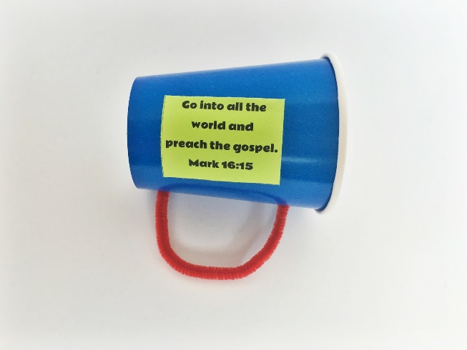

- For a fun snack idea, use nutter butter cookies, icing in a tube, and small candies to make a foot to remind us to go out to the world to share what we know about Jesus:
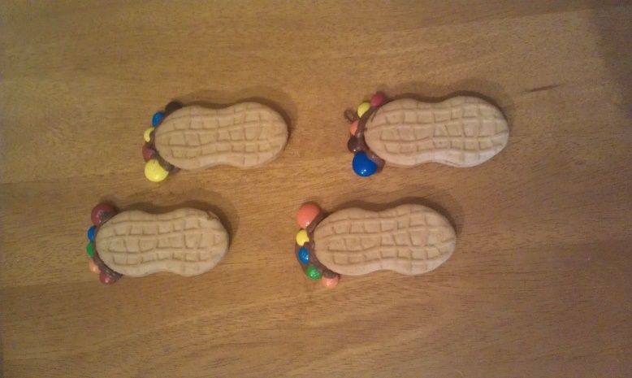

- Since we are talking about going out into the world, try making a paper mache globe – you can follow the instructions at the link below and modify as needed according to your kids’ ages. This activity is messy, so try doing it outside to keep them busy for an afternoon, then take a hose to the workspace.
Paper Mache Light-Up Globes | Housing a Forest
- Additional printable sheets are attached to use in whatever way you find helpful.

