Sunday School from Home
Easter Sunday 2021

- Read the Resurrection story in Matthew 28:1-10
- You can watch a video summery HERE
- Give each child a copy of the Jesus is Alive journal page. Have them write or draw their favorite part of the story
- Give each child a copy of the Easter butterfly page. Talk about why we often use egg, flowers, and butterflies to signify Easter. Make connections between the life cycle of a butterfly and the way God changes us. Let your children use any art supplies you like to decorate their butterfly. One option might be to glue small pieces of colored tissue paper to the butterfly. Example:
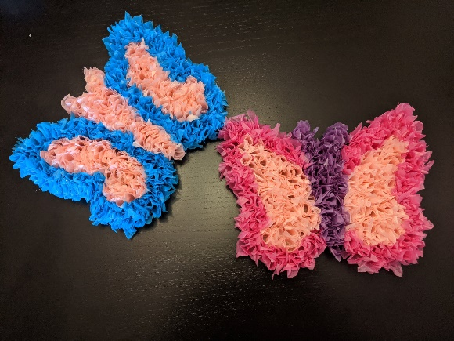
- If you haven’t already done them, you can find my video of Easter crafts to do with kids HERE
- Play and egg rolling game! Get plastic Easter eggs in two different colors (as many as you wish). Mark a start and a finish line with painters tape on the floor or with chalk outdoors if the weather allows. Let family members compete by rolling the eggs one at a time from their start to their finish line using a flyswatter, wooden spoon, or similar. The first person to get all of their eggs across the finish is the winner! If you have a large enough family, this may be played as a relay game. Remind children that we are ROLLING the eggs because the stone was rolled away from the tomb, and that the eggs are EMPTY because the tomb was empty – Jesus was not there!
- Some books that may help you as you talk to your children about Easter (these are available at the library and on Amazon):
The Easter Story by Carol Heyer - YouTube
Hope Is an Open Heart: Thompson, Lauren: 9780545268882: Amazon.com: Books
Waiting for Wings (Rise and Shine): Ehlert, Lois: 9780152026080: Amazon.com: Books
- Resurrection Rolls are a fantastic (and delicious!) teaching tool for Easter. There are tons of recipes, but here is a link with several options: Resurrection Rolls (4 Ways To Make Them And A Printable!) (catholicicing.com)

