Sunday School from Home
May 16, 2021
Peter visits Tabitha (Dorcus) and performs a miracle!
- Read the story in Acts 9:36-43
- Allow children to reenact the story. You may want to use one of the scrips available in the printables.
- If you prefer, have children create one or more characters from the story using popsicles sticks and fabric like this:
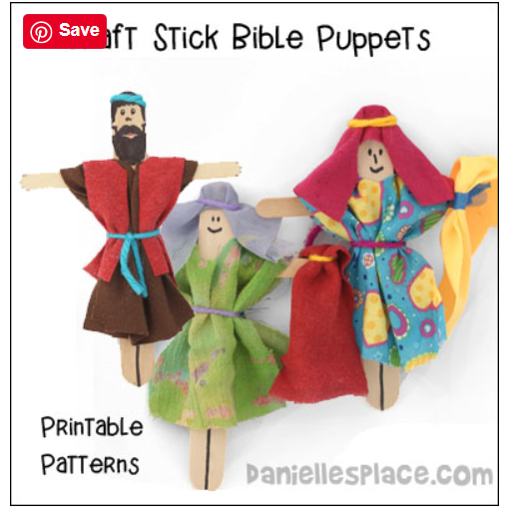
These can be used to retell the story.
- Tabitha was well known and liked in her community because she went out of her way to help others. She made beautiful clothing for those in need. Do you know someone who is a “Tabitha”? Are you a “Tabitha” to others? Discuss these questions with your children, and point out that everyone has talents that he or she can use to help others. Tabitha from our story sewed clothes. What can YOU do? Try using the journal page to write your answers.
- If your children are interested, teach them some simple sewing by hand or with a sewing machine. Encourage them to help you make a project to give to someone else. For very young children, teach them to sew with yarn, paper plates, and a plastic needle. Some simple instructions are HERE.
- One way we can help others is to provide clothing for those in need. Tabitha made clothes by hand. Ask your children how they would provide clothing for others without sewing? One way is to donate clothes we are no longer using. With the change of seasons, this is a perfect time to go through your child’s wardrobe and weed out items they have outgrown or no longer enjoy wearing. Have them help you pack up and donate items in good condition. Items with stains or holes can be recycled: Find a Bin - Planet Aid, Inc.
- Play a game! Work as a family to create an obstacle course (outside if weather permits!). Use household objects such as broomsticks, boxes, laundry baskets, etc. Take turns running through the course while pretending to be Peter looking for Tabitha. See who can get through the course the fastest!
- Make a t-shirt! Use an old shirt or purchase an inexpensive one for your child to decorate. Try using fabric markers or paint to create a design. You can find a scribble design to make initial shirts HERE. Or, go for a TIE DYE look! An alternative to traditional tie dye but with less mess is HERE. Be creative and have fun!

