Sunday School from Home
May 23, 2021
This week we learn about Pentecost.
- Read the story in Acts 2:1-12. Your Bible might mention that some people in the crows claimed the disciples must have been drunk. Depending on the age of your children, you might want to substitute another word, such as confused or even skip that part altogether.
- You can watch a video summary of the story HERE
- Allow children to retell the story, and let them recreate the strong wind with an electric or hand-held fan.
- In the church, we use different colors to signify different parts of the liturgical year. Red is the color for Pentecost because it reminds us of the color of the flames on the disciples’ heads. Take your children on a color hunt and find as many red objects as you can! You may want to pick up these objects and put them in a basket or make them into a collage. For older kids, ask them to write down as many red things as they can find in a certain amount of time. See who can find the most red items.
- For an easy art project, give your children a piece of white or black paper. Tear or cut pieces of construction paper in shades of red, orange, and yellow to signify flames. Allow children to glue down the bits of paper randomly or in a defined pattern. Your project might look a little bit like the following, except for the colors:
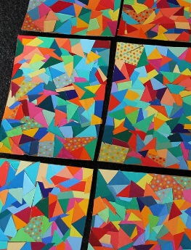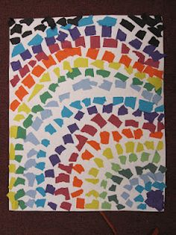
- Since the story this week involves a strong wind, make some wind chimes to hang outside! There are lots of ideas online, but here is one I think is easy and fun: Beaded Windchime - Amy Latta Creations
- Try Blow Painting! Use the flame template paper if you wish, or a plain piece of paper and craft paint. Put a drop of paint on your paper and then blow through a straw to move the paint around. Try using colors that would remind you of a flame, like red, orange, and yellow. More instructions may be found in the attachments. Once you have tested out the technique, you might want to create a more permanent piece of art by using a canvas instead of a piece of paper. Dollar stores sell these cheaply.
- Learn the word for worship in many languages! Use the page in the attachments call Many Languages. If you like, learn some other words in these languages, or perhaps other languages like ASL.
- In our story we learn that many languages were spoken on Pentecost. If you have foreign language picture books, try pulling them out and reading them! The story video for this week includes some Spanish words.
- As always, use as many of the attachments as you find helpful! I have included a few from the story of Paul’s conversion in case you also want to read that Bible story. It can be found in Act 9:1-19.

