Sunday School from Home
May 9, 2021
The disciples solve a conflict in the early church by designating seven people to help distribute food to all in need.
- Read the passage: Acts 6:1-7
- You can watch a video summary of the lesson HERE
- The disciples chose seven people to help serve others. Ask your child what it means to serve others? Can we show love by helping others? How? You can use the journal page in the attachments to allow your children to write or draw their answers.
- Consider with your children why there were seven people named for this special assignment, rather than just one or two. For older kids and adults, you might want to point out that the chosen leaders were all men. Discuss why that would have been the case. Compare that to the way our church selects leaders today – are they always men? Why or why not? Why don’t we rely on the pastor to perform all of these service jobs in the church?
- Older kids and adults might enjoy relating the idea of service in the church to Love Languages (see BOOK or website). Read about the 5 love languages, determine the love language for the people in your family, and how they can be used to serve the church.
- For younger children, ask them to brainstorm ways they could serve others (with or without adult help). Select one or two of these ideas to implement this week.
- Consider making a chart or other visual with some of your ideas above, and then checking them off as each child completes a task. This could be a long term project for the month, or even this SUMMER.
- For younger children, try making an art project with handprints and allow your child to tell how they can serve others. Here is a possible example: 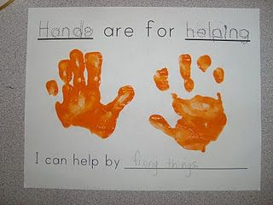
- Another idea:
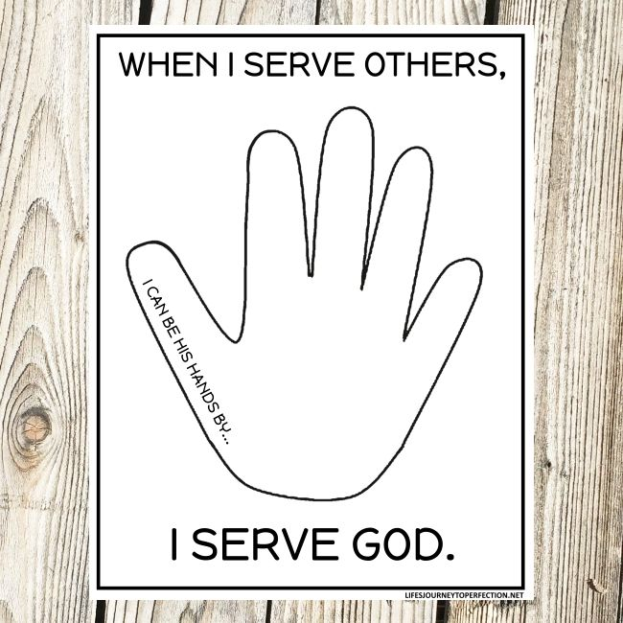
- An art project for older kids (or younger ones with adult help in tracing): Helping Hands | KIDS & GLITTER (lbrummer68739.net)
- Here are two books that would go well with this lesson:
Ordinary Mary's Extraordinary Deed: Pearson, Emily, Kosaka, Fumi: 9781423648871: Amazon.com: Books
and
Miss Rumphius: Cooney, Barbara: 9780140505399: Amazon.com: Books

