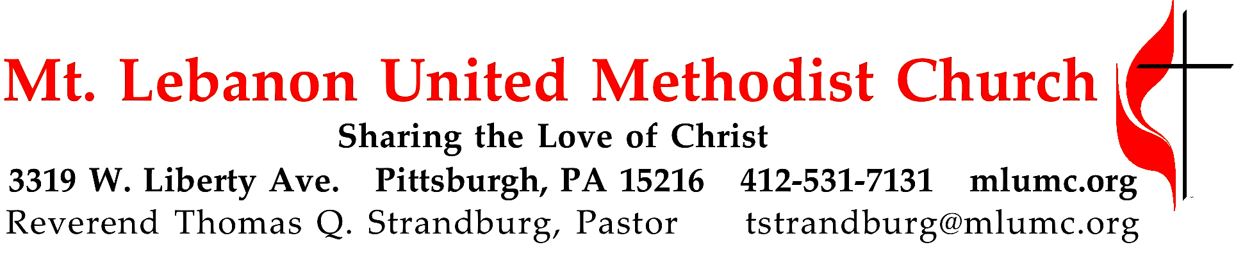

January 9, 2022 8:30 & 10:45
Baptism of the Lord

Isaiah tells us what baptism promises during our life on this earth: God will be at our sides during difficult times. And we, as Christians, live out this example by worshiping together and accompanying each other as part of a community.

WE GATHER IN GOD’S NAME …

*Asterisk indicates to rise in body or spirit
Prelude Wie Schön Leuchtet Der Morgenstern (BWV223, Excerpt)
Dietrich Buxtehude (1637-1707)

Announcements

*Call to Worship
Pastor: The Father's voice bears witness to the Son.
People: And so, God is shown to us.
Pastor: The Son bows his head beneath the waters of the Jordan.
People: And in so doing, God is shown to us.
Pastor: Christ submits to John's baptism and frees us from slavery to sin and death.
People: And in so doing, God is shown to us.
Pastor: God's love is seen to the end of the world.
People: And so, God is shown to us.
Based on Mark 1: 9-11, Luke 3:21-23

… TO GIVE PRAISE TO GOD …

*Opening Hymn "Arise, shine out, your light has come" UMH725

*Opening Prayer
O God of all creation: You came into the world that we might know love and new life. Pour your Spirit on your church, that it may fulfill Christ’s command to live the gospel everywhere; that the proclamation of the good news might be heard throughout the earth. Reassure us, that we are your beloved people. Defend us against all evil and temptation. Give us grace to bear faithful witness to you. Endue us with love, keep us constant in prayer, empower us for the service of love. Amen.

Silent Prayer

*Response "Word of God, come down on earth" (vv.1,4) UMH182

TO CELEBRATE THE FAMILY OF FAITH …

A Lesson for Young Disciples
All children are invited to come forward at the invitation of the pastor. After the children’s message at the 10:45 service, children ages 3 - 3rd grade may attend Kids Praise. Children will be escorted to and from Kids Praise by teachers. They will return to the sanctuary near the end of the service. The congregation will sing, as the children depart:
Tell me the stories of Jesus I love to hear;
Things I would ask him to tell me if he were here:
Scenes by the wayside, tales of the sea,
Stories of Jesus, tell them to me. (UMH#277, stanza 1)

… TO HEAR GOD’S WORD PROCLAIMED …

Scripture Reading
A Lesson from the Hebrew Scriptures
Isaiah 43:1-7 Restoration and protection promised

Response
Leader: The Word of the Lord.
People: Thanks be to God.

Pastoral Prayer

The Lord’s Prayer
Our Father, who art in heaven, hallowed be thy name. Thy kingdom come, thy will be done, on earth as it is in heaven. Give us this day our daily bread. Forgive us our trespasses, as we forgive those who trespass against us. Lead us not into temptation, but deliver us from evil. For thine is the kingdom, the power, and the glory forever. Amen.

Sermon “In Good Company” Rev. Thomas Q. Strandburg

… TO OFFER OUR GIFTS AND TO DEDICATE OUR LIVES …

Offertory
8:30am "O Morning star, how fair and bright" UMH247
10:30am The Three Kings Peter Cornelius (1824-1874)
Kirby Dilworth, soloist
Soloist: Three kings have journeyed from the eastern land,
A star hath led them to Jordan’s strand,
And in Judea inquire the three, Where the newborn infant king may be?
With gold and myrrh and incense sweet, They bring the holy child an offering meet.
And brightly shineth the guiding star; Unto the manger the kings repair,
With rapture on the boy they gaze, and bow before him in joy and praise.
With gold and myrrh and incense sweet, they bring the holy boy an offering meet.
O child of man! Hold thee firm and true; The kings come hither, O come thou too!
The star of mercy, the star of love shall point thee the pathway to Heaven above,
And fail thee gold and incense sweet, lay thou thy heart at the Saviour’s feet! Bring him thy heart!

Choir: How brightly shines the morning star! With grace and truth from heaven afar
our Jesse tree now bloweth.
Of Jacob’s stem and David’s line, for thee, my Bridegroom, King divine,
my soul with love o’erfloweth.
Thy word, Jesu, inly feeds us, rightly leads us, life bestowing.
Praise, O praise such love o’erflowing.

*Doxology "Praise God, from whom all blessings flow" UMH94

*Prayer of Dedication

Closing Hymn "Praise and Thanksgiving be to God, our maker" UMH604

… TO GO REJOICING IN GOD’S NAME!

*Benediction

*Postlude Wie Schön Leuchtet Der Morgenstern (Concluded) D. Buxtehude

Today’s Services
The flower arrangement provided for worship today is given by the Street and Diller families in loving memory of William J. Street.

Acolytes Emily and Evan Shoff

Honor or remember a loved one with a flower donation. The flowers that grace the sanctuary each week are generously donated by our church family members. This is a great way to honor or memorialize a special person, event, or milestone in your personal life or in the life of the church. To donate flowers on a particular Sunday, contact Lizzie Diller , 412-860-3614. The cost is $33 for the altar, narthex, or columbarium arrangements, and $66 for the chancel flowers.

Podcasts of Sunday Sermons Catch up on messages from MLUMC. Pastor Tom Strandburg and Pastor Scott Miller contribute podcasts of Sunday sermons on a rotating basis. Sermons can be found at http://mlumc.buzzsprout.com or navigate to the site from the link on our webpage, www.mlumc.org. Sermons also will be posted to iTunes. Full recordings of the service are available upon request.

Today’s Scriptures

Isaiah 43:1-7
43But now thus says the Lord, he who created you, O Jacob, he who formed you, O Israel: Do not fear, for I have redeemed you; I have called you by name, you are mine. ²When you pass through the waters, I will be with you; and through the rivers, they shall not overwhelm you; when you walk through fire you shall not be burned, and the flame shall not consume you. ³For I am the Lord your God, the Holy One of Israel, your Savior. I give Egypt as your ransom, Ethiopia and Seba in exchange for you. ⁴Because you are precious in my sight, and honored, and I love you, I give people in return for you, nations in exchange for your life. ⁵Do not fear, for I am with you; I will bring your offspring from the east, and from the west I will gather you; ⁶I will say to the north, “Give them up,” and to the south, “Do not withhold; bring my sons from far away and my daughters from the end of the earth— ⁷everyone who is called by my name, whom I created for my glory, whom I formed and made.”

Keep in Prayer

Convalescing in Care Facilities
Carolyn Dagg, Baptist Home
May Frederick, Baptist Home
Anne Hoffman, Friendship Village
Dorothy King
Mark Lewis, Concordia
George Lindow, Friendship Village
Ed Reichard, St. Clair Hospital

Convalescing at Home
Shirley Baker, Bishop George Bashore,
Jean Boyer, Susan Lichtenfels, Carol Van Sickle

In the Military

Jason Boyer, SPC Natalie Brown,

PFC William Dilla III
Maj. Zachary Allen Finch, USMC,
James Iantelli, 1st Lt. Jaskiewicz,
S. Sgt. Keith Kimmell, Sgt. Brendan Lamport, Matt Lewis, USMC,
Sgt. Matthew McConahan, Thomas Orda,
David Poncel, Sgt. Steven Reitz,
LTC Scott B. Rushe,
Pvt. Max Siergert,USMC

Pastor Rick Townes, Maj. Azizi Wesmiller,

Maj. Matthew C. Wesmiller,
Sgt. Keith Scott Winkowski,
Sgt Michael Zimmerman

Sympathy
Condolences are offered to the family of church member Dolores Kortlandt, who passed away on January 3, 2022 at the age of 91. Dolores was an active member of Mt. Lebanon United Methodist Church, a member of Mensa and was active in the South Park Historical Society. She worked at Limbach Co and she retired from AO Management.

Words of comfort can be sent to the family:
Family of Dolores Kortlandt
c/o Paul Henney Funeral
5570 Library Rd.
Bethel Park, PA 15102

COVID-19 Precautions at MLUMC
Based on CDC recommendations and Allegheny County reaching substantial community transmission levels, we encourage everyone, regardless of vaccination status to wear a mask when gathering inside the church building.
We are grateful for the ability to worship together both in person on Sunday morning and online. We encourage you to continue to participate in worship in whatever way you feel comfortable. You are a part of the MLUMC community regardless of where or how you attend. Stay connected via the web site, www.mlumc.org for the most up to date information

Pastor Tom Strandburg

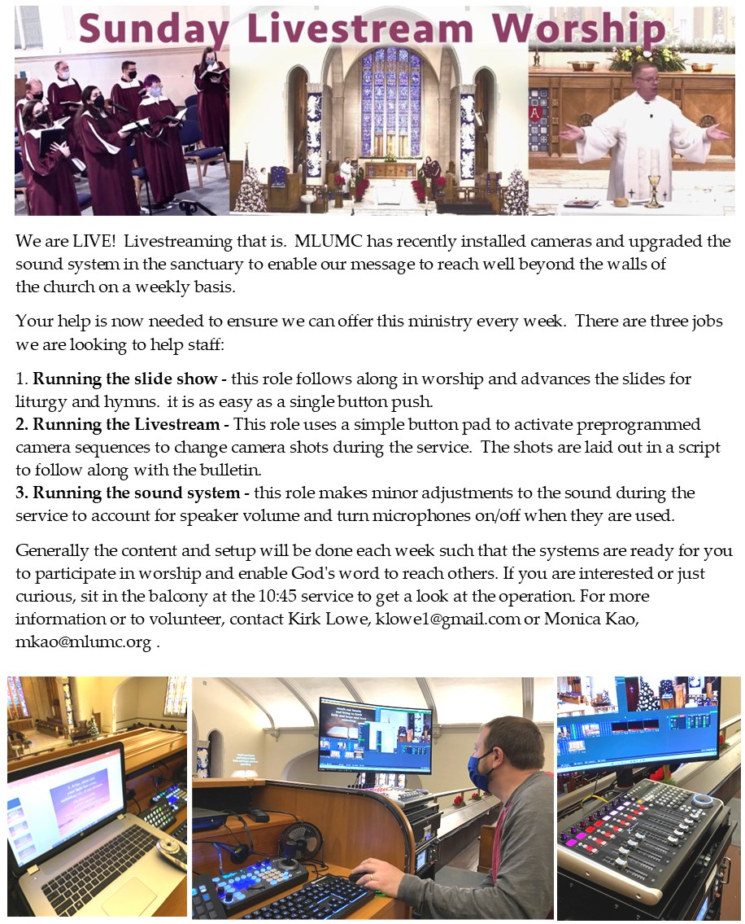
CALENDAR – SUNDAY, JANUARY 9 THRU SATURDAY, JANUARY 15

SUNDAY 1/9
8:30 am Worship Sanner Chapel
8:30 am The Gathering Asbury
9:30 am Sunday School Various
10:45 am Worship Sanctuary
10:45 am Kids Praise Welcome Center

MONDAY 1/10
7:00 pm Church Council ZOOM

TUESDAY 1/11
10:00 am WDM Chapel Sanner Chapel
7:00 pm Troop 23 Meeting Wesley
7:00 pm Troop 9023 Meeting Network

WEDNESDAY 1/12
2:00 pm Women’s Bible Study Bridges
7:00 pm Finance Committee Meeting Welcome Center
7:00 pm Bear, Tiger, Lion, and Wolf Meetings Various

THURSDAY 1/13
7:30 pm Choir Rehearsal Sanctuary

FRIDAY 1/14
7:00 pm Pack 870 Arrow of Light Epworth

