WEEKDAY MINISTRIES CHILD CARE CENTER
PARENT HANDBOOK





Weekday Ministries
Mt. Lebanon United Methodist Church
3319 West Liberty Ave.
Pittsburgh, PA 15216
412-531-5790

2021-2022

Weekday Ministries Office

Telephone: 412-531-5790

Fax: 412-531-7155

Beth Brack – Director

Email: bbrack@mlumc.org



Mt. Lebanon United Methodist Church Office
412-531-7131

Rev. Thomas Strandburg, Pastor tstrandburg@mlumc.org
Kim Rhoton, Dir. Christian Ed. krhoton@mlumc.org
Michelle Rizzo, Church Secretary churchsecretary@mlumc.org

Contents
1. Our Mission
2. Philosophy
3. Licensing
4. Ratios
5. Organizational Structure
6. Curriculum
7. Registration Procedures
8. Classroom Descriptions
9. Nondiscrimination Policy
10. Tuition and Miscellaneous Fees
11. Weather
12. Parking
13. Locked Doors
14. Parental Supervision
15. Drop-off and pick-up
16. Health
17. Suspicions of Neglect or Abuse
18. Emergency Plan
19. Clothing
20. Birthdays
21. Parent/Teacher Communication
22. Room Procedures/Meals
23. Diapers
24. Potty Training
25. Transitioning: New Baby? New to a classroom?
26. Pick-up Time/Hours
27. Toys from Home
28. Discipline
29. Allergies
30. Termination of Service
31. Donation to the Center
32. Coronavirus Plan
33. School Year Calendar

Welcome to Weekday Ministries Child Care Center

- Our Mission

Weekday Ministries Child Care Center is an outreach ministry of Mount Lebanon United Methodist Church. We believe in early childhood education within an atmosphere of faith, hope and love.

Weekday Ministries was founded by Mt. Lebanon United Methodist Church in 1982 in response to the community’s need for quality child care. Our goal is to provide child care within a warm, Christian atmosphere. We strive for healthy child development and parental trust.

- Philosophy

Young children learn through relationships. Our teachers share a dedication and love for the children in their care. Our classrooms are not overcrowded. Our children receive developmentally appropriate instruction in a healthy environment.

- Licensing

The center is licensed by the Department of Human Services (DHS) of the Commonwealth of Pennsylvania. It is our goal to surpass all Pennsylvania state guidelines. If you see areas needing improvement, please see the director. If you determine the center is unwilling to make corrections and is non-compliant with daycare regulations, you may call the department at 1-800-222-2149. A copy of the state regulations is posted in the stairwell on the parent bulletin board. Find it online at
http://www.pacodeandbulletin.gov/Display/pacode?file=/secure/pacode/data/055/chapter3270/chap3270toc.html
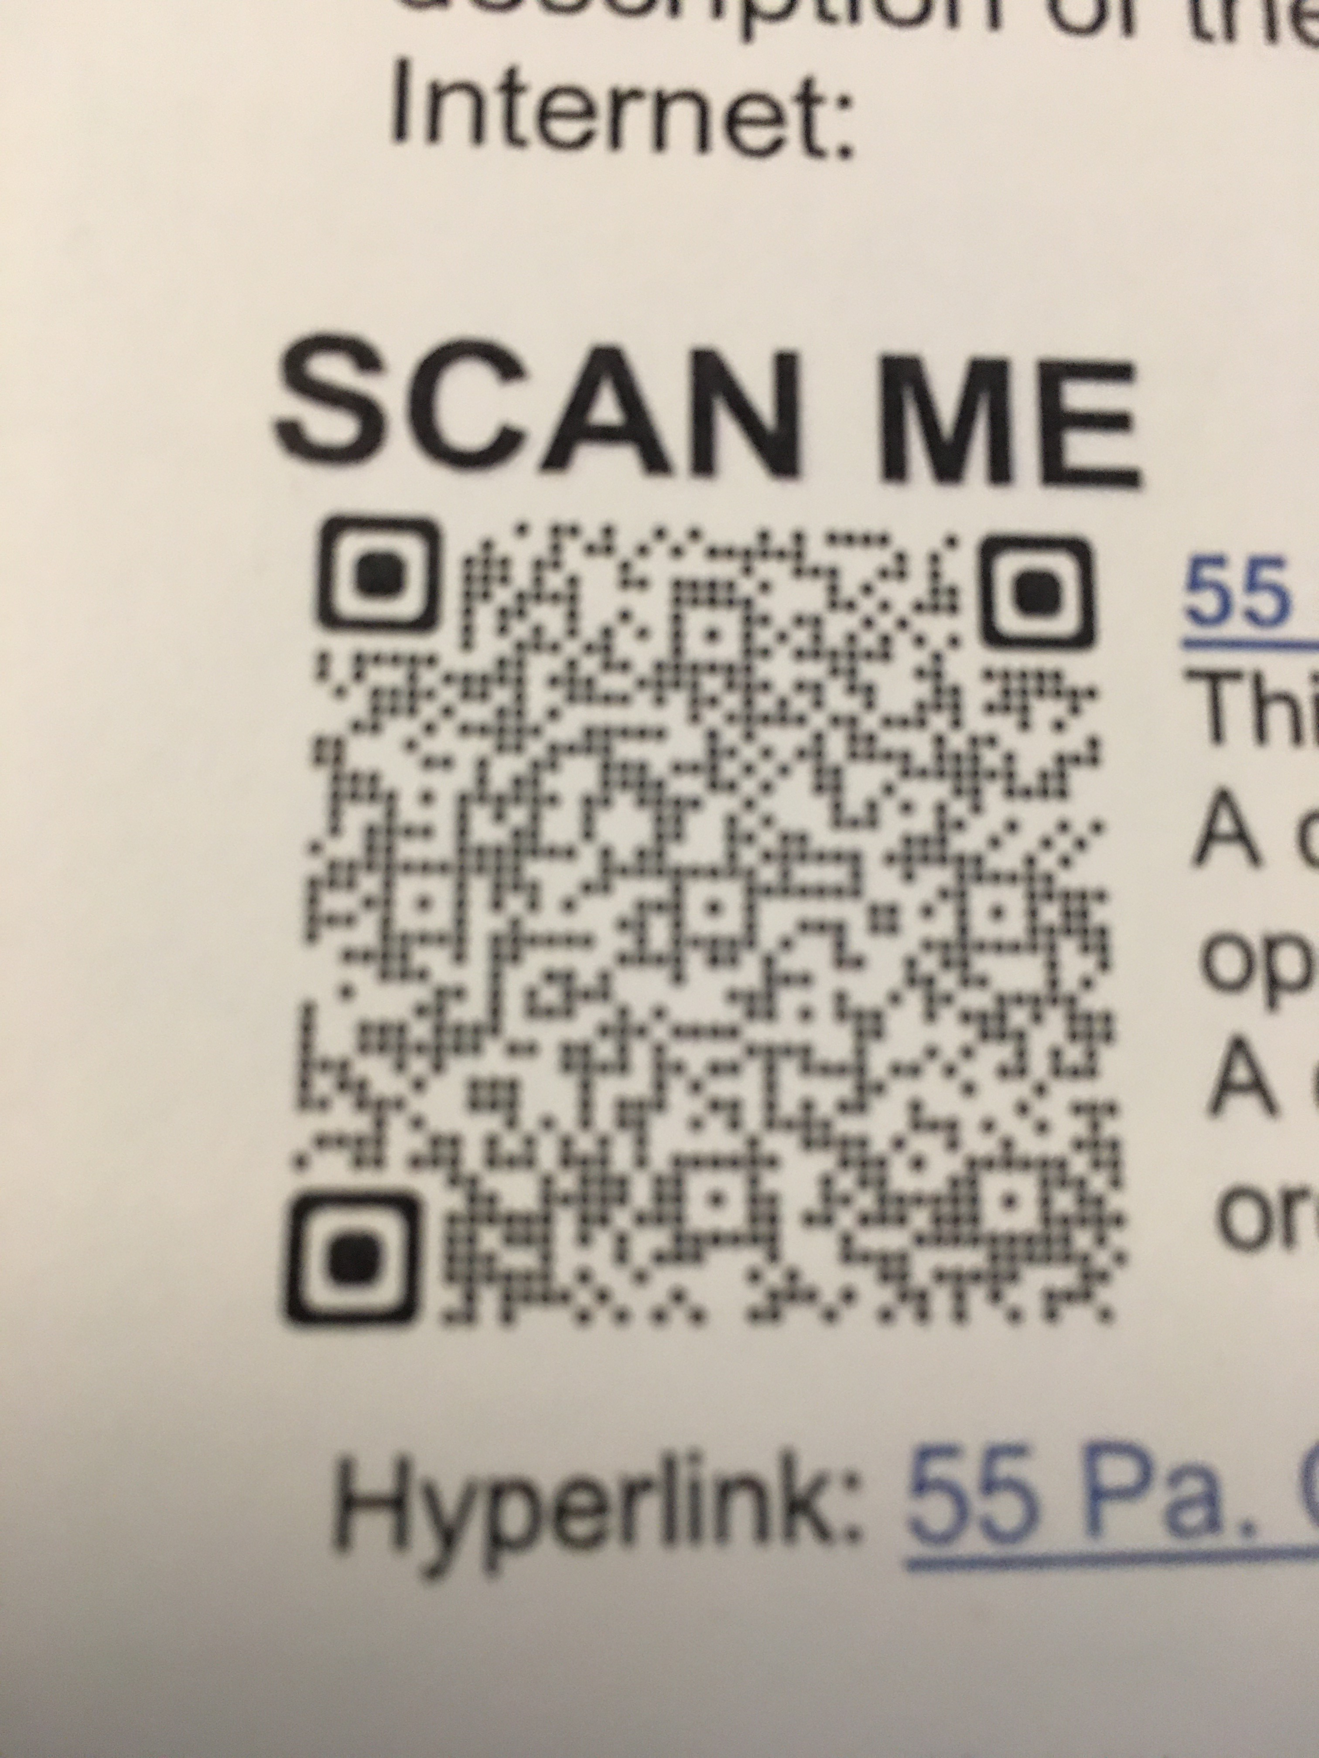

4. Ratios
Group | Legal ratio | # adults in our room
Infants (9wk-12 mos.) | 1 adult to 4 children | 2-4
Tiny Tots & Supertots (1yr. – 2 yrs.) | 1 adult to 5 children | 2
Older Toddler (2 yrs – 3 yrs) | 1 adult to 6 children | 2-4
Pre-K (3 yrs – Kindergarten) | 1 adult to 10 children | 2-3

5. Organizational Structure

Each class has a lead teacher that oversees the maintenance, procedures, lessons, and schedule of the children and equipment in the room. The lead teacher reports to the center director. The center director reports to the senior pastor of the congregation who is responsible to the church council.

- Curriculum

The purpose of the Weekday Ministries curriculum is to facilitate the cognitive, physical, social, emotional, spiritual, and character development of young children. Lesson plans include activities in art, movement, music, social studies, science, pre-math, and reading readiness. Lesson plans are reviewed by the director. Your child will have free time to play in the classroom, as well as gross motor time in the social hall or courtyard.
The Pennsylvania Early Learning Standards are posted in the main hallway and incorporated into our planning.
Monthly Christian themes are included. All themes are based upon Christian teachings shared by all Christian denominations. These basic lessons are taught through Bible stories, crafts, and songs in order to help children learn that God wants His children to know Him and love Him.

Parents of children with an Individualized Education Plan (IEP) must make the document available to the center so that we can coordinate appropriate curricula and activities.

7. Registration Procedures

A non-refundable registration fee of $100 is charged for daycare and is due with every application. Emergency contact information must be available for staff use on the child’s first day. Child Health Report forms must be received no later than 30 days after enrollment and must be updated at every well-child visit. Other forms are updated every six months. We require two weeks’ notice to terminate our written enrollment agreement, or we will charge the equivalent of two weeks’ tuition.

Infant registration is a little different. A reservation for beginning care in the infant room can be made in advance of the start date with a $100 fee plus 50% of the first month’s tuition. This fee is refundable (less $100) within sixty days of the start date. If the start date is delayed by a month, the pre-paid tuition will be forfeited. If the child does not start the second month, the reservation will be canceled without a refund.

8. Classroom Descriptions

We sometimes mix ages, but generally, children are grouped as follows.
9 weeks to 12 months Infant Room
12-24 months Supertots Room
12-24 months Tiny Tots Room
24-36 months Older Toddler Room
36 months – 48 Jr. Pre-K
48 months – 5 years Sr. Pre-K

9. Non-discrimination Policy

Admissions, the provisions of services, and referrals of clients shall be made without regard to race, color, religious creed, disability, ancestry, national origin (including limited English proficiency), age, or sex.

Program services shall be made accessible to eligible persons with disabilities through the most practical and economically feasible methods available. These methods include but are not limited to, equipment redesign, the provision of aides, and the use of alternative service delivery locations. Structural modifications shall be considered only as a last resort among available methods.

Any individual/client/patient/student (and/or their guardian) who believes they have been discriminated against, may file a complaint of discrimination with:

Mt. Lebanon United Methodist Church
3319 W Liberty Ave
Pittsburgh, PA 15216

Dept. Human Services
Bureau of Equal Opportunity
Room 225, Health and Welfare Bldg.
PO Box 2675
Harrisburg, PA 17110

PA Human Relations Commission
301 Fifth Ave.
Suite 390, Piatt Place
Pittsburgh, PA 15222

US Dept. of Health and Human Services
Office for Civil Rights
Suite 372, Public Ledger Bldg
150 South Independence Mall West
Philadelphia, PA 19106

Dept. of Human Services
Bureau of Equal Opportunity
Western Regional Office
301 Fifth Ave
Suite 410, Piatt Place
Pittsburgh, PA 15222

10. Tuition and Miscellaneous Fees (Posted in the hallway by the cubbies and on the large bulletin board in the stairwell)

Fees are based upon monthly charges. There are no refunds for vacations, illness, or unexpected closures due to COVID, weather, water, or power outages. A temporary reduction to a two-day per week schedule is available to hold a spot over two summer months or for two months due to the mother’s maternity leave. A child who withdraws risks another child taking that spot. A new application requires the collection of the registration fee. Rates are set for the year in January.

Checks are to be made out to Mt. Lebanon United Methodist Church. You may write payable to MLUMC on your check.

Please include the child’s full name and information necessary to accurately post the amount to your account.

An electronic payment form can be used to automatically deduct charges from your bank account or credit card using Vanco Services. See the director for an authorization form.

Please place your payment in the director’s office mailbox. The due date is the 1ST. A late fee of $30 will be applied if payment is received after the 15th.

11. Weather

The easiest way to receive emergency information is to sign up for Remind. Using your smartphone find the Remind: School Communication app. Search for Weekday Ministries Childcare. The class code is @bethbrack.

- Our policy is to close or delay only when necessary for the safety of our staff, students, and parents.
- Please understand that many of our staff members do not live close by. We cannot operate without them.
- Delays may be necessary to allow time for local roads and the church parking lot to be cleared.
- The Dept. of Human Services requires that we shut down if we lose power or water for two hours.
- Since we charge a flat monthly fee, there are no refunds for closures.
- If we need to close early for any reason, we will call the emergency phone numbers you leave with us. It is therefore your responsibility to make sure we have active emergency numbers and that you check your voicemails. Using the Remind app makes it easier for you! You will be notified instantly.
- Late pick-up fees will apply if we have to close early. We charge $10 per child for the first 15 minutes and another $10 per child for every fifteen minutes thereafter.

12. Parking

Please follow the one-way sign in the church parking lot for safety reasons. Also, hold hands and keep a close eye on children in the parking lot. If a grandparent, friend, or relative is picking up your child, make sure there is a car seat. It is unlawful to leave children alone in a vehicle.

Do not leave your vehicle in our lot all day unless you have permission from the church office. The church needs space for its own events.

Refrain from parking in all fire lanes included on the church property. Do not park in the driveway between Scott Road and the parking lot.

13. Locked doors

The Scott Road entrance is locked at all times. Please do not try to use this door.

Upon registration, you will be given an access code to use at two entrances near the parking lot and a code for the center doors. Memorize the codes and keep them secure. Give the codes to those you authorize to pick up your children. There may not be someone in the church office to buzz them in. Office staff cannot be held responsible for recognizing all visitors.

14. Parental Supervision

The safety and care of your children are your responsibility while in the hallway, entering or leaving the building. Do not allow children to open stairway doors unless supervised by an adult. Please hold your child’s hand going up and down the stairs. When your child is signed out of the classroom, he or she is not to go back into the room. At that point, the child is your responsibility.

Smoking is strictly prohibited in our facility.

15. Drop-off and Pick Up

Children will only be released to those authorized by the parent in writing. We will ask for photo identification if a person is not familiar with our staff.

No one under the age of 18 can pick up a child or sibling.

Any caregiver who appears to be under the influence of drugs or alcohol will be reported to the authorities.

A parent can legally pick up his or her own child unless we have a court order on file stating otherwise.

Please drop off your child before 10:30 am. Coming in late makes it difficult to instruct and settle children into the routine, especially during naptime.

Children and adults must wash their hands before entering the classroom.

16. Health

Our center follows guidelines established by the American Academy of Pediatrics (AAP). The parent, legal guardian, or other persons authorized by the parent shall be notified immediately when a child has symptoms requiring exclusion from the facility, as described below.
- If the illness or injury cannot be reasonably handled by the staff.
- If the child has had a fever within 24 hours greater than 101 degrees.
- If the child has been experiencing vomiting or diarrhea within 24 hours.
- A note from a medical professional may be required upon returning.

The director has the final authority when determining when a child shall be excluded for health reasons unless directed otherwise by a doctor. Please call the center if your child is ill and will be absent. A door posting and email will inform you if there are viruses circulating. Children need to be symptom-free for 24 hours to return to childcare.

If your child requires medication, it must be in the original container labeled for that specific child. Medicine may not be put into milk or juice. We will administer over-the-counter medication with proper documentation. Containers must be labeled with your child’s name. If the dosage instructions are different from the label, you must get a doctor’s written instruction. A signed medication form must be on file in the classroom.

The initial Child Health Report must be received within 30 days of enrollment and must be updated at every well-child visit. We require all children to be vaccinated.

NOTE: We are required to mandate flu vaccines. Please send updated vaccination records whenever shots are administered.

17. Abuse or Neglect

Pennsylvania law mandates that anyone working with children must report suspicion of neglect or abuse to Childline at 1-800-932-0313. We will not forewarn the parent. Neglect may include ignoring recommended medical or behavioral evaluations. Childline will contact the appropriate authorities. Childcare workers who do not report their suspicions may face fines or jail time.

18. Emergency Plan

Our emergency plan is posted on the parent bulletin board. It is revised yearly and filed with emergency management offices in Dormont and Allegheny County.

19. Clothing

Individual spaces are provided for storage. Please provide an extra set of clothing, (shirt, pants, socks, underwear), in the correct size for your child. Please dress your child with comfort in mind. Provide clothes that are washable. Provide jackets in keeping with the weather. Make sure all clothing is labeled with the child’s name. Shoes should fit well and have good grips for active play. Make sure if your child wears boots to school that there are shoes to wear inside the building. Shoes must be worn indoors at all times. No clothing or shoes can be left hanging in plastic grocery store bags due to state regulations.

20. Birthdays

Birthdays are special! We encourage you to send a special snack for your child’s class! Cookies, small cupcakes, and fruit are great ideas. Please ask if any of your child’s classmates have allergies so that everyone can be included.

21. Parent/Teacher Communication

Parent /teacher conferences are offered twice each year. Evaluations are completed to track your child’s progress. There are also whiteboards and notices posted on each classroom door with messages for you. A monthly center newsletter will inform you of holidays, special occasions, and other noteworthy information.
There is a telephone in each room. When you call 412-531-5790, you will reach either staff or the director’s voicemail. You may call at any time to check on your child.
Small problems do not have to become large ones if they are handled between the parties involved. Please do not hesitate to ask the staff for explanations about anything that concerns you. See the director about unresolved issues.
By law, you have access to our center at any time. You may drop in to check on your child if you wish.
We have a private group page on Facebook called Weekday Ministries Childcare Center. Membership is limited to parents/guardians and staff only. When you withdraw from the program, your membership in the group will be removed.

22. Room Procedures/Meals

Please wash your child’s hands before entering the classroom. Parents must use the sign-in sheet posted on the room door, indicating time in and time out. Make staff aware of pick-up times or other concerns, stow your child’s belongings in the designated area and leave, confident your child will settle in comfortably. Long good-byes are often catalysts for tearful ordeals. Children will usually find something interesting to distract them from your absence with help from the teachers.

Lunches are provided by the parent and will be stored in our refrigerators. There are microwaves available to warm food if needed but please do not send frozen meals as they take too long to cook.
Breakfast may be brought in prior to 8:30 am. After 9:00 am, the scheduled portion of our day begins so we need to be finished with breakfast. Milk is provided. Please provide a cup for your child. Preschoolers drink from disposable cups.

23. Diapers

Extra diapers may be stored in the classroom. Please note that we use disposable diapers only.

24. Potty Training

The Older Toddler Room is the only room in which toilet training occurs. When you have had some success at home, speak with the lead teacher about your methods and convey your helpful tips. As a team, you and the teachers can provide a unified plan to make potty training successful. This is important because a child can become very confused when things are different at home than at school.

25. Transitioning

Children move into new classrooms when they approach their birthdays. You will be notified of the dates ahead of time.

26. Pick up Time/Hours

The center is open from 6:30 am until 6:00 PM Monday through Friday. We close promptly at 6:00 PM. We will charge a $10 late fee per child for the first fifteen minutes past 6:00 PM. There will be another $10 fee charged per child for every fifteen minutes thereafter.

Call us if you will be late. If you do not call by 6:15 PM, we will call your designated emergency contacts. If your emergency contacts cannot be reached, and we do not hear from you by 6:45 PM, we will call the Dormont Police Department.

27. Toys From Home

Toys from home stay at home or in the car. If your child’s teacher announces a special show-n-tell day, children may bring one toy marked with their name. The toy will be placed in a backpack or cubby after show-n-tell. We do not permit toy guns or weapons at the center. A soft animal and/or blanket may be kept for your child to use during nap time. Please wash these items weekly.

28. Discipline

It is important to learn self-control and respect for other people. We believe that these qualities are developed through positive reinforcement, modeling appropriate behaviors, and helping children to understand the results of their actions. Time Out is used when necessary to remove a child from a hurtful situation and to help the child regain emotional control. Parents will be notified by the teachers and/or director if there are any difficult behavior problems.

29. Allergies

Keep us informed about verified or suspected food allergies.

We are not peanut-free because we share space with church functions and cannot guarantee there are no peanut products served in our absence. If a child has an allergy, we will work with you to make sure the child is kept safe.

30. Termination of Services

A child can be dismissed if tuition is not paid; special needs cannot be met; immunization or other records are not received in a timely manner. These decisions are made at the discretion of the director.

We require two weeks’ notice to terminate our services. A fee of two weeks will be added to your account if we do not receive this notice.

31. Donations to the Center

We are a 501c3 nonprofit organization (church). We can accept donations and offer you a tax receipt earning you a tax deduction for anything above the tuition you pay. We are grateful for any help you can give us. We respectfully decline most donations of used toys, however, due to safety and recall issues. Please check with us first.



We will be CLOSED on the following dates.

33.
Sept. 6, 2021 Labor Day

Nov. 2, 2021 Election Day

Nov. 25 – 26, 2021 Thanksgiving Weekend

Dec. 24-Jan 1, 2022 Christmas & New Year’s Week

Jan. 17, 2022 MLK Day/Inservice

April 15, 2022 Good Friday

April 18, 2022 Easter Monday

May 30, 2022 Memorial Day

July 4, 2022 Independence Day

Sept. 5, 2022 Labor Day

